An Election of Self-Centered Tweets: Analysis of Twitter Usage in the 2016 São Paulo Mayoral Election

Claudio Luis de Camargo Penteado[1]

Natasha Bachini[2]

Tathiana Senne Chicarino[3]

Pedro Malina[4]

Denis Carneiro Lobo[5]

Abstract

In order to observe the uses of Twitter in the 2016 São Paulo mayoral election, this article presents a predominantly quantitative analysis of the digital campaigns carried out by the main candidates Celso Russomano (PRB); Fernando Haddad (PT); João Dória (PSDB); Luiza Erundina (PSOL); Marta Suplicy (PMDB); Major Olímpio (SD) and Ricardo Young (REDE). Researchers from NEAMP (PUC/SP - Brazil) and DMRC (QUT - Australia) combined Big Data analysis techniques to verify the continuities and innovations in two main variables: (1) the current digital campaign strategies compared to previous ones and (2) the candidates/followers interactions. The results pointed to a correlation between the broadening of political issue debate on social media and the increase of personalistic contents along with the reduction of the candidate/follower interactive dialogues.

Keywords: Twitter; Big data; 2016 São Paulo Mayoral Election; Digital Campaigns; Social Media Political Campaigns.

Introduction

This article aims to analyze the uses of Twitter in the 2016 São Paulo mayoral election. Considering the digital political marketing field of study and the conjuncture in which this election took place, we verified the digital campaign strategies’ continuities and innovations in comparison to previous elections.

The 2016 São Paulo mayoral election occurred under *sui generis* conditions. It was strongly influenced by an economic slowdown and a serious political crisis at federal level. The economy’s poor performance at the end of President Rousseff's first term and in the beginning of her tumultuous second term led to increased unemployment, reduced social programs budgets, and lower GDP per capita growth rates. As the economic crisis worsened, a major political crisis sprouted. The 2013 June Journeys, when millions took to the streets to protest for assorted demands, stating a crisis of traditional political representation, can be considered as an aftermath of this systemic deadlock. Undoubtedly, social media played a central role in the emergence of new forms of mass mobilization (Ruediguer et al., 2014).

Another phenomenon that deepened the political crisis scenario was the advance of a Federal Police (PF) investigation, named Operation Car Wash, into reports of corruption surrounding the state-run firm Petrobras, involving several politicians, mainly from the Workers’ Party (PT).

Since the results of the 2014 presidential runoff, when Dilma Rousseff (PT) was re-elected by a small margin of votes – only 3%[6] more than her opponent, Aécio Neves (Brazilian Social Democracy Party, PSDB) – the people was (and probably still is) politically divided, precisely by right-wing ideological radicalization on social media platforms, as pointed out Vera Chaia and Fabrício Brugnago (2014).

These elements shaped the context in which Brazil experienced Rousseff’s impeachment[7], following a wave of protests in several cities over the subsequent years. In these outcries, Penteado and Guerbali (2016) identified social media platforms, specifically Twitter, as new-media spaces for political dispute and meaningful recruitment between the pro and anti-president groups.

Throughout this period of time, social media platforms were crucial for understanding society's attention and reaction to this process. The contest on all these events unfolded in an inflamed way on the Web, both with regards to politicians’ advocacy, and the showdown between political positions. Exempt from the necessary face-to-face civil contact and encouraged by their “algorithmic bubbles” (Bauman, 2005), citizens promoted a virtual warfare with the aim of publicizing their political positions, which resulted, among other things, in the propagation of hate speech (Dos Santos, 2015).

The main candidates for the 2016 São Paulo mayoral election were as follows: (1) the incumbent Fernando Haddad (Workers' Party - PT); (2) businessman and adman João Dória (Brazilian Social Democracy Party - PSDB); (3) federal representative and journalist Celso Russomano (Party of the Republic - PRB); (4) former São Paulo mayor from 2001 to 2005, Marta Suplicy (Brazilian Democratic Movement Party - PMDB); (5) former São Paulo mayor from 1989 to 1993, Luiza Erundina (Socialism and Liberty Party - PSOL); (6) businessman and former city councillor Ricardo Young (Sustainability Network - REDE); and (7) the federal representative and retired military police officer, Major Olímpio (Solidarity - SD).

Election polls first placed Celso Russomano (PRB) in the lead, taking 33% of mayoral voting intention[8]. Nevertheless, just as in the previous race, his candidacy was losing approval and other candidates from larger parties began to climb in the polls, such as João Dória (PSDB), Marta Suplicy (PMDB), and Fernando Haddad (PT). At the end of the campaign, João Dória (PSDB), who started with lower voting intention, was elected in the first round with 3,085,187 votes (53.29%), followed by incumbent mayor Fernando Haddad (PT), with 16.7% of the votes[9].

In order to study Twitter usage as a new-media space for political rivalries, social mobilization and party platform advertisement, the article presents an analysis of the digital campaigns conducted by the main São Paulo mayoral candidates. Tableau and Gephi software assisted the collection and analysis of the tweets on the candidates’ official accounts from September 6 to October 13. The election occurred on October 2, 2016.

Besides this introduction, the article is structured into the following four sections: (1) a brief bibliographic review of digital political marketing studies; (2) an overview of our methods; (3) the presentation of the results; (4) and conclusions and recommendations.

1. Digital Political Marketing

The rapid expansion of Internet use and the popularization of social media platforms have drawn political communication researchers’ attention to management shifts in electoral campaigns. Patrícia Rossini (2015) points out that the academic studies on digital electoral campaigns have been in existence for three decades already. In Brazil, this field of study has gained momentum since the 2000s, with the growth in Internet access.

Jennifer Stromer-Galley (2014) notes that digital campaigns were initially less interactive and actually functioned as a repository for advertisements produced for mass media circulation. From the experience of Howard Dean, a primary Democratic contender for the 2004 presidential race, the intensive and interactive use of social media in political campaigns has gained more relevance, especially in relation to US electoral fundraising (Hindman, 2005; Stromer-Galley, 2014).

However, Barack Obama's first winning campaign revealed the efficient use of Internet resources, and that fact can be considered the turning point of digital marketing for political campaigns (Gomes et al., 2009), inaugurating a new phase in which the Internet and its devices received greater space and budget within campaign management.

The use of the Internet in electoral campaigns is correlated with the advancement of information and communication technologies (ICT), as well as its appropriation by World Wide Web users. In the development of political marketing activity, particularly in Brazil, it is possible to identify three phases: (1) premodern (1945-1984); (2) modern (1985-2002) and (3) postmodern (2003 to present day) (Penteado, 2011).

Intuitive political marketing characterizes the premodern phase. At this stage, one-to-one interaction between candidates and voters and the mobilization of social groups shaped the campaigns. The main collective communication outlets were the party newspapers, leaflets and pamphlets.

The political marketing professionalization process characterizes the modern phase. With the development of the mass media, a team of specialists came up with the means to accurately focus on voter persuasion through TV and radio commercials.

The postmodern phase portrays a period of time in which political marketing begins to use Internet resources for campaigns in an instrumental way, allowing message diffusion by targeted strategies for different audiences. The earliest campaign websites were developed and e-mails were used as direct marketing. In a second moment of the postmodern stage, new campaign communication arrangements began to be structured by collaborative practices fundamentally associated with social media (blogs, video repositories, and online social networks) for fundraising purposes.

It is also possible to identify a third moment in the postmodern phase, associated with what W. Lance Bennett and Alexandra Segerberg (2012) called the “personalization of politics”. The enhancement of social media enabled users to participate more actively in the communication process, either by producing content or distributing information on their networks. This new informational ecology allowed a personalized political interaction, as well as the expansion of the political information flow, which can leverage electoral results. Thus, in studying social media conversations to design more efficient and effective campaigns, political marketing specialists began to work with Big Data techniques, monitoring users’ responses to their own posts (Nickerson & Rogers, 2014).

Looking at this phenomenon and analyzing Obama's digital campaigns for 2008 and 2012 presidential election, Bruce Bimber (2014) found that Democrat campaigns were more creative and innovative in the use of Internet resources, notably in relation to social media usage (in the 2008 presidential election) and data analytics management (in the 2012 presidential election), compared to their Republican opponents. Data analytics[10] has innovated by developing campaign strategies based on the analysis and testing of datasets collected on and through the Internet, and the creation of targeted messages and content tailored to users' profiles.

The innovations introduced by the Obama organizations in 2008 and 2012 represent adaptation to the digital media environment in the context of the unusual electoral arrangements of the U.S., in which communication is both candidate-centric and citizen-centric at the same time. Campaign organizations can now facilitate citizens becoming engaged on their own terms and in ways that activate their personal networks; at the same time, they can direct highly personalized political communication to individuals on the basis of extraordinarily fine-grained models of their behavior (Bimber, 2014: 145-146).

Digital campaigns began to adopt strategies based on personalized communication, acting according to the interaction characteristics standardized by digital media environments in which the citizen can interact with candidates and other citizens. In digital campaigns, the communication strategies work in two ways, one keeps the information controlled by the staff of the candidates, and in the other hand the supporters have autonomy to create and share messages from their favorite candidates in their personal networks.

Bimber (2014) comments that this communication strategy was quickly appropriated by candidates for legislative roles in the USA following elections. Candidates and their parties began to invest heavily in Big Data analysis as a campaign-oriented mechanism. The emphasis on personalized campaigns, according to the author, led in 2012 to an increase in polarization among voters, contrary to optimistic views on the 2008 election campaign, when engagement on social media was expected to enhance cohesion.

In 2016, the improvements in Big Data's use in political campaigns were evidenced by the successful Leave.EU[11] campaign for Brexit, and by Donald Trump’s presidential campaign. Both used innovative methods that combined data mining and voter data analysis with multidisciplinary scientific research, especially in behavioral psychology. One leader of such innovation was Cambridge Analytica, a Strategic Communication Laboratories (SCL) subsidiary which claims two decades of extensive expertise in political campaigns around the world[12]. The breakthrough point was the development of users’ psychological traits measurement patterns – mainly focusing on Facebook users –, developed over the past few years by the Psychometrics Centre within the University of Cambridge[13].

The supposedly decisive role played by Cambridge Analytica in Donald Trump's victory, through digital network psychographic mapping and the delivery of specific messages as directed by data, has been extensively covered (DOWARD & GIBBS, 2017; GRASSEGGER & KROGERUS, 2017; PERSILY, 2017; TETT, 2017). This fact has led the company to open new offices in various countries, including Brazil.

Natasha Bachini's work (2013) on the use of Twitter in the 2010 Brazil presidential election – the first Brazilian election under the influence of the so-called "Obama effect" – highlights the limited potential of this digital platform, but with significant weight in the campaigns of candidates from smaller parties, such as Marina Silva (Brazilian Socialist Party - PSB), who presented herself as a viable alternative to the ideological polarization between PT and PSDB, which has dominated the electoral contest since 1994. The results found by Bachini’s work allowed the inference that there was a significant increase in political debate on digital media and in the interaction between candidates (or their staff) and voters, who questioned candidates about their proposals and, in some cases, sought to collaborate with them. However, this debate and this interactive mode were, according to the author, based to a great extent on the agenda of the parties in the campaign, and on mass media coverage.

Through the observation of official accounts, the author visualized multiple layers of candidates’ image management, which guided their tweets for campaign news, personal preferences and celebrity support, revealing an image marketing strategy that reinforces the attachment between public and private spheres. Therefore, on the one hand, the research results led to a finding that Twitter made it possible to bring the candidates closer to the voters' universe; on the other hand, it did not provide a broad discussion of political issues and proposals as well as a close candidate/voter narrative. A later study by the author pointed out that the presidential candidate who provided a warmer candidate/voter narrative, creating such broad political discussion, was Plínio de Arruda Sampaio (Socialism and Liberty Party - PSOL) (Bachini, 2013b).

In another study by Bachini, this time dedicated to an analysis of the use of Facebook in the 2012 São Paulo mayoral election, it emerged that the campaigns staff implemented different strategies. However, none of the analyzed profiles identified an interactive and collaborative pattern between campaign staff members and Facebook users. In the four main candidates’ profiles, the top-down communication logic prevailed, in which voters had little or no possibility at all to propose or discuss distinct political issues (Bachini et al., 2015).

Finally, during the 2014 presidential election, Facebook was a valuable political marketing tool, generating a significant number of posts. Analyzing the profiles of Dilma Rousseff (PT) and Aécio Neves (PSDB) on Facebook in October 2014, and especially during the second round of voting, Penteado et al. (2016) once again pointed out that each campaign staff chose different strategies. While Rousseff's profile focused on a greater frequency, dynamics and diversity of communication, Neves’s profile focused more on the use of media space to publicize his election campaign. Reading the data allowed the authors to infer that there was no correlation between the number of posts and self-engagement (represented by the sum of “likes”, “comments”, and “shares”), and also that this second variable could predict any electoral success.

1. Method

For the digital campaigns study of the main candidates for the post of mayor in São Paulo, we checked and analyzed the João Dória (PSDB), Celso Russomano (PRB), Fernando Haddad (PT), Marta Suplicy (PMDB), Luiza Erundina (PSOL), Ricardo Young (REDE), and Major Olímpio (SD) Twitter accounts.

The growth of social media usage and of cloud data storage, in sync with increasing data processing capacity, are enabling the development of new approaches to the dissemination of online information (Weller et al., 2014). In this way, online communication platforms such as Facebook and Twitter have become an important media space for different types of studies.

Using some of these techniques, in this article we explore for the first time the digital campaigns in order to understand its ongoing dynamics. A short time ago, most of our interpretive efforts on this phenomenon were based on manual collection techniques and a predominantly qualitative analysis that did not allow us to undertake extensive short-term monitoring or draw more comprehensive inferences about the candidates/voters interactivity and their online campaign strategies.

Although our bibliographic review indicates that Twitter currently has significantly fewer users compared to Facebook in Brazil, data collection and manipulation allowed us to utilise this new methodology, and enabled our research purposes with regard to the observation of digital campaign strategies, besides the possibility of better tracking the candidate/follower interaction. At the time we started the research, this would not have been possible for Facebook, in an autonomous way.

For this study, an extended version of the Twitter Capture and Analysis Toolkit (https://github.com/digitalmethodsinitiative/dmi-tcat/wiki) was used to capture data using Twitter’s Application Programming interface[14]. Funded by the São Paulo Research Foundation (FAPESP) and the Australian Technology Network of Universities (ATN), oriented to the development of shared methodologies for the analysis of networked political practices, this toolset was deployed jointly by Brazilian researchers from the Research Nucleus on Art, Media and Politics (NEAMP), linked to the Program of Postgraduate Studies in Social Sciences at Pontifical Catholic University of São Paulo, and by Australian researchers from the Digital Media Research Centre (DMRC) at Queensland University of Technology (QUT).

We collected the main candidates’ official accounts tweets from September 6 to October 13, 2016, as well as any tweets that @mentioned or retweeted any of these accounts during this time, in order to follow the political discussion some weeks before and the week after the first round results (October 2).

After the collection of tweets, the data were analysed using Tableau and Gephi software. Tableau allows data visualization and cross-referencing. Gephi is an open-source network analysis software, making it possible to observe the candidate accounts’ behaviors.

We present below the major results from this work.

1. Results[15]

The graph below is based on a count of the distinct tweet posted by each candidate. We observed that Celso Russomano (PRB), Fernando Haddad (PT), Luiza Erundina (PSOL), and Ricardo Young (REDE) were the most active Twitter users, with a higher overall volume and more pronounced peaks of tweets on single days. Russomano’s strong performance on Twitter is exceptionally noteworthy.

**Graph 1: Candidates’ tweets per day**

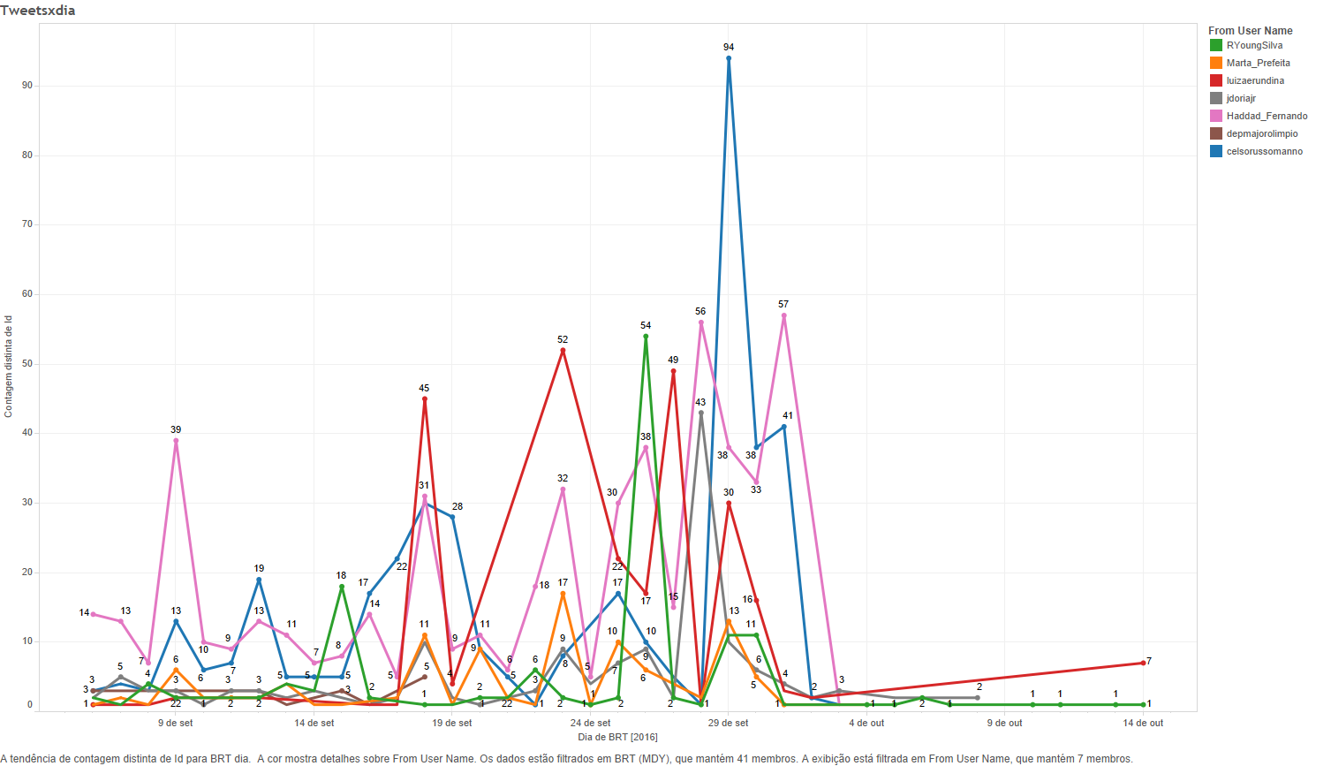

Source: NEAMP and DMRC, 2017.

Overall, the candidates used Twitter to publicize their proposals to the city, to notify followers of campaign events, and to mobilize their followers via hashtags and avatars, but without significant feedback from their followers. Concerning the campaign events, the candidates emphasized their major press interviews and debates appearances.

In the specific cases of Fernando Haddad (PT) and Marta Suplicy (PMDB), the candidates used Twitter to remind voters of what they had already done for the city when they were mayors in earlier times. In a similar vein, Celso Russomano (PRB) also sought to emphasize his achievements over 30 years in the field of consumer rights. On the other hand, Celso Russomano (PRB) and Luiza Erundina (PSOL) sought to attack their direct opponents João Dória (PSDB) and Marta Suplicy (PMDB). Celso Russomano (PRB) and Fernando Haddad (PT) also sought to deny rumors about their proposals. Another similarly identified, this time involving Fernando Haddad (PT) and João Dória (PSDB), was the use of Twitter to publicize the support they received from public figures, generating many quotes and retweets, as shown below. Finally, João Dória (PSDB) stood out among the others for also investing in personal marketing.[16]

The second graph presents the use of hashtags per day. The hashtag is an important feature on Twitter, used to group and track messages on the same topic. It was verified that candidates have used this feature on specific dates. Crossing the data from the first and second graphs, it is noted that the candidates who tweeted the most are also the ones who hashtagged the most.

It is important to highlight the isolated peak on Celso Russomano’s account on September 29, the last official day of the campaign, and day of the final debate on the main free-to-air television network (Rede Globo). On that date, the last poll on voter intentions in the first round was also published (IBOPE inteligência). This poll indicated that Celso Russomano (PRB) and João Dória (PSDB) were tied for first place and also that Russomano (PRB) would beat Suplicy (PMDB) in a hypothetical second round.

In this context, Russomano's campaign triggered a series of tweets through his account and his staff’s accounts. The main goal was to disseminate the poll results, attacking João Dória (PSDB) and calling out voters to watch the debate on television. In executing this strategy, the main hashtags used were #Eleicoes2016, #SP, #DebateNaGlobo, #RussomanoNoDebate e #aGenteResolve. (It is important to note that #Eleicoes2016 was hashtagged by most candidates).

**Graph 2: Candidates’ use of hashtags per day**

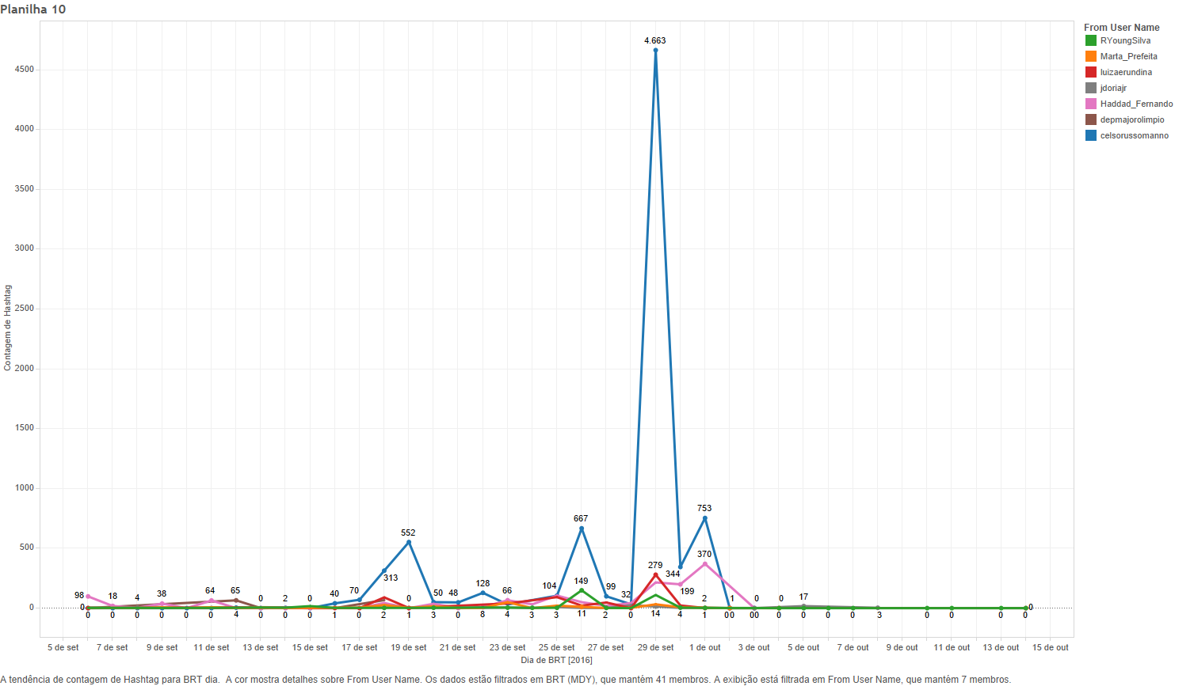

Source: NEAMP and DMRC, 2017.

However, from graph 3, which shows the number of *distinct* hashtags used by each candidate per day, it is evident that originally there were few, repeated and consistent hashtags, most likely in order to ensure the viral transmission of the candidates’ messages. In line with the previous chart, the highest variety in the hashtags used by the candidates occurred on the day of the televised debate.

The greatest diversity in the hashtags used on any one day was observed for Russomano (50), followed by Haddad (11), Erundina (10), Dória and Suplicy (both with a peak of 7 different hashtags in a single day).

**Graph 3: Count of distinct hashtags per candidate per day**

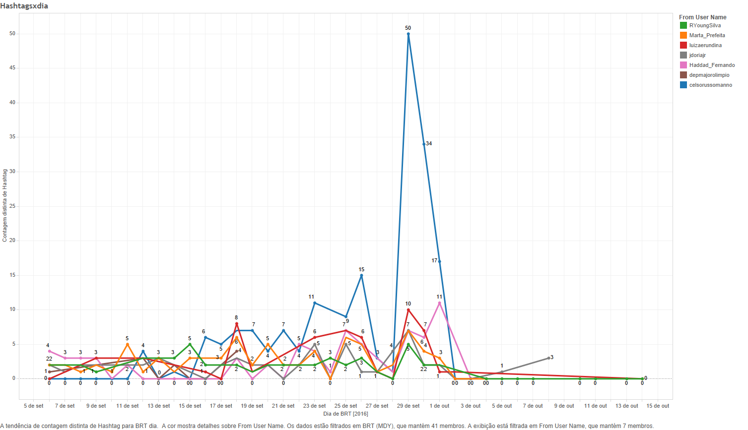

Source: NEAMP and DMRC, 2017.

Figure 1 shows the main hashtags used by the candidates as well as by all the ordinary Twitter users who interacted with the candidate accounts. In addition to the hashtag #eleiçoes2016, the analysis shows the prominence of hashtags campaigning in favor of João Dória (#acelerasp) and Fernando Haddad (#viradahaddad13), as well as of hashtags referring to television debates (#gazetaestadao and #debateglobosp).

Although there was initially an expectation regarding the broadening of the political debate on social media, because of their supposed interactive and participative affordances, in practice, most candidates, and in most cases, only carried out self-promotion and passed on content released by the mainstream media (BACHINI et al., 2015).

**Figure 1: Most prominent hashtags**

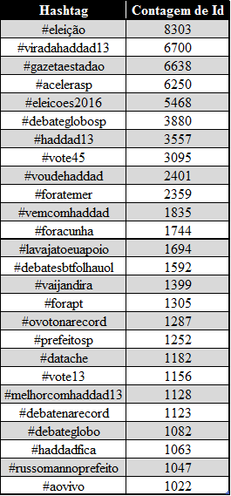

Source: NEAMP and DMRC, 2017.

Graph 5 below examines the use of links to additional content – ranging from embedded images and videos to links to articles on external sites – in the candidates’ tweets. This feature was commonly adopted by digital voting campaigns within Twitter, since a single tweet can contain only a maximum of 140 characters. The orange bar indicates the percentage of messages from each candidate that contained a URL, and the blue bar shows the percentage of the messages that did not. The graph shows that João Dória (PSDB) included an URL in each of his posts; Major Olímpio (SD) and Ricardo Young (REDE) likewise included URLs in around three quarters of all posts.

Graph 5: Total Tweets URLs Percentage

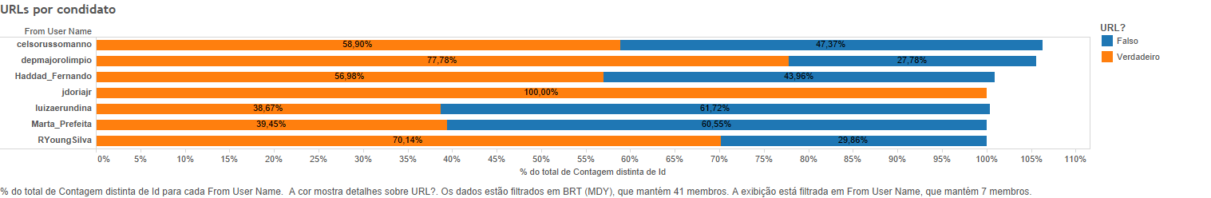

Source: NEAMP and DMRC, 2017.

But while most candidates included URLs in a substantial number of their tweets, graph 6 indicates that this worked in a circular fashion, since most of these URLs pointed back to Twitter itself (sharing embedded images or videos hosted on Twitter, or linking to other users’ tweets). This constitutes an innovation in campaigning strategy. The only candidate who behaved abnormally in this respect was Fernando Haddad (PT), since 32 of his tweets have linked to his official campaign webpage. In addition to links within Twitter and links directed to the candidates’ campaign webpages, URLs also targeted other social media platforms such as Facebook, mainstream media webpages, and well-known web communication channels.

Graph 6: Domains referenced in tweets

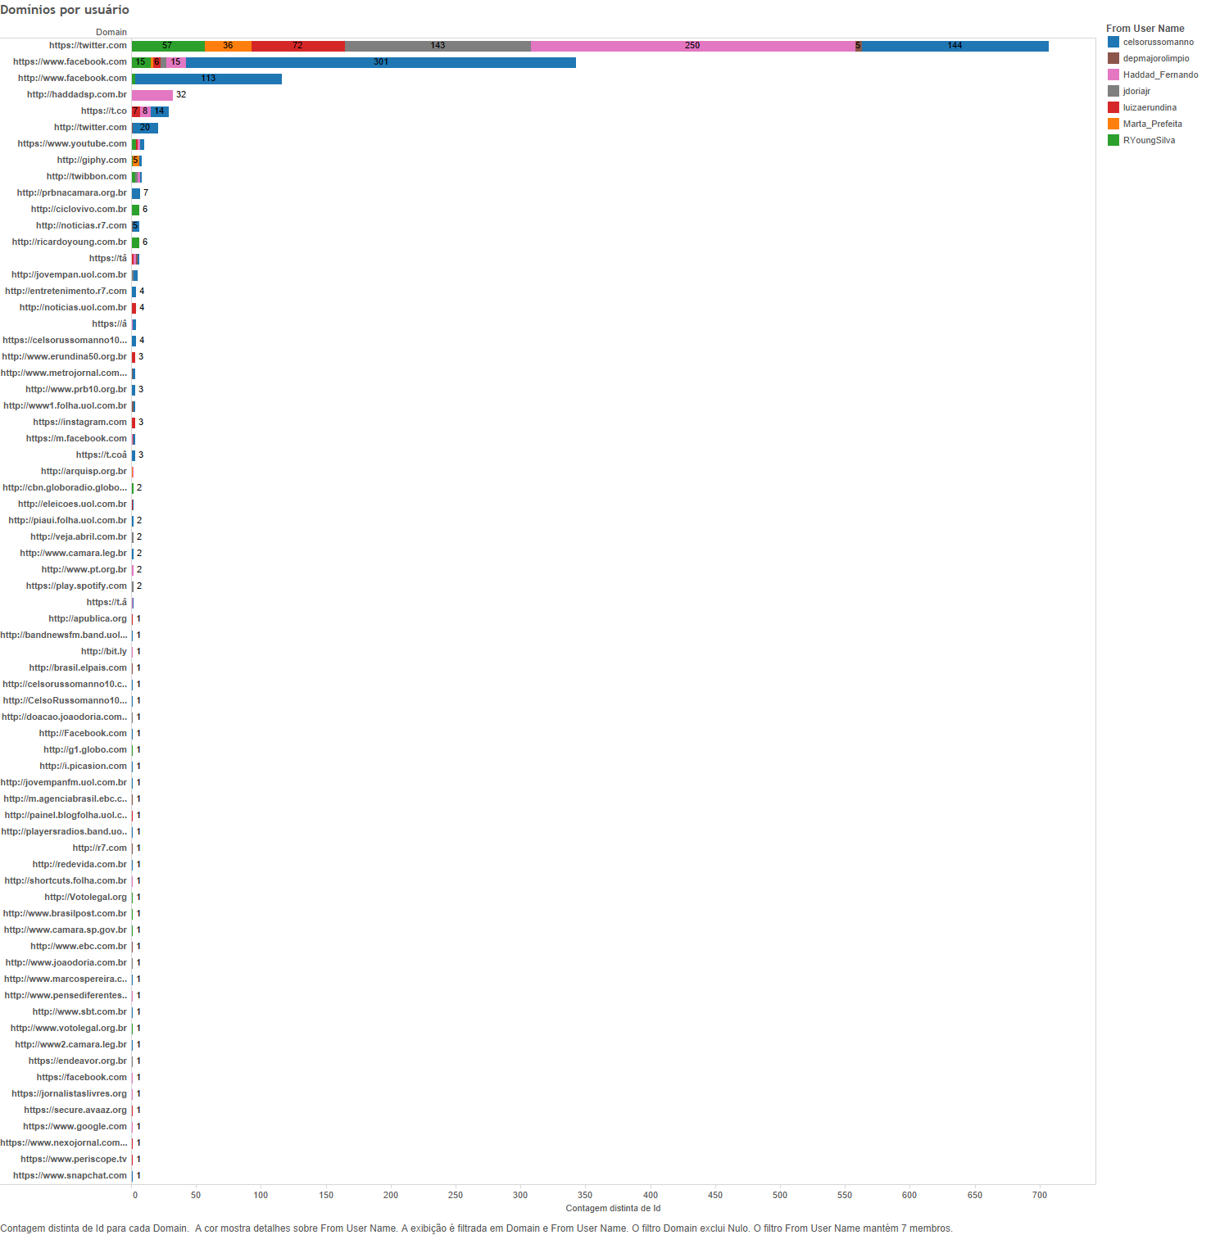

Source: NEAMP and DMRC, 2017.

Another innovation observed was the low use of links to videos on YouTube. In previous elections, candidates very often posted links to YouTube videos containing their own party broadcasts (HGPE)[17]. This decrease in links to YouTube is probably due to the greater use of the new video embedding features provided by Twitter.

**Graph 7: Links to YouTube videos**

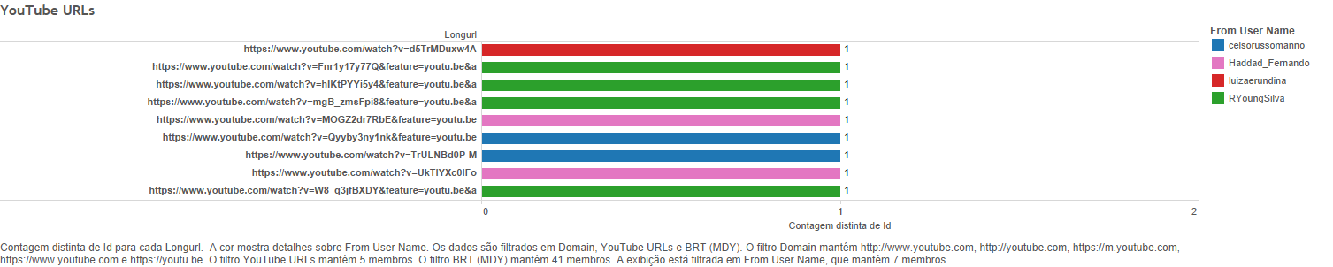

Source: NEAMP and DMRC, 2017.

Graph 8 below shows the number of different accounts with which candidates interacted on Twitter. Celso Russomano (PRB), Fernando Haddad (PT), and Luiza Erundina (PSOL) were the candidates who most interacted with their followers. However, if we take into account the total turnout of São Paulo city voters in the election (8,886,324)[18], these numbers still represent only a minute fraction of all voters.

**Graph 8: Number of accounts involved in candidate interactions**

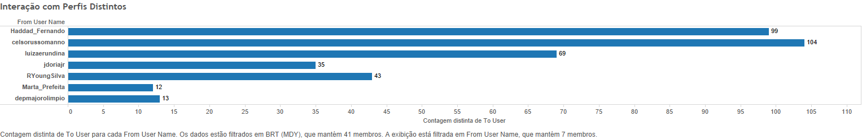

Source: NEAMP and DMRC, 2017.

Graph 09 shows the three different types of tweets produced by the candidates: (1) those that make *original* statements without @mentioning or retweeting another account; (2) those in which the candidates *@mention* another account, (3) and those in which the candidates *retweet* another account.

This graph points to the diverging digital campaign strategies employed by the candidates on Twitter. It is evident that Haddad’s account was the one that produced the most original tweets, and was also most active at @mentioning other accounts. In contrast, Russomano’s account, while also very active in producing original tweets and @mentions, was by far most active at retweeting other accounts. This leads us to believe that Haddad sought to conduct a more dialogical digital campaign, suggesting to his followers that it was usually himself who answered them. Russomano, pursued a similar campaign, but also opted to share the tweets of other accounts more actively.

**Graph 09: Amount of original tweets, @mentions, and retweets posted by each candidate**

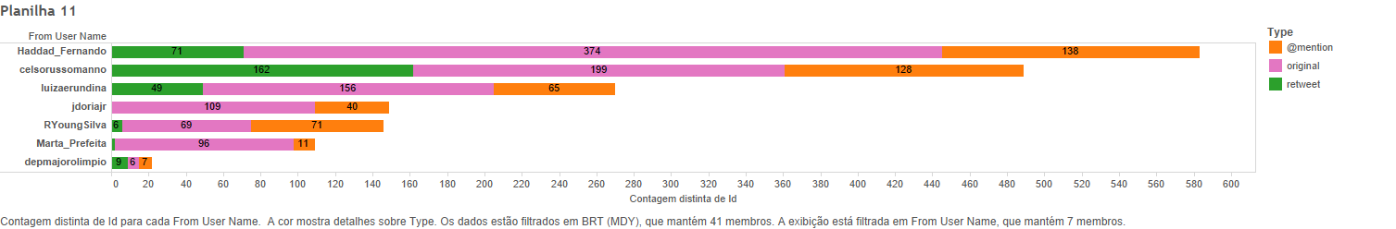

Source: NEAMP and DMRC, 2017.

1. Conclusions and Recommendations

The main candidates’ Twitter accounts revealed different behaviors. Celso Russomano (PRB) was highly active, but his more expressive use of this social medium had no explicit effect on the results of the election, which was won by João Dória (PSDB).

Therefore, the 2016 mayoral election did not show significant innovations for the digital campaigns analysed here. The candidates for the post of mayor did not interact extensively with their Twitter followers, losing potential opportunities for online political mobilization. The results suggest a circularity of communication. The candidates most likely interacted mainly with their communication staff and party members, missing an opportunity to broaden the reach of their proposals and to foster political debate.

In summary, these electoral campaigns on Twitter adopted a mainly propagandistic approach, and stood against the broadening of political discussion on social media. Although the candidates’ campaigns may be still aimed at their own audiences in future elections, it is important to note that the candidates’ behavior can change according to the media platform in use. Future studies proposing to compare them, using similar metrics across multiple platforms, may contribute to filling this gap in digital political marketing studies in Brazil.

References

BACHINI, Natasha. “As cibercampanhas no Brasil: uma análise dos Twitters de Dilma, Serra e Marina em 2010”. *Ponto-e-Vírgula*. Revista de Ciências Sociais, v. 12, 2013.

________________. *Sob o piado do Twitter: o novo tom das campanhas eleitorais com a difusão da internet no Brasil*. Mestrado em Ciências Sociais defendido na PUC-SP. Maio, 2013b.

BACHINI, Natasha; PENTEADO, Claudio; MARTINHO, Silvana; AVANZI, Clarice. Curtiu? O uso do Facebook nas eleições municipais de São Paulo em 2012. In ALDÉ, A; MARQUES, J. *Internet e Poder Local* (orgs.). Salvador: EDUFBA; Rio de Janeiro: Compolítica, 2015.

BAUMAN, Zygmund. *Identidade: entrevista a Benedetto Vecchi.* Rio de Janeiro: J. Zahar, 2005.

BENNETT, W. Lance; SEGERBERG, Alexandra. “The logic of connective action: Digital media and the personalization of contentious politics. Information”. *Communication & Society*, 2012, 15.5: 739-768.

BIMBER, Bruce. “Digital media in the Obama campaigns of 2008 and 2012: Adaptation to the personalized political communication environment”. *Journal of Information Technology & Politics*, 2014, 11.2: 130-150.

CHAIA, Vera Lucia Michalany; BRUGNAGO, Fabricio. “A nova polarização política nas eleições de 2014: radicalização ideológica da direita no mundo contemporâneo do Facebook”. *Aurora*. Revista de Arte, Mídia e Política, 2014, 7.21: 99-129.

DOS SANTOS, Marcelo Alves. “Cartografia das Redes da Revolta: fluxos políticos de oposição no Facebook”. *Contemporânea*, 2015, 12.2.

DOWARD, Jamie; GIBBS, Alice. “Did Cambridge Analytica influence the Brexit vote and the US election?”. *The Guardian,* 4, march, 2017. Availeble in: https://www.theguardian.com/politics/2017/mar/04/nigel-oakes-cambridge-analytica-what-role-brexit-trump.

GOMES, W., FERNANDES, B., REIS, L., & SILVA, T. "Politics 2.0: Barack Obama's on-line 2008 campaign”. *Revista de Sociologia e Política*, 2009, 17(34), 29-43.

GRASSEGGER, Hannes; KROGERUS, Mikael. “The Data That Turned the World Upside Down”. *Motherboard,* jan 28, 2017. Available in: https://motherboard.vice.com/en_us/article/big-data-cambridge-analytica-brexit-trump.

HINDMAN, Matthew. “The real lessons of Howard Dean: Reflections on the first digital campaign”. *Perspectives on Politics*, 2005, 3.01: 121-128.

NICKERSON, David W.; ROGERS, Todd. “Political campaigns and big data”. The *Journal of Economic Perspectives*, 2014, 28.2: 51-73.

PENTEADO, Claudio. “Marketing político na era digital: perspectivas e possibilidades”. *Revista USP*, 2011, 90: 6-23.

PENTEADO, Claudio; BACHINI, Natasha ; FIACADORI, Giuliana. “O PLANALTO EM DISPUTA NO FACEBOOK: Um estudo dos perfis de Dilma Rousseff e Aécio Neves nas eleições de 2014”. In: Cervi, Emerson U; Massuchin, Michele G; Carvalho, Fernanda C de. (Org.). *Internet e Eleições no Brasil*. 1ed.Curitiba: CPOP (grupo de pesquisa em Comunicação Política e Opinião Pública), 2016, v. 1, p. 275-298.

PENTEADO, Claudio & GUERBALI, João. “As manifestações do impeachment no Twitter: uma análise sobre as manifestações de 2015”. *Ponto-e-Vírgula*. Revista de Ciências Sociais. 2016, (19).

PERSILY, Nathaniel. “Can Democracy Survive the Internet?”. *Journal of Democracy,* 2017, Abril, Volume 28, nº2, pgs.63-76.

ROSSINI, Patricia Gonçalves. “Campanhas eleitorais digitais: descobertas, desafios e transformações em mais de duas décadas de pesquisa e prática (Entrevista com Jennifer Stromer-Galley)”. *Compolítica*, 2016, 5.2: 173-186.

RUEDIGER, M. A., MARTINS, R., da LUZ, M., & GRASSI, A. “Ação coletiva e polarização na sociedade em rede para uma teoria do conflito no Brasil contemporâneo”. *Revista Brasileira de Sociologia-RBS*, 2014, *2*(4).

SIBÍLIA, Paula. *O show do eu: a intimidade como espetáculo*. Rio de Janeiro: Nova Fronteira, 2008.

STROMER-GALLEY, Jennifer. *Presidential campaigning in the Internet age*. Oxford University Press, 2014.

TETT, Gillian. “Donald Trump’s campaign shifted odds by making big data personal”. *Financial Times,* 26, jan, 2017. Availeble in: https://www.ft.com/content/bee3298c-e304-11e6-9645-c9357a75844a.

Weller, Katrin, Bruns, Axel, Burgess, Jean, Mahrt, Merja, and Puschmann, Cornelius. *Twitter and Society*. New York: Peter Lang, 2014.

1. Phd in Social Science PUC/SP
2. Doctorate in Sociology IESP-UERJ
3. Doctorate in Social Science PUC/SP
4. Doctorate in Social Science PUC/SP
5. Master in Social Science PUC/SP
6. Superior Electoral Court database. Available at: http://www.tse.jus.br/eleicoes/estatisticas/estatisticas-candidaturas-2014/estatisticas-eleitorais-2014-results. Access date: February 2, 2017.
7. The impeachment was based on the accusation that the federal government borrowed money from public banks – which is forbidden by the Fiscal Responsibility Law – to pay for social programs. The Federal Court of Accounts (TCU) announced in 2015 that it had rejected Rousseff’s accounts administration for the year 2014, arguing she allegedly committed an administrative crime.
8. Ibope Research (August 23, 2016); Available at: http://g1.globo.com/sao-paulo/eleicoes/2016/noticia/2016/08/russomanno-tem-33-e-marta-17-na-disputa-prefeitura-de-sp-diz -ibope.html. Access date: February 2, 2017.
9. São Paulo Regional Electoral Court Database. Available at: http://www.tre-sp.jus.br/eleicoes/eleicoes-2016/eleicoes-2016. Access date: February 2, 2017.
10. Analytic data: data analysis collected on the internet by monitoring and tracking social media (Bimber, 2014).
11. <http://leave.eu/>
12. <https://sclgroup.cc/elections/projects>
13. The psychometric model known as BIG5 or OCEAN was developed in the 1980s through a set of questions and answers capable of identifying five human personality traits. In 2007, Cambridge University researcher David Stillwell created the myPersonality Project, a Facebook application that uses the BIG5 by conducting quizzes with users to assess their psychological profiles. After a few years, there were millions of results accumulated, which allowed several correlations with other Big Data sources. Michal Kosinski, a member of the project team, reversed the correlations and discovered that it is possible to draw psychological profiles from Facebook “likes”. The method proved to be effective, and Kosinski proved that based on an average of 68 “likes”, it was possible to discover skin color, sexual orientation, political preference, religion, eating habits, and alcohol and drug use, among other things. The story can be read at: http://outraspalavras.net/posts/big-data-toda-democracia-sera-manipulada/.
14. Twitter API information available at: <https://dev.twitter.com/overview/api>. Accessed on 2/13/2017.
15. We would like to thank the NEAMP researchers Tathiana Chicarino, Pedro Malina, and Denis Carneiro for their fundamental assistance , in developing the graphs presented here. Without their help this work would not have been possible.
16. Paula Sibília's work is a reference in Brazil regarding the study of how technology forces people to rethink the public/private distinction through intimacy exposure on social media. See SIBÍLA (2008).
17. In Brazil, the party broadcast (Horário Gratuíto Político Eleitoral- HGPE) is a space reserved by law, within television and radio programs, for electoral propaganda.
18. Source: Superior Electoral Court (TSE).