O corpo deslizando sentidos: o en(tre)lace discursivo do político nas fronteiras com o social * / The body overflowing meanings: the discursive interlace of the political on the borders with the social

author **

ABSTRACT
This article aims to discuss the question of the significant materiality of the body in the discursive and political interlace imbricated in the social borders, based on the works of Dan Halter. In order to proceed with that, we propose a theoretical-analytical dialogue between the dialogical perspective developed by the Russian Mikhail Bakhtin and the perspective of the historical-materialism, based on the theoretical approach of the French Discourse Analysis, in order to analyze the object of this study in the relation with “body”, “memory” and “discourse”. In this sense, by working with the imbrication between verbal and non-verbal materiality (ORLANDI, 1995), we seek analyze two specific works by the Zimbabwean artist Dan Halter, considering the meaning effects that slide metaphorically and metonymically to other senses of the body which is unfold into different images of the subject (LAGAZZI, 2014a). We also consider in our analysis the processes which structure the conflict and the tensivity of the social from the spaces occupied by these bodies and crossed by the symbolic, by the ideology and by the history.
KEYWORDS: Discourse; Memory; Ideology; Body significant materiality.

RESUMO
Este artigo tem como objetivo discutir a questão da materialidade significante do corpo no en(tre)lace discursivo do político imbricado nas fronteiras com o social, a partir das obras de Dan Halter. Para tanto, proponho um diálogo teórico-analítico entre a perspectiva dialógica desenvolvida pelo russo Mikhail Bakhtin e a perspectiva do materialismo-histórico, tendo como base o dispositivo teórico da Análise do Discurso francesa, a fim de analisar o objeto de estudo em questão na relação corpo, memória e discurso. Nesse sentido, ao trabalhar com a imbricação entre a materialidade verbal e não verbal (ORLANDI, 1995), busco lançar olhar sobre duas obras do artista zimbabueano Dan Halter, considerando os efeitos de sentido que deslizam metafórica e metonimicamente para outros sentidos do corpo que se desdobram em diferentes imagens do sujeito (LAGAZZI, 2014a). Levo também em conta, desse modo, os processos de estruturação do conflito e da tensividade do/no social, a partir dos espaços ocupados por estes corpos e atravessados que são pelo simbólico, pela ideologia e pela história.
PALAVRAS-CHAVE: Discurso; Memória; Ideologia; Materialidade significante do corpo.

Introduction

When we observe the significant materiality of the body in its relationship with language, history and society, the dialogue with the Russian philosopher and thinker Mikhail Bakhtin is to a large extent timely and profitable. In this sense, the influence of his work and his Circle is rich and wide, considering the constant reference on several authors – such as Julia Kristeva, Jacqueline Authier-Revuz and Tzvetan Todorov, among others – about important concepts around the principle and the dialogical character of language. And, unlike the notions of polyphony, chronotope, and exotopy for example, M. Bakhtin’s perception of the question of the body (as a support for discourse) is not organized centrally in one of his books, but it is dispersed throughout several works, such as the essay Author and hero in aesthetic activity¹ from 1920 in which the problem of the cultural value of the body appears for the first time in Bakhtin’s work. This causes a significant effect a priori: the need to consider the question of the body in its whole complexity, from its social, discursive, political, historical and ideological dimensions.
Thus, what is intended in this article is to elucidate this conceptual complexity revisiting some of the main points of Bakhtin’s theory (important for this discussion), in a dialogue² with the perspective of the historical materialism of the Discourse Analysis of French line. In this way, we try to observe what in Bakhtin’s thoughts (starting from the idea of art as a responsible act) allows us to reflect on the dialogical projections of the body in/through art, thinking about the question of the meanings (mobilized by the body) which slide through/in the social borders. In order to do so, we take in our analysis prototypical scenes of some street protests in South Africa, in different historical moments captured by some images and frames extracted from the videos Untitled – Zimbabwean Queen of Rave (2005; 3:33s) and Beitbridge Moonwalk (2010; 5:24s), works by the Zimbabwean artist Dan Halter, who, by mobilizing in his work the question of the body occupying different social spaces, constructs his criticism to the political situation of the postcolonial Zimbabwe. And from these two videos we examine how the artist looks to these protests which fought for the end of Apartheid and also for the end of the xenophobia against some the refugees who left Zimbabwe moving to South Africa.
In this sense, considering the discursive materiality and some political and social representations of “body” we analyze from these video-frames turning our attention first to Bakhtin’s thought regarding the body. For Bakhtin (1990), the body is the materiality of singular events and a type of signature of the subjects constituted by language, by ideology and by history. It is always an unfinished body, which becomes a whole when contemplated by the other. Thus, according to the understanding of the Russian philosopher, what makes the body an ideological sign is its materiality as an object, as well as its historical materiality and its ideological value. In this sense, by approaching this significant materiality of the body³ as a support for discourse of struggle, militancy, resistance and protest in the social borders, we bring to reflection the words of the Russian philosopher that “both body and meaning can do a cartwheel” (BAKHTIN, 1984 [1968], p. 415)⁴.
The Bulgarian scholar Galin Tihanov proceeding with a review of how the idea of body was getting shape in the course of the work of M. Bakhtin and his Circle (and considering the question of the body as a philosophical problem) outlined some phases of the Bakhtinian understanding of the body.
According to Tihanov (2012), the 1920 essay of M. Bakhtin (already quoted here) seeks to delineate, initially, the limits of the individual body, which is, however, inaccessible to itself – resulting in the idea of an inner body (element of the self-consciousness, controllable) and an outer body (fragmented, with which one cannot act in an immediate way). The inner body is completed through the outer, not sufficient in itself. The outer body, by the other hand, embraces the inner body, shaping a kind of unarticulable mass into a whole. This feeling of wholeness and separation “becomes the prerequisite for a desirable human existence in which the body assumes cultural value” (TIHANOV, 2012, p. 168)⁵. Thus:

[...] Bakhtin‘s division of the body into internal and external originates in Max Scheler’s phenomenology. Scheler speaks of the ‘animate’ body (Leib) and the ‘physical’ body (Körper) ³ to suggest – similarly to Bakhtin – that it is someone else’s feeling of sympathy directed towards my physical body that endows me with the sense of unity and with the gratifying experiencing of the boundaries of my body as a whole. Bakhtin’s term sochuvstvie is a precise rendition of Scheler’s Sympathie. We hear the echo of this significant concept in Bakhtin’s contention that ‘I myself cannot be the author of my own value, just as I cannot lift myself by my own hair. The biological life of an organism becomes a value only in another’s sympathy and compassion [sostradanie] with that life’ (THIANOV, 2012, P. 167-168)⁶.

After an initial look, Bakhtin would reshape his thinking about the body, (re)shifting it from its individual aspect to the idea of social and collective body. According to Tihanov (2012), Bakhtin, under the influence of his friendship with Kanaev in the 1930s, turned to a different idea of the human body in his work on Rabelais, written in the second half of the 1930s. Then, in the 1940s, Bakhtin started to analyze the “collective body, whose identity is shaped not by drawing a boundary between the self and the other, but through the experience of trangressive togetherness” (THIANOV, 2012, p. 169)⁷ Thus, according to Thianov “the radical shift in Bakhtin’s interpretation of the body lies in his contention that it is not a unitary entity; it is neither ‘so single’, nor ‘so my own’” (idem)⁸.

The body in the in(ter)lace of the political with the social

Building bridges between the I and the other, we propose in this article a dialogue, therefore, between Bakhtin’s thought and the historical-materialism work by Michel Pêcheux in France – to what he calls “a materialist theory of discourse” (PÊCHEUX, 1982, p. 60)⁹ – so that can help us to broaden the horizons of our theoretical-analytical view on the body present in different textualities, from its representations, in the case here, from the art.
Starting from the thought developed throughout the work of M. Bakhtin that the collective body is established through an experience of transgressive union (not being a mere unitary entity) we will focus on the question of the body as a support of discourse and on the body textualized in different significant materialities (such as the artistic image, film and documentary scenes, video frames), seeking to reveal, in this sense, according to Aline Fernandes de Azevedo Bocchi “that the corporality itself is also a significant materiality, discursiveness inscribed in conditions of borders productions” (AZEVEDO, 2014, p. 322)¹⁰.
In the material which we analyze here, the body appears crossed by the political in the work with the symbolic, occupying different spaces of protest and meaning in different ways, given the different conditions of production of meaning, in the relation between body, space, time and subject.
Thus, for M. Bakhtin, on the one hand, the body “ is not separated from the rest of the world. It is not a closed, completed unit; it is unfinished, outgrows itself, transgresses its own limits” (BAKHTIN, 1984 [1968], p. 26)¹¹, on the other hand, it is essential to observe it from the materialistic discursive perspective, as reflected by Aline F. Azevedo Bocchi, considering “the movement of constitution of senses on / of the body” (AZEVEDO, 2014, p. 322)¹². From this understanding, the author statutes taht “the modes of meaning and signifying materiality are plural: the body is a place of opacity that gains meaning through the look” (idem, p. 323)¹³. Thus:
[...] through the theoretical affiliation to the historical materialism, the material form is always historical. In other words, taking the body as a material form implies removing any conception that treats it as an empirically understandable and biologically functional reality, common in areas such as health, where the body is natural, segmentable, controllable and transparent (ibidem, p. 323)¹⁴.

To read the body under this discursive bias represents an investment in the gestures of interpretation of different materialities, as in the images and in the visual formulations (LAGAZZI, 2013, 2014a, 2014b) of the body. This requires from the analyst a look that seeks to go beyond the meanings in evidence, in the methodological beat between the gestures of description and interpretation, making the opacity work around the representations of the body. From what is stated by J-J. Courtine the human body was, and remains for us, covered with signs, even if their nature, the look that deciphers them, the position of the interpreter and the intention of the person who expresses them have changed historically (COURTINE, 2011, p. 37)¹⁵.
In the case of art, we can also observe different representations of the body. Some of them, which are here the objects of our analysis, arise in certain prototypical scenes of protests (bodies in marches, raised fists, crowds in the streets, hands hovering banners and posters). Such representations of the body are not only constituted as an aesthetic element, in the dialogical confluence between bodies and images, but they also interpellate different meanings (around) of the body in the interweaving between verbal and nonverbal (ORLANDI, 1995) crossed by the political, the ideological and occupying different spaces, different temporalities that are determinant in their processes of signification.
Taking into account, for example, the relation time-space, we therefore seek to reflect on how body and subject are placed on the borders of meaning, from the experience of the streets and public spaces and from the discursiveness of the protests, which is forged in the temporality of manifestations and social-political struggles. The protests space is the meeting point between heterogeneous bodies discursively crossed by ideology and history. In this sense, as Marilia Amorim points out, “[...] at the meeting, the temporal definition (at that moment) is inseparable from the spatial definition (in that place)” (AMORIM, 2006, p. 102)¹⁶. In this way, it is possible to understand that in the imbricated relation time-space, the transformations (as we observe) begin to operate from which bodies and subjects are placed, displacing themselves and (re)signifying in different meaning (such as union, struggle, manifestation, confrontation, resistance).

Art, protest and body in the works of Dan Halter

In some of Dan Halter’s works ¹⁷ the body’s images emerge in the constitution and construction of a critique of the artist in relation to the political system of the postcolonial Zimbabwe. A descendant of Swiss refugees in Zimbabwe after the First World War, Dan Halter was born in Harare, Zimbabwe’s capital, a small African country that in 1980 was no longer a British colony. In 2005, he witnessed the forced exile of his parents. Commenting on the political situation of his country, he mentions the important step that must be taken by the revolutionaries who have fought against repression and, today in power, are also corrupted. The recognition of Dan Halter’s work has resulted in the participation in several art exhibitions, such as in the 10th Havana Biennial (Cuba), the 3rd Triennial in Guangzhou (China), the 9th Biennial of Contemporary African Art (Dakar, Senegal), and the Smithsonian National Museum (Washington, USA).
In the convergence between art, social and political, the images in the documentary work of the Zimbabwean artist Dan Halter, entitled Untitled – Zimbabwean Queen of Rave (2005), present some prototypical scenes of social protest in the interweaving of different images of black demonstrators on South African streets contrasting with flashes of rave parties throughout Europe in the early 1990s.
Using an artistic technique of overlaying images in scratch videos, Dan Halter configured Untitled in videoclip format (3m32s), having as soundtrack the hit Everybody’s Free (To Feel Good) by the Zambian singer Rozalla, who made her first appearances on stage performances in the 1980s in Zimbabwe, reaching international fame with this dance-style song, released in 1991. In the intertwining of the images and verses of the song, the visual and verbal materialities intertwine in dialogical bridges that intersect in the whole of this Dan Halter’s work. The chorus Everybody’s free (to feel good) – repeatedly repeated, (re)sounds producing meaningful effects like that of a “spokesperson song” that (re)moves, in the threads of the speech, standing on the borders between scenes of the European raves in contrast to the different movements of resistance and protest in the streets of Africa against the Apartheid regime that appear in some scenes of the video.
The Apartheid policy, led by successive National Party governments in South Africa over the years of 1948 and 1994, was a regime of racial segregation in which the rights of the majority of the inhabitants were curtailed by the government formed by a white minority. After the March 21, 1960, massacre in Sharpeville, in the context of the period of decolonization, international critics against that segregationist political regime began to grow. As a result, many of the popular movements of the anti-apartheid ideology have gained ground in different African countries. In this sense, the first scenes of the video (0:08s) of Untitled, in which bodies of militants appear in protest¹⁸ trying to bring down the iron railings of the gates in a public space (figure 1) are thus crossed by an ideology of social struggle, of struggle for freedom against a segregationist political system (in contrast to images of crowds of young people gathered at rave festivals on the streets of Europe, indicating in this case not a political struggle but a form of “expression” and “celebration” of freedom).

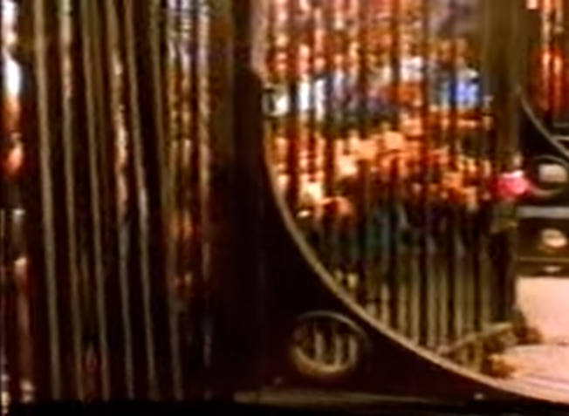
Fig. 1. Protesters fighting against Apartheid. Source: Untitled (2005)

It is possible to observe, thus, the criticism that Dan Halter’s work establishes by denouncing that some are freer than others. These initial scenes converge with the statements echoing from the verses of Rozalla’s song, producing a sense effect of spokesperson in a kind of “defense” of the black movement on the streets of South Africa. Thus, the sense of mobilization through / for the union is enunciated from verses like “[...] brother and sister / together we’ll make it through” “[...] we are a family that should stand together as one / helping each other instead of just wasting time”. At this point, we reflect with Volochínov, that the essay Slovo v zhizni i slovo v poezii (The word in life and the word in poetry), from 1926, teaches us that:

[...] the social essence of verbal discourse stands out here in sharper relief and the connection between an utterance and the surrounding social milieu lends itself more easily to analysis […] In life, verbal discourse is clearly not self-sufficient. It arises out of an extraverbal pragmatic situation and maintains the closest possible connection with tha situation. Moreover, such discourse is directly informed by life itself and cannot be divorced from life without losing its import (VOLOSHÍNOV 1976 [1926], p. 98)¹⁹.

From these reflections of the authors on the indissociability between life, discourse and art, it is also possible to observe, on the other hand, according to UNICAMP´s discourse analyst Suzy Maria Lagazzi-Rodrigues that “it is the material interweaving between the verbal and the visual that enables the formulated criticism” (Lagazzi-Rodrigues, 2011, p. 11) ¹⁹. In this case, it can be said that this is a criticism that goes through the constant irruption of the sense between the political ideology of oppression / segregation as an element that can be overcome by bodies gathered in protest and in struggle, occupying a given space and historical moment. It is also possible to identify other meaning effects that this work of Dan Halter produces, as the art curator of the Cultural Video Brazil Association (which hosted this documentary in Brazil in 2014) points out, highlighting that:

[...] the dynamic edition, reminiscent of the English scratch videos of the 1980s, creates a parallel between two situations that, subject to the media re-contextualization, lose their potential for confrontation. The raves, marked by the refusal of the yuppie lifestyle, gain an image of empty fashion; the contestation movements in Africa seem to be devoid of causes. The freedom of dance while protest and protest as a dance is framed by the television rectangle, rendered metaphor of a process of appropriation and emptying (VIDEO BRASIL, 05/08/2014)²⁰.
This possible effect of emptying (deleting) evidence inevitably passes through the process from which, in producing certain textuality, other senses are silenced (ORLANDI, 1992). The overlap of images of the bodies of crowds of young people in Europe and of South African militants occupying the streets of Zimbabwe, marking the confluence between different temporalities and different spaces, which passes through the film spectrum of dynamic editing work through art, functions discursively producing these effects - as one can observe in figures 2 and 3:

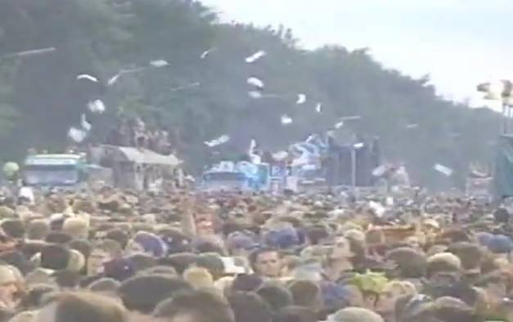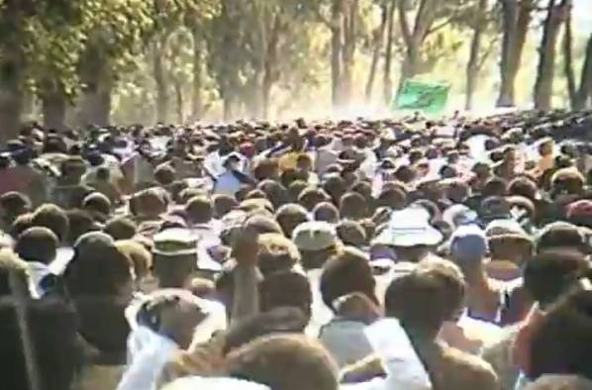
Fig. 2. Crowd of young people in European raves Fig. 3. Bodies gathered in Zimbabwe protests

Reflecting with Milanez, images register “the movement of bodies in a succession of scenes [...] making other images resurrect in us, which form a chain of displacements in the movement of the meanings” (MILANEZ, 2011, p. 36-37) ²². From this analytical perspective, it is important to observe, according Lagazzi (2011), that both the “intersection of different materialities” and “significant material imbrication” ²³:

emphasize that it is not a matter of analyzing an image and the speech and musicality, for example, as additions to each other, but rather of analyzing the different signifying materialities one in the middle of the other (LAGAZZI, 2011, p. 402) ²⁴.
Thus, the visual language which is also the place of failure, of hole, of equivocation, of erasure, is constituted by the constant production of meaning effects that escape to the total apprehension of the symbolic, being that that something which always returns through different ways of signification. So, according to Valentin Nikolaevich Voloshinov:

[...] a sign does not simply exist as a part of a reality – it reflects and refracts another reality […] it may distort that reality or be true to it, or may perceive it from a special point of view, and so forth. Every sign is subject to the criteria of ideological evaluation (VOLÓSHINOV, 1973, p. 10)²⁵.

In this analysis, considering the parallel of the visual formulations of the body in contrast (on one hand, of the bodies in protest, and on the other hand, of the bodies occupying the spaces of the rave parties), we question ourselves about how the alterity processes (of the body in relation to the other) are structured in the images in terms of regularity.
These parallels leave discursive marks by which we seek to examine from the images here in question. The massive concentration of people, for example, brought together by a common interest, the permanent movement, the climate of exaltation, the streets taken by bodies in protest suggest us, as we can see, that the visual formulations of the body “unfold in different images of the subject and show us the importance of the remission of the intra-discourse to the inter-discourse” (LAGAZZI, 2014a, p. 111) ²⁶.
The English term “rave”, in addition to designating outdoor electronic music festivals, can be understood as “moving or advancing violently”. The contrast of meanings (constituted by a discursive heterogeneity) highlights, in this case, some white young people who have the privilege of meeting to celebrate, while black people of different ages (not just young ones) need to come together to claim the most basic human rights.
This leads us to take into account the idea of a collective body as a discourse support (which arises, for example, the discursivity of resistance in the social and political protests). So by that point it is possible to understand the issue of otherness as a dialogical bridge, in Bakhtin’s terms, and formulated in terms of distinction, contrast, in the spaces of signification in which the bodies are interpellated by memory and by different social positions occupied by the subjects in discourse. From this perspective, we consider that meanings pass through these bodies and occupy different places as theses bodies move. Thus, there are meanings occupying these bodies, as well as these bodies emerge occupying the spaces discursively and ideologically.
An example of this is the case of the typical African dance from Zimbabwe, present in the protests that appear in Untitled (figures 4 and 5). The movements and gestures of the bodies that are formed in march (in the dance called Toyi-Toyi ²⁷, much used by the forces of ZIPRA, Revolutionary Army of the Zimbabwean People) represent signs integrated in different meaning. According to Gilbert (2008), Toyi-Toyi is a “militant dance”, organized in protest marches and accompanied by songs and slogans. In the following frames, extracted from one of Dan Halter’s documentary, it is possible to observe some images of bodies being placed in the borders of signification between the political, the ideological and the social places, from the Toyi-Toyi marches.

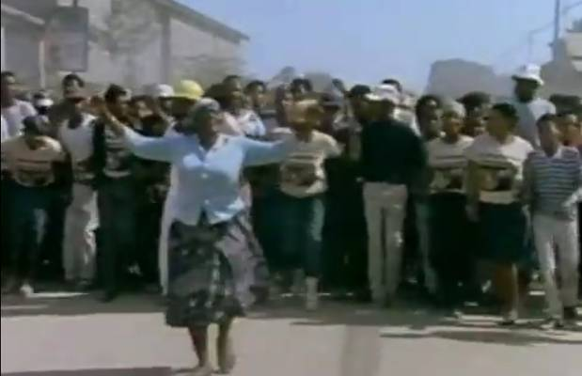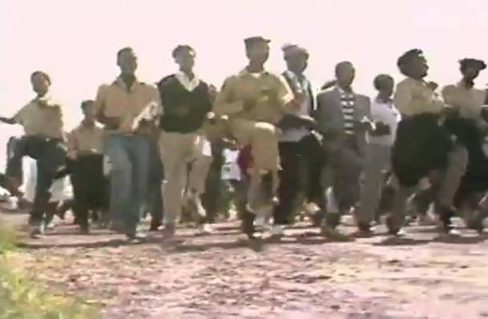
Fig. 4. Bodies occupying the spaces of the street Fig. 5. African militants in the Toyi-Toyi marches

Used not only to intimidate the African police forces during the anti-apartheid protests, the Toyi-Toyi “is still present in some specific contexts, such as political protests, rallies and trade union movements” (BRAZ DIAS, 2012, p. 100) ²⁷. Thus, in the words of the anthropologist Juliana Braz Dias, “toyi-toyi is part of a sequence of practices that refer to the armed struggle in a symbolic way only because of the impossibility of carrying out the actual armed struggle”(idem, p. 103) ²⁸. In her reflections, she points out that in this form of protest “we would have a case of ‘symbolic compensation’ for the absence of power” (ibidem, p. 103) ²⁹.
Thus, by observing the filmic images of these bodies in struggle, the author describes that:

[...] the approach of the protesters is announced by a sharp cry: “Amandla!” – which, in zulu and xhosa, means “poder”. The answer comes from the crowd, in chorus: “Awethu!” (“For us!”). The images start to [...] focus on the movement of resistance to apartheid. They are young people who, in the direction of the weapons, sing songs of protest, evoking their leaders: Oliver Tambo and Nelson Mandela. Carry posters in which is read: [...] “Freedom, justice and peace, now!”; “How long will we be humiliated, kicked, strangled, beaten, raped, and killed?”(BRAZ DIAS, 2012, p. 110-111) ³⁰.

In Eni Orlandi’s reflections on a discursive theory of the subjects’ resistance forms, the author states that “there are forms of omnipotence also in the social domain: ‘together we can do anything’, position that is supported by the quantity and by the intended collective conscience” (ORLANDI, 2012, p. 2013) ³¹. Such a consideration echoes in Braz Dias’s (2012) description of the bodies assembled in the Toyi-Toyi marches as a form of struggle and popular resistance:

[...] many of them carry in their right hands a piece of wood, like a spear. Others only have their hands closed. Several wear school uniforms; some with the tie – a traditional part of the uniform – tied to the forehead, remembering the adornments worn by the Zulus warriors. Many bring a serious aspect. Others reveal a slight smile as they sing the songs and let their bodies follow the movement together: knees to the top, alternately, and fists in the air ?”(BRAZ DIAS, 2012, p. 111)³².

Taking into account the discourse mobilized through the body and launched in the relationship with the body of the other, there is the sliding and (re)displacement of meanings in the memory paths in which the already-said and the pre-constructed are reformulated. In this sense, the imbrication³³ between the verbal materiality (the slogans, the chants sung in the marches) and the visual formulations of the body (fists in the air, arms given in movements together) seems to resonate also Volochínov’s reflection that the “intonation establishes a firm link between the verbal discourse and the extraverbal context –genuine, living intonation moves verbal discourse beyond the border of the verbal” (VOLOCHÍNOV, 1976 [1926], p. 102). ³⁴.

Bodies and subjects under surveillance

At another point in our analyzes, we also look at other aspects of the relation of otherness of bodies and subjects in different spaces. When we observe, for example, certain prototypical scenes of protests and body images occupying the spaces of the streets, in Dan Halter’s work, we have identified different relations between the “I” and the other. Examining, further, the documentary Untitled, it is possible to see, for example, some scenes highlighting the different subject positions occupied by both the African militants and young people having fun at rave parties in Europe, in contrast (by the visual) with the positions occupied by the police authorities that place in the borders of the vigilance of the crowds in the streets (figures 6 and 7).

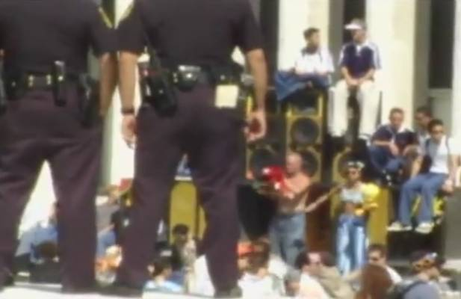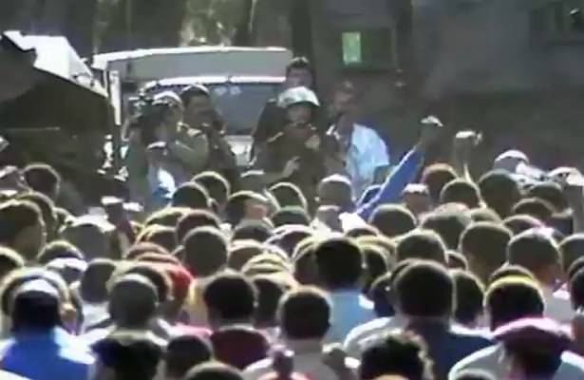
Fig. 6. Policers watching young people in raves Fig. 7. Armed guards and African protesters

These scenes let slip, in the borders of discourse, different meanings attributed to the body. There are, on the one hand, bodies expressing in the parties certain meanings of freedom, others expressing the union to fight for the conquest of freedom, and there are, on the other hand, bodies that stand in the social borders, exercising power in positions of control and vigilance, as reflects Nascimento (2017) – remembering what, for Althusser (1971), functions as a Repressive State Apparatus, which conceives to certain agents a machine that allows the ruling classes to assure their domination over other classes.
So there is the body that watches over and the body under surveillance. There is the look to the body and the body being looked at by ‘security guards’. Bodies overflowing meanings and at the same time being overflowed by a lot of meanings. There is the image and the body, the image of the body and the image of the body taking shape from one corner to another (allowed to move from the perspective of the viewer and from the very materiality of the visual). What we have to take into account, from the words of Lagazzi, is that “we do not have materialities that are completed by each other, but that are related by the contradiction, each working the incompleteness in the other” (LAGAZZI, 2009, p. 68)³⁵. As Janaina da Costa Sabino also points out, there is in the filmic process of the constitution of the meanings the displacement in a continuous (dis)cadence of scenes that, according to the author:

[...] get together, overlap each other, merging each other into the images that, together with words and music, play with the rhythmic senses of a modernity. Rhythm of music, of images that get together (and separate), find disparate images, of images that are in between (within) other images [...]: conjunction and heterogeneity from the observer’s view and listening. They are different textualities that conjugate in this filmic fabric allusive meanings alluding to a modernity in the daily life of century XX, and that opening in intertextual and interdiscursive windows, play with meanings that (dis)organize, that unravel, which highlight and erase the relations between events and meanings, exposing the daily life in a relationship of confluence with memory (SABINO, 2008, p. 49)³⁶.

Metaphorically, we can verify how the image projects in the object (in focus) the meanings in condensation (LAGAZZI, 2014b). Thus, it is possible to notice, from these scenes, a relation of alterity by the process of drift. Metonymically, the image marks the lack in the slip of the meanings by the reiteration of the close-up of the object in focus: the guns (in wrist or waists) of the policemen watching the crowd. Metaphorizing itself into prototypical images of protests, these sense-of-vigilance effects work in the boundaries between saying and not saying, silence and gesture, in an ever-moving structure.
Another Dan Halter’s work that we have selected for our analysis – which also addresses this crucial body issue under surveillance – is the video Beitbridge Moonwalk (2010). In it, the artist portrays the political-social problem of xenophobia directed at Zimbabwean refugees living in South Africa. The video (part of the “Videobrasil” Cultural Collection since the 17th edition of the Festival) is inspired by the story of an immigrant who illegally crosses the border between these countries, without being noticed by police surveillance and without leaving traces that pointed his direction. In this case, Michael Jackson’s mention in the video´s title make reference to the dance called moonwalk and underscores the ironic tone of Halter’s sociopolitical-cultural criticism.
Here we allude to Volochínov (1973) thoughts that the word is a kind of bridge between me and others, being language the link of this relationship – in the case here, for example, through the reconstitution (artistic intervention) of Zimbabwean immigrant attitude of crossing, which is seen at the boundaries between the citizen and the refugee (figure 8).

Fig. 8. Reconstitution of the immigrant’s crossing – Beitbridge Moonwalk (2010)

The bridge emerges on the focus of the image. In the frame, from the very beginning of the video scenes (0: 09s), it is possible to the see the represented figure of a subject who, through the artist’s eyes, would correspond to the immigrant who leaves Zimbabwe moving to South Africa seeking for a refuge place which offers better social conditions of life.
The movement of the migrant who walks backwards between the two ends of the bridge (from right to left, by the angle proposed by Dan Halter) is in relation to the movement of a woman walking in the opposite direction of his. This puts at the borders of the visual materiality meanings that are not under evidence. There is no statement, no word. And so there is a relationship between oneself and the other in the movement of walking. Walking forward and walking backwards (from front to back – in a movement associated with the “moonwalk” dance) which is settled by this counterpoint.
The allusion to the “moonwalk” steps in Michael Jackson’s dance is kind of an invitation to this exteriority of the discourse that runs through space, time, and visuality, and functions as a resource strategically used by the refugee. The steps backwards in dance, in relation to the origins of the “moonwalk”, have historically passed since the 1930s by different artists such as Fred Astaire, Bill Bailey, Cab Calloway, Sammy Davis Jr. Daniel L. Haynes, Eleanor Powell, among others. The dance step became popular around the world after the American singer Michael Jackson performed it during his presentation of “Billie Jean” in the TV special Motown 25: Yesterday, Today, Forever, which occurred on March 25, 1983, and which was broadcasted on May 16, 1983. Subsequently, this came to become the most famous dance step of Michael Jackson’s career³⁷.
By bringing this element (the moonwalk) to entitle the video, the artist takes a critical look at the criticism of xenophobia against Zimbabwean refugees. The moonwalk dance is confused and intertwined with the “walking backwards” used by the refugee as a strategy, a kind of juggling, of trickery not to be caught (and have the face identified) by the authorities that control and monitor the frontiers between the two countries (Zimbabwe and South Africa). Body, subject, bridge and movement, so articulated in the work, act as a trigger for criticism in an ironic tone. In this case, the strategy of social survival becomes a political-ideological weapon. The ideologically dominant subject and the subject dominated by the dominant ideology (under surveillance, at risk of being caught) both overflow meanings in the borders of discourse. The body under surveillance is placed on the bridge between the I and the other, in the relation with the vigilant body, not present (but possible and of threatening meanings), put as implied.
This relation between the moving body in relation to the other is placed from a set of angles, images and reference, supposing that the watcher is not the spectator of the video (which from an angle X can observe the walk from front to back [the moonwalk] from Y, which is possible for an observer who is also in another position, but which is not possible for the one who is in a certain angle).
Similarly, this relation of walking backwards (front to back) cannot be grasped by the image (which is static, as we have here), but only through a succession of moving body scenes. We make this important observation precisely to elucidate, from the thoughts of Lagazzi that language “is structurally flawed, constitutively incomplete, and capable of (re)associations” (LAGAZZI, 2012, p. 1) ³⁸.

Fig. 9. Crossing the bridge between Zimbabwe and South Africa

During the video scenes, the body-landscape-silence relationship is put into operation, which is interwoven, contrasting with the sound of the wind and the noise of motor vehicles passing by the bridge – as it is possible to observe in one frame of the video scenes (0:29s), from which we have the represented figure of the refugee walking backwards in his crossing. Body, space and subject divide the image of the screen with the passage of a white truck (figure 9). In this point, to think about that silence, according to Sabino (2008):

[...] is to consider the other meanings (that are also possible) [...] It is to put, as Orlandi tells us, “questions about the limits of the dialogue” (...): “the relationship with the other as being a contradictory relation” (p. 49). In this case, to understand the connection of the subject with the silence is to see the opacity of the other manifest, which, like silence, is not visible, but becomes visible by discursive theoretical-practical methods (SABINO, 2008, p. 14)³⁹.

Final considerations

The Bakhtinian chronotopic concept, thus, is considered in the analyzes made at the end of this article, putting the works of Dan Halter at the confluence between the verbal and non-verbal materiality of the space crossed by silence, by image and by boddies overflowing meanings also mobilized by the music of the Zambian singer Rozalla and interpellated by the presence of the other in a position of vigilance. The marches, the bodies in the street protests, the dance (the raves, the Toyi-Toyi, the moonwalk) move discursively – for example, in the fugee crossing, which, as we have seen, has in the bridge the place (space) of reference marked by an instant (temporally) marked by the very duration of the crossing, which allows this body to mean differently from its movement. Meanings in movement meaning beyond the gesture of moving. Body which puts the discourse also in movement in the social and in the political borders.
Taking all these considerations made here, therefore, what we observe, in the meshes of the social, political and discursive matters, is that both the gesture of the immigrant and the South African movements against Apartheid are rebuilt by the look of art as remembrance, as (re)constitution of indissoluble movements in history – interpellated by (re)formulated senses that are updated in memory. Thus, one can observe the experience, for example, of a refugee operating in confluence with memory as kind of a discursive window where meanings overflow, so many of them exposed, so many of them silenced (SABINO, 2008).

REFERENCES
AMORIM, M. Cronotopo e exotopia. In: BRAIT, B (org). Bakhtin: outros conceitos-chave. São Paulo, SP: Contexto, 2006, p.95-114.
ALTHUSSER, L. Ideology and ideological state apparatuses. Translated from the French by Ben Brewster. Lenin and Philosophy and other Essays, pp. 121–176, 1971.
AZEVEDO, A. Sentidos do corpo: metáfora e interdiscurso. Linguagem em (dis)curso, v.14, n. 2, p. 321-335, 2014.
BAKHTIN, M. Rabelais and his world. Translated by Hélène Iswolsky. Cambridge, MA: MIT Press, 1984 [1968].
BAKHTIN, M. Author and hero in aesthetic activity. In: Art and answerability: early philosophical essays. Translated by Vadim Liapunov. Austin: University of Texas Press, 1990.
BRAZ DIAS, J. Dança e conflito: uma reflexão sobre o toyi-toyi sul-africano. Antropolítica, v. 33, p. 99-117, 2012.
COURTINE, J-J. Déchiffrer le corps: penser avec Foucault. Grenoble: JérômeMillon, 2011.
GILBERT, S. Singing against apartheid: ANC cultural groups and the international anti-apartheid struggle. In: OLWAGE, G. (org.) Composing apartheid: music for and against apartheid. Johannesburgo: Wits University Press, 2008, p. 155-184.
LAGAZZI, S. A equivocidade na imbricação de diferentes materialidades significantes. In: XXIII Encontro Nacional da Anpoll, Universidade Federal de Goiás (GO), 2008.
LAGAZZI, S. O recorte significante na memória. III SEAD – Seminário de Estudos em Análise do Discurso, UFRGS, Porto Alegre, RS, 2007. In: Indursky, F, Ferreira, M.; Mittmann, S. (orgs.). O Discurso na contemporaneidade. Materialidades e Fronteiras. São Carlos, SP: Claraluz, 2009, p. 67-78.
LAGAZZI, S. O recorte e o entremeio: condições para a materialidade significante. In: Rodrigues, E. et. al. (orgs.). Análise de Discurso no Brasil: pensando o impensado sempre. Campinas, SP: RG Editora, 2011, p. 401-410.
LAGAZZI, S. O exercício parafrasático na imbricação material. In: XVII Encontro Nacional da ANPOLL, GT de Análise do Discurso. Gramado (RS): FAURGS, 2012.
LAGAZZI, S. A imagem do corpo no foco da metáfora e da metonímia. Redisco, v. 2, n. 1, jan./jun. 2013. Vitória da Conquista, ES: Edições UESB, 2013, p. 104-110.
LAGAZZI, S. Metaforizações metonímicas do social. In: Orlandi, E. (org.) Linguagem, sociedade, políticas. Campinas, SP: RG Editores, 2014a, p. 105-112.
LAGAZZI, S. A deslinearização em diferentes materialidades significantes. In: XXIX Encontro Nacional da ANPOLL, GT de AD. Florianópolis, SC: UFSC, 2014b.
LAGAZZI-RODRIGUES, S. Stations dans la discursivité sociale: alternance et fenêtres. Astérion, n. 8, p. 1-11, juillet 2011.
MILANEZ, N. Discurso e imagem em movimento: o corpo horrorífico do vampiro no trailer. São Carlos: Editora Claraluz, 2011.
NASCIMENTO, E. A. Les mouvements sociaux dans les frontières signifiantes du corps et du discours. Revista DisSol – Discurso, Sociedade e Linguagem, v. 5, p. 26-41, 2017.
ORLANDI, E. As formas do silêncio: no movimento dos sentidos. Campinas: Editora da Unicamp, 1992.
ORLANDI, E. Discurso em análise: sujeito, sentido, ideologia. Campinas, SP: Pontes, 2012.
PÊCHEUX, M. Language, semantics and ideology. Translated by H. Nagpal. New York: St. Martin’s Press, 1982.
SABINO, J. Nós que aqui estamos por vós esperamos: discurso, rememoração e esquecimento. 2008. 232 f. Dissertação (Mestrado em Linguística) – Instituto de Estudos da Linguagem, Universidade Estadual de Campinas, Campinas, SP, 2008.
SCHELER, M. Wesen und Formen der Sympathie. 3. ed. Bonn: Friedrich Cohen, 1931.
TIHANOV, G. The Gravity of the Grotesque. Bakhtiniana, São Paulo, v. 7, n. 2, p. 165-178, 2012.
VOLÓSHINOV, V. Marxism and the philosophy of language. Translated by L. Matejka and I.I . Titunik. New York and London: Seminar Press, 1973.
VOLÓSHINOV, V. Discourse in life and discourse in art – corcerning sociological poetics. In: VOLÓSHINOV, V. N. Freudianism. Translated by I. R. Titunik. New York: Academic Press, 1976.

* Acknowledgments: thanks to the research fellows Diego Pinto Souza (IEL/UNICAMP), Ivo di Camargo Jr. (UFSCAR) and Moisés Carlos de Amorin (UFMT) for their support regarding the search of the reference works of the Russian masters Mikhail Bakhtin and Valentin Volóshinov.
** Campinas State University – UNICAMP, Master degree (MS) researcher in Linguistics, Campinas, Sao Paulo, Brazil, https://orcid.org/0000-000X-XXXX-XXXX, xxxxxxx@yahoo.com.br
¹ Not failing to consider here the divergences and approximations between the Bakhtin’s theory and the French perspective of the Discourse Analysis, however, we decided for an attempt to establish a possible dialogue, at the same time challenging and productive, based on current discursive studies.
² English translation from the original in Russian Aвтор и гэрои в эстэтичэскои дэиатэльности.
³ We work here with the notion of significant materiality developed by Lagazzi (2009, 2011).
⁴ Op. cit. Rabelais and his world, translated by Hélène Iswolsky.
⁵ The Gravity of the Grotesque, in Bakhtiniana, v. 7, n. 2.
⁶ See footnote 5.
⁷ See footnote 5.
⁸ See footnote 5.
⁹ Op. cit. Language, semantics and ideology. translated by H. Nagpal.
¹⁰ Our translation for “que a própria corporalidade é também uma materialidade significante, discursividade inscrita em condições de produção fronteiriças”, in portuguese.
¹¹ See footnote 4.
¹² Our translation from the portuguese “o movimento de constituição de sentidos sobre/do corpo”.
¹³ Our translation for “os modos de significar e a matéria significante são plurais: o corpo é um lugar de opacidade que ganha sentido pelo olhar”, in portuguese.
¹⁴ Our translation from the portuguese “[...] pela filiação teórica ao materialismo histórico, a forma material é sempre histórica. Em outras palavras, tomar o corpo como forma material implica afastar qualquer concepção que o trate como realidade empiricamente compreensível e biologicamente funcional, comuns em áreas como a da saúde, por exemplo, em que o corpo é natural, segmentável, controlável e transparente”.
¹⁵ From the original in French Déchiffrer le corps: penser avec Foucault, p. 37
¹⁶ Our translation for “[...] no encontro, a definição temporal (naquele momento) é inseparável da definição espacial (naquele lugar)”, in portuguese.
¹⁷ Our first contact with Dan Halter’s work happened the exhibition”Memórias Inapagáveis”, at SESC Pompeia, in Sao Paulo (SP), 2014. At the time, it was possible to watch the documentary video Untitled – Zimbabwean Queen of Rave (2005).
¹⁸ We take here the question of the discursiveness of the protest in the constant work of the politician in its relation with the symbolic.
¹⁹ Translation into English by I. R. Titunik, in 1976.
²⁰ Our translation to English from the original in French “l’imbrication matérielle entre le verbal et le visuel qui rend possible la critique qui se formule”.
²¹ Our translation from the portuguese “[...] a edição dinâmica, que lembra os scratch vídeos ingleses dos anos 1980, cria um paralelo entre duas situações que, submetidas à recontextualização midiática, perdem seu potencial de confronto. As raves, marcadas pela recusa do estilo de vida yuppie, ganham imagem de modismo vazio; os movimentos de contestação na África parecem desprovidos de causas. A liberdade da dança enquanto protesto e do protesto enquanto dança é enquadrada pelo retângulo televisivo, tornado metáfora de um processo de apropriação e esvaziamento”.
²² Our translation from the original in portuguese “o movimento dos corpos, numa sucessão de cenas [...] fazendo ressurgir em nós outras imagens, que formam uma cadeia de deslocamentos na movimentação de sentidos”.
²³ Our translation for the original terms in portuguese “intersecção de diferentes materialidades” e “imbricação material significante”.
²⁴ Our translation for the passage in portuguese: “[...] ressaltam que não se trata de analisarmos uma imagem e a fala e a musicalidade, por exemplo, como acréscimos uma das outras, mas sim de analisarmos as diferentes materialidades significantes uma no entremeio da outra”.
²⁵ Marxism and the philosophy of language. Translated by L. Matejka and I.I . Titunik.
²⁶ Our translation for “se desdobram em diferentes imagens do sujeito e nos mostram a importância da remissão do intradiscurso ao interdiscurso”.
²⁷ It is possible to understand Toyi-Toyi as a discursive practice marked by political engagement and as a symbolic practice inscribed in determining historical conditions from which we observe the functioning of ideology by questioning individuals in subjects (protesters, militants).
²⁷ Our translation for the passage in portuguese “ainda se faz presente em alguns contextos específicos, como protestos políticos, comícios e movimentos sindicais”.
²⁸ Our translation for “o toyi-toyi é parte de uma sequência de práticas que se referem à luta armada de maneira simbólica, apenas pela impossibilidade de realização da luta armada de fato”.
²⁹ Our translation for “teríamos um caso de ‘compensação simbólica’ para a ausência de poder”.
³⁰ Our translation for the passage: “[...] a aproximação dos manifestantes é anunciada por um grito cortante: ‘Amandla!’ – que, em zulu e xhosa, significa “poder”. A resposta vem da multidão, em coro: ‘Awethu!’ (‘Para nós!’). As imagens passam [...] a enfocar o movimento de resistência ao apartheid. São jovens que, sob a mira das armas, entoam canções de protesto, evocando seus líderes: Oliver Tambo e Nelson Mandela. Carregam faixas em que se lê: [...] ‘Liberdade, justiça e paz, agora!’; ‘Por quanto tempo seremos humilhados, chutados, estrangulados, espancados, estuprados e mortos?’”.
³¹ Our translation for “há formas de onipotência também no domínio do social: ‘juntos podemos tudo’, posição que se sustenta na quantidade e na pretendida consciência coletiva”.
³² Our translation for “[...] muitos deles carregam na mão direita um pedaço de pau, empunhado como uma lança. Outros trazem apenas as mãos fechadas. Vários vestem uniformes escolares; alguns com a gravata – parte tradicional do uniforme – amarrada na testa, lembrando os adornos usados pelos guerreiros zulus. Muitos trazem o semblante sério. Outros revelam ligeiro sorriso enquanto entoam as canções e deixam seus corpos seguirem o movimento conjunto: joelhos ao alto, alternadamente,e punhos em riste”.
³³ In her work The equivocacity in the imbrication of different signifying materialities, from 2008, Suzy Lagazzi proposes the notion of imbrication, considering the materialistic theoretical-analytical device to which the author affiliates.
³⁴ See footnote 19.
³⁵ Our translation for “não temos materialidades que se completam, mas que se relacionam pela contradição, cada uma fazendo trabalhar a incompletude na outra”.
³⁶ Our translation for “[...] se juntam, se sobrepõem, se (con)fundem umas às outras nas imagens que, junto às palavras e à música [...] jogam com sentidos rítmicos de uma modernidade. Ritmo da música, das imagens que unem (e separam), (des)encontram imagens díspares, das imagens que estão no entre(dentro) de outras imagens [...]: conjunção e heterogeneidade no olhar e na escuta do espectador. São diferentes textualidades que conjugam nesse tecido fílmico significados alusivos de uma modernidade num quotidiano do século XX e, que se abrindo em janelas intertextuais e interdiscursivas, jogam com sentidos que (des)organizam, que des-atam, que realçam e apagam relações entre acontecimentos e sentidos, expondo o quotidiano numa relação de confluência com a memória”.
³⁷ We bring here, in the material under analysis, the question of the Moonwalk dance step popularized by Michael Jackson, placing it in particular in relation to the historical conditions of its emergence and its updating / re-appropriation taken as strategy by the Zimbabwean refugee.
³⁸ Our translation for “é estruturalmente falha, constitutivamente incompleta, e capaz de (re)associações”.
³⁹ Our translation for “[...] é considerar os outros significados (também possíveis) [...] É colocar, como nos diz Orlandi, “questões a propósito dos limites da dialogia” (...): “a relação com o outro como sendo uma relação contraditória” (p. 49). Nesse caso, compreender a ligação do sujeito com o silêncio é ver-se manifestar a opacidade do outro, que, como o silêncio, não é visível, mas torna-se visível por métodos teórico-prático discursivos”.

