Interdisciplinarity, design thinking, and innovation
in public spaces: a teaching experience in
Florianopolis Botanical Garden Park.

Author 1 e-mail institution
Co-author 2 e-mail institution
Co-author 3 e-mail institution
Co-author 4 e-mail institution
(Authors’identification were excluded for the blind reviewing process.)

Abstract:
Innovation of public spaces requires dense management efforts. Interdisciplinary studies must be conducted to raise needs of stakeholders. Then, potentialities, problems, and opportunities are explored. These works require interdisciplinary knowledge to carry out a broad analysis of the social, technological, economic, environmental, political, and legal spheres to understand influencing factors in the management of such spaces. In this context, one important challenge faced by professors is to promote the development of strategic skills among students. This work has arisen from the specific need of designing an active learning method, to motivate business administration undergraduate students to think strategically while dealing with complex problems. To achieve the objectives of the course – Change Management and Business Consulting –, we have created a nine steps study guide based on design thinking. Our proposal is to reflect upon key learning outcomes provided by this teaching experience. We argue that future managers need to learn how to explore, and frame problems before solving them, since the highest risk they might encounter is to misdiagnose complex problems. The paper is structured into five sections. The introduction describes the research problem and the object of study. The second section presents theoretical references, which integrates authors and concepts from different management fields. The methodological section explains how design thinking was applied, by describing each step of the experience. It has followed a study guide developed for the exploration of Florianopolis Botanical Garden Park, combining fieldwork visits with in-class lectures and debates. Next, we present results and learning in three subtopics: conceptual aspects, related to the purpose of the studied space; infrastructural needs and management challenges. To conclude, we indicate possible ways of exploring this public space, and also recommend the development of future didactic experiences with similar scopes.

Keywords:
interdisciplinarity, design thinking, knowledge management, innovation, public spaces.

Resumo:
A inovação em espaços públicos exige densos esforços de gestão. Estudos interdisciplinares devem ser conduzidos para levantar necessidades dos stakeholders. Em seguida, potencialidades, problemas e oportunidades são explorados. Tais trabalhos exigem conhecimentos interdisciplinares para realização de análises abrangentes, de modo a compreender que fatores sociais, tecnológicos, econômicos, ambientais e político-legais interferem na gestão desses espaços. Nesse contexto, um desafio importante enfrentado pelos professores é promover o desenvolvimento de competências estratégicas dentre alunos. Este trabalho surgiu da necessidade específica de criação de um método de aprendizado ativo para motivar graduandos em administração de empresas a pensarem estrategicamente na gestão de problemas complexos. Para atingir objetivos da disciplina – Gestão da Mudança e Consultoria Empresarial –, desenvolvemos um roteiro de estudos com nove passos baseados no design thinking. Nossa proposta é refletir sobre os aprendizados proporcionados por esta experiência didática. Argumentamos que futuros gestores necessitam aprender a explorar e enquadrar os problemas antes de solucioná-los, pois o maior risco que poderão correr será diagnosticar problemas complexos equivocadamente. O artigo possui cinco seções. A introdução descreve o problema de pesquisa e o objeto de estudo. A segunda seção apresenta referenciais teóricos, que integram autores e conceitos de diferentes campos da gestão. A seção metodológica explica como a o design thinking foi aplicado, narrando os passos da experiência. Esta seguiu um roteiro de estudos desenvolvido para exploração do Parque Jardim Botânico de Florianópolis reunindo visitas de campo, aulas expositivas e dialogadas. Em seguida, resultados e aprendizados obtidos são apresentados em três subtópicos: aspectos conceituais, relacionados à vocação do espaço estudado; necessidades infraestruturais e desafios para gestão. Para concluir, indicamos caminhos possíveis para dar continuidade ao estudo deste espaço público e também para desenvolver futuras experiências didáticas com escopos similares.

Palavras-chave:
interdisciplinaridade, design thinking, gestão do conhecimento, inovação, espaços públicos.
Introduction
The management of public spaces comprises continuous and comprehensive activities of strategic planning. These activities seek to meet the needs of citizens, institutions and other social actors. There are several types of public spaces – squares, parks, libraries, museums –, this research specifically studied the Botanical Garden Park of Florianopolis.
The choice of this space was motivated by four factors. First, it is a space with free access to citizens. Second, it was inaugurated recently, in September 2016, but still needs to develop strategic planning to guide its management, its conceptual development, infrastructure and cultural programming. Currently, the Botanical Garden Park presents evident deficiencies in architectural, landscape, botanical, communication and educational terms, which stimulated the study of its potentialities, needs and mission. Third, the location very close to the State and Federal Universities of Santa Catarina (ESAG/UDESC and UFSC), facilitated the field trips, essential for the study of the site. Fourth, the space remained invisible to students, despite being geographically so close to the universities they attended.
Field trips arose from the need to find active learning methods, based on practical exercises and didactic tools, capable of developing students' strategic thinking. After all, future managers of companies or public bodies need to develop implicit and explicit knowledge, which will enable them to explore, diagnose and solve complex problems.
The didactic experience reported in this work was carried out with students of the course “Change Management and Business Consulting” . It sought to integrate theory and practice through different activities. First, the object studied is presented; then the theoretical-methodological basis and the study guide. Finally, the main results and learning obtained are discussed to encourage future didactic experiences of this type in this or other public spaces, which also require changes or innovations.

The discipline of Change Management and Business Consulting
The course of Change Management and Business Consulting is taught for undergraduate students in Business Administration at the Socioeconomics and Business Science Centre (ESAG) of the State University of Santa Catarina (UDESC). Its general objective is to stimulate the development of critical, reflective and creative thinking among students, to prepare them to develop business diagnoses and to act in organisational consultancies. Its specific objectives are to enable students to act professionally as external or internal consultants in organisations.
The afternoon class of this discipline had twenty-one students enrolled in the first semester of 2018. Of this total, only two students had already visited the Botanical Garden Park in Florianopolis when the study was proposed by professor exclusion of co-author’s name. The lecturer invited postdoctoral fellow exclusion of author’s name, his colleague in the Postgraduate Programme in Engineering and Knowledge Management (PPGEGC / UFSC), to prepare the study roadmap together and carry out the experience described here. exclusion of co-authors’ names (PPGEGC / UFSC) also collaborated.

The Botanical Garden Park of Florianopolis
The Botanical Garden Park of Florianopolis occupies an area of 19 hectares and is located at 890 Admar Gonzaga Road in the neighbourhood of Itacorubi on the island of the capital of Santa Catarina. It was opened to the public on September 24, 2016. Currently, four public bodies are responsible for its management.
They are the Agricultural Research and Rural Extension Company of Santa Catarina (EPAGRI), the Capital Improvement Authority (COMCAP), the Municipal Foundation of the Environment of Florianopolis (FLORAM) and the Florianopolis District Council.
COMCAP took over the management of the Botanical Garden Park in partnership with the Municipal Foundation of the Environment of Florianopolis (FLORAM), after signing a cooperation agreement between EPAGRI and the Florianopolis District Council in August 2016. COMCAP has thus far assumed the costs of the operation, but the management plan for this space is being developed in partnership with FLORAM, with the support of citizen participation (Florianopolis, 2016).
The current infrastructure was built with resources from private donations and materials recycling. It is still basic, and therefore needs to be completed and improved. Despite this, the space already has a walking and running track, a playground, a sports court, a small area with hammocks for people to rest in, a vegetable garden and a space for exhibitions and community activities.
Geographically, the Florianopolis Botanical Garden Park is very close to the UDESC campus, the UFSC Agriculture Department, the COMCAP and EPAGRI headquarters. All these institutions are located in the vicinity of the Itacorubi mangrove, which is the second largest mangrove swamp in Brazil (G1, 2013).

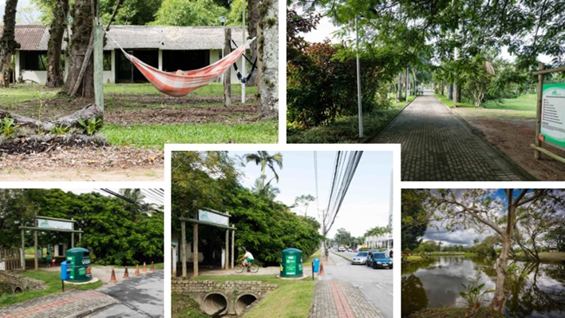

Figure 1 – Photographic record: the park during a field trip
Source: prepared by the authors, 2018

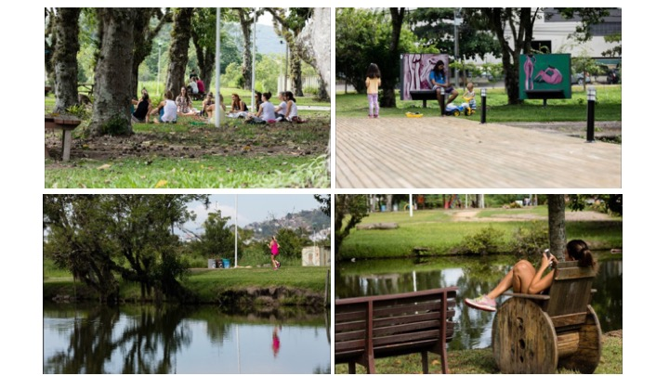

Figure 2 - Photographic record: park users during a field visit
Source: prepared by the authors, 2018

According to information from FLORAM, available online on the portal of the Florianopolis District Council, the mangrove is one of the most productive and complex ecosystems on the planet. Considered a transitional coastal ecosystem, it is typically found in tropical and subtropical regions, which are close to estuaries. It presents typical plant species, associated with other terrestrial and marine components. It is also subject to influences from tidal phenomena. (Florianopolis, 2018).
It is worth mentioning that the island part of the municipality of Florianopolis includes a huge green area, a distinct feature of many Brazilian capitals. And, in addition to the mangroves, there are three other ecosystems that are significant for the biodiversity of Santa Catarina Island. They are the Atlantic forest, the dunes and the coastal scrub.

Theoretical reference
This work is based on the interdisciplinary approach of design thinking applied to the management of changes in public spaces and aimed at the construction of new knowledge in study or work groups. Interdisciplinarity combines fragmented analyses and simplifying syntheses. To this end, it integrates rational, instrumental and subjective logic in the production of individual or collective works. In this way, knowledge is constructed by gathering empirical, interpretive or critical theories and methods as complementary strategies, necessary for the elaboration of new knowledge (Leis, 2005, p.9).
The design thinking approach has been widely used to solve complex problems in ways that focus on users’ needs (Melles, Howard & Thompson-Whiteside, 2012). As Buchanan (1992) points out, the expansion of knowledge - beyond libraries and laboratories – is fundamental for the production of new knowledge. From this perspective, design thinking has proved to be relevant, especially in situations where problems involve several stakeholders with frequently conflicting values. The practice of design thinking incorporates interdisciplinary teams and integrates different paradigms, professions and work tools. So – in design thinking – work processes connect the business vision, the technical and the human dimensions during the design and execution of projects, products or services (Holloway, 2009; Buchanan, 1992, p. 163,).
In general terms, social innovation seeks to solve social problems to improve the quality of life in society (Juliani, 2015). In this approach, the management of changes in public spaces involves social innovation and requires dialogue with different stakeholders, together with the interdisciplinary understanding of the intervening factors in the contexts in question.
Takeuchi and Nonaka (2008) argue that knowledge management is vital to management of change because present-day changes are happening rapidly in multiple dimensions. These authors (ibid.) explain that knowledge is formed of explicit and tacit knowledge. While explicit knowledge can be formally transmitted to people in quick and systematic ways through words, numbers, visual or sound resources, tacit knowledge is difficult to formalise, visualise, or share because it pertains to individual actions and physical experiences. It encompasses technical and informal skills resulting from know-how developed over many years of experience. It also includes insights, hunches, intuitions and personal inspirations, as well as the cognitive dimension related to perceptions, emotions and personal values derived from the interpretations of the world in which we live (Takeuchi & Nonaka, 2008).
To complement the theoretical references, we present the conceptual distinctions between the terms urban park and botanical garden, since the space surveyed has a hybrid denomination.
According to Magnoli (2006), urban parks are spaces free of buildings, which first appeared in the city of Munich in Germany in 1789 for leisure and public recreation activities. Thereafter, in the 19th century, St. James Park and Regent's Park were established in Britain. Then, Central Park was established in New York and stood out as the largest public park of that time. In general, urban parks are intended for various activities (physical, contemplative, artistic, cultural and recreational) practiced by citizens and tourists, who frequent them alone or in groups. These parks also function as areas for plant conservation or green lungs of cities (Magnoli, 2006).
In contrast, Pereira and Costa (2010) note that botanical gardens appeared in the 16th century for the cultivation and study of medicinal plants in Europe. They are, therefore, protected spaces whose purpose is research in botany or related sciences. Their functions include conservation of biodiversity, raising awareness of visitors about the impacts of human action on the environment and promotion of sustainable development (Pereira & Costa, 2010).
Currently, Brazil has only 34 botanical gardens, so Pereira and Costa (ibid.) assert that it is necessary to develop partnerships and priorities to ensure the conservation of endangered species of Brazilian flora. According to these authors (ibid.), the public management of botanical gardens requires permanent functional frameworks, continuous investments in research and maintenance of infrastructure, so as to facilitate the promotion of ongoing scientific, educational and recreational activities among the public. In short, botanical gardens should be managed as research spaces for the production and dissemination of knowledge about the regional flora, but also for the creation of innovative products derived from local biodiversity (Pereira & Costa, 2010).

Research Methodology
The study was based on the interdisciplinary approach of design thinking. Within this framework, we developed an experimental plan that guided the stages of the didactic experience and incorporated field trips, lectures and seminars. Initially, students were encouraged to explore the site on the first field trip. Then, each work group carried out a sequence of tasks to collectively highlight potentialities, problems and opportunities related to the Botanical Garden Park of Florianopolis. The plan was constructed based on the following authors: Logan (2012), Brown (2010), Buzan (2005), Liedtka and Ogilvie (2015), Lupton (2013) and Vianna et al. (2012). Table 1 presents the topics covered in the study:

Table 1 – Study Plan: Botanical Garden Park of Florianopolis
Source: prepared by the authors, 2018

The design thinking approach systematises the production of knowledge to stimulate innovation in business and society. In their application of this approach, the work teams explore several possible solutions to the problems investigated, alternating divergent and convergent movements until they reach a final solution (Logan, 2012). In this sense, Brown (2010) emphasises that the ecosystem of design thinking seeks solutions that are technologically viable, feasible for the businesses and desirable for the people. Thus, it becomes possible to innovate in developing the processes of creation and the experiences of the users.
Due to the limitations of the course timetable and the complexity of the problem studied, our study guide focused on two stages of design thinking, corresponding to exploration (1) and problem framing (2), but excluded the final step related to the solution of problems (3).
According to Logan (2012) the design thinking process consists of three stages: (1) problem finding, (2) problem framing and (3) problem solving. In the exploration of problems (1), the mapping of emerging opportunities and trends in human and technological environments is carried out to inspire the development of future products and services. In the framing of problems (2), ethnographic research or research into habits and attitudes is conducted. Such research aims to understand the users’ demands, to generate the knowledge necessary for prototyping the products and services to be created. In this stage, different possible solutions are explored, and the best solution is selected. Finally, in the third stage, the solution is implemented. Thus, the product or service is designed; including its aesthetics, materiality, ergonomics and usability, as well as its business model, operational structure, marketing strategies and branding (Logan, 2012 apud exclusion of author, 2017).
To begin with, the class was divided into four working groups. Each group focused its analysis on two specific themes, namely economy and governance (group 01), mobility and social inclusion (group 02); environment and security (group 03) and place and identity (group 04). The thematic division sought to stimulate students to identify needs for general and specific changes in the collective study of this space.
During the execution of the activities, the students covered nine topics listed in the plan (Table 1). The activities integrated the collection of secondary data, available on the Internet (information, documents, news) with the use of design thinking tools (the map of the stakeholders, the development of the personas, the empathy maps and the customer journey maps).
After the first visit to familiarise themselves with the local space, each group wrote up the history and built the stakeholders map of the Florianopolis Botanical Garden Park. According to Buzan (2005) and Lupton (2013), the mind map is a visualisation technique, often used by designers and educators, to facilitate the organisation of ideas and concepts. It consists of visual representation that graphically illustrates associations and processes of human thought. Its structure presents a central theme. From this theme the emergence of new ideas is expressed using different colours, words and images. So the networks of mental associations expand in different directions and express a synthesis of subjects or concepts related to the mapped theme.
The students then carried out the STEEP and SWOT analyses. As Logan (2012) explains, the identification of factors that stimulate social innovation is fundamental to change management; because these factors help us to visualise future scenarios that are desirable, likely, or possible. While the STEEP analysis synthesised social, technological, economic, ecological and political factors related to the studied Botanical Garden Park, SWOT analysis highlighted the strengths, weaknesses, opportunities and threats.
The subsequent step involved the benchmarking exercise, in which each group researched references of inspiring ideas, already implemented in other national or international botanical gardens, as possibilities for the Botanical Garden Park of Florianopolis.
During the second field trip, the students interviewed users of the Botanical Garden Park. As Brown (2010) points out, empathy is very important for design thinking, because it corresponds to the ability to identify with other people, to understand what they feel, do, and want. For this reason, Brown believes that contact with the experiences and emotions of others is precisely what inspires us to create new ideas (Brown, 2010, p. 46-47).
In this stage, the students talked to users during their interactions with the park. To do so, the work groups applied three design thinking tools (persona development, empathy map and customer journey experience), but also made field notes and photographic records.
According to Vianna et al. (2012), the persona design serves to illustrate relevant target audiences by describing their profiles and relationships with the subject being researched. They are fictional characters, whose names, histories and needs synthesise behaviours observed in the field. Such profiles include demographic data, lifestyles, motivations, desires, expectations, and needs. The purpose of this technique is to reveal to the work teams who the users of the products or services in development are. The people contribute to the creation and validation of ideas, directing the solutions of the problems to the fulfilment of the users’ needs. (Vianna et al., 2012).
The empathy map visually synthesises feelings, thoughts, words, actions, difficulties and expectations of users whereas the journey map expands this record, including high and low points of each experienced moment. Its purpose is to illustrate each step of the daily routine, to inspire new ideas and solutions capable of bringing the user experience closer to what would be the ideal journey. In this way, the mapping of the journey visually registers each moment of the user experience, facilitating the identification of unmet needs, opportunities for innovation and creation of value (Liedtka & Ogilvie, 2015).
In the penultimate stage, the study of problems and opportunities incorporated the main lessons learned from previous activities. Finally, the strategic suggestions were based on previously developed activities and especially on the discussions of the purpose, the desired changes and the possible paths for the future of the Botanical Garden Park of Florianopolis.

Results and Discussion
This section synthesises the main lessons learned from our didactic experience. On the first visit to Botanical Garden Park of Florianopolis (figures 3 and 4), students’ conversations spontaneously extended to broader issues, among them: rubbish management, public transport, urban violence, tourism and real estate speculation in Florianopolis. At that time, the students found it difficult to concentrate on the analysis of the park, its terrain and infrastructure. On the other hand, they quickly learned how difficult it is to tackle complex problems. As seen, the complex problems are broad and interdisciplinary, since they cover urban, environmental, social, political-legal, economic and technological issues that permeate different management activities.
On the initial exploration, the impression that the park was unfinished was consensual. Following that, new questions arose: what is the purpose of this place? What are the differences between parks and botanical gardens? Can this place play both roles?

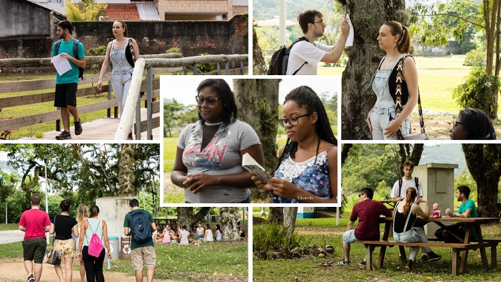
Figure 3 – Photographic Record: the students during field research
Source: prepared by the authors, 2018

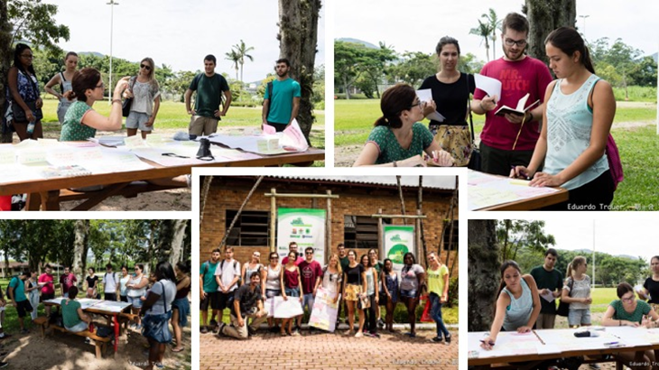
Figure 4 – Photographic Record: Design Thinking activity in the field
Source: prepared by the authors, 2018

At the end of the first visit, the students reported positive and negative impressions on the Botanical Garden Park of Florianopolis. Initially, they indicated positive feelings of tranquillity, well-being, relaxation and reflection due to contact with green areas, as well as the suitability of the space for community activities and physical exercise. They also observed the presence of fruit trees, birds, medicinal plants and families with children. Then they mentioned the negatives. Among them, the lack of information (few signs with explanations about the garden, the plants, the rules of use of the park), and the lack of staff to help the public were highlighted. For the students, the project of the park is unfinished in architectural, botanical and landscape terms. A sense of insecurity prevails, due to the lack of guards and security cameras in place.
Next, we present the synthesis of the resultant learning, grouping it into three topics: conceptual aspects related to the purpose of the space; infrastructure needs and challenges to management.

Conceptual aspects related to the purpose of space
In the students’ perception, conceptual uncertainty is the main current problem of the Botanical Garden Park of Florianopolis. After completing the proposed exercises, they concluded that it is necessary to define, first and foremost, the purpose of the place. Is it a park or a botanical garden? Should both functions be served or only one of them chosen?
The students agree that clear positioning will enable the development of the Botanical Garden Park of Florianopolis, focused on its function. At the same time, they believe that this space can undertake the hybrid functions of urban park and botanical garden. In this way, it would meet the demands of leisure and cultural activities, highlighted by the interviewees; but could also offer activities typical of a botanical garden (environmental education, scientific research and flora preservation). After all, it has been frequented by families with children, by the university community and by the residents of the nearby neighbourhoods. In addition, the community is promoting yoga classes and meditation gatherings in the park, again confirming the demand for hybrid uses.
From the political-legal point of view, it is necessary to guarantee the permanent use of the land for the functions of Park and Botanical Garden. As the Botanical Garden Park of Florianopolis history shows, the land has been subject to judicial lien for eleven years, due to R$ 26 million in labour debts, according to EPAGRI (G1, 2016). Nonetheless, FLORAM is already developing the master plan of the botanical garden and there are municipal decrees and federal resolutions in place that guide the establishment of botanical gardens in Brazil.
After consulting the legislation, the students found that the space studied is not yet equipped for activities essential to the characterisation of a botanical garden. The diversity of species is limited, there is no herbarium nor research laboratory. No environmental education activities or conservation or preservation practices are carried out.
According to resolution 339 of the National Environment Council (CONAMA), of 09/25/2003, a botanical garden
.. the protected area, constituted wholly or in part, by scientifically recognised, organised, documented and identified collections of plants, for the purpose of studying, researching and documenting the country's floristic heritage, accessible to the public, wholly or in part, serving education, culture, leisure and conservation of the environment (Brazil, 2003, p.1).

According to this federal resolution (ibid.), botanic gardens should promote research, conservation, preservation, environmental education and leisure to spread the multicultural value of plants and their sustainable use. Their objectives include the use of appropriate technologies for cultivating local or regional species which are considered rare or threatened with extinction, ensuring the preservation of species economically relevant to ecosystems, scientific exchange, training of human resources and systematised cataloguing of the plants in the collection.
At the municipal level, the mayor of Florianopolis Gean Loureiro officialised the creation of the Botanic Garden of Florianopolis, when he signed the Municipal Decree 17,708 of June 7, 2017. The objectives determined for this public space were as follows:

(...) I - the conservation, preservation, rescue and DNA banking of the Atlantic forest species, mainly of dense ombrophylous forest and pioneer formations (mangrove and coastal scrub); II - the guarantee of spaces for research, environmental education, culture, leisure and ecological tourism; III - systematic and organised registration of plants and documentation related to the collection of plants, which will be fully accessible for nature conservation; IV - the conservation of plants, through banks of ex situ germplasm and genetic reserves "in situ", with the objective of research, demonstration and environmental education; V - protection, including through appropriate technology for cultivation, wild, vulnerable, rare species endangered by anthropical action, especially at local and regional level, as well as protecting economically and ecologically important species for the restoration or rehabilitation of ecosystems; VI - scientific, technical and cultural exchange with national and foreign entities and bodies; VII - the training of human resources; VIII - environmental education, both formal and informal, as well as stimulation of research in the scientific community; IX - the security and protection of local fauna (Florianopolis, 2017, p.1-2).

It is noteworthy that the decisions of the Florianopolis District Council meet the potentialities and opportunities indicated by the students. These focus on the recommendation of the use of the Botanical Garden of Florianopolis as a hybrid public space, aimed at promoting knowledge of the biodiversity of the Island of Santa Catarina; with the following purposes: to make society aware of the importance of protecting and preserving regional ecosystems and to promote healthy habits among city dwellers and tourists.

Infrastructure needs
During their research of references, the students sought inspiration to develop the Botanical Garden Park of Florianopolis. To this end, they consulted websites of Brazilian and foreign botanical gardens. The suggestions presented were based on practical activities and equipment available at the botanical gardens of Curitiba, Rio de Janeiro, Recife, Brasilia, Bauru, Sorocaba, Kew (UK), Montreal (Canada), Edinburgh (Scotland), Portugal and San Antonio (United States).
With reference to the activities of botanical research and environmental education, the university students suggested the construction of a herbarium, a greenhouse and a sensory garden. Finally, they recommended the control of water and energy consumption and the practice of sustainable principles in the disposal of garbage and sewage in the park.
With regard to the leisure areas, they supported the placement of drinking fountains and the completion of the sports court, the children's playground and the picnic area. In addition, they suggested the installation of a cafeteria or cafe for the sale of food and drinks on the premises.
The lack of signs with important information was criticised by all (figure 5). For this reason, the students recommended the development of an efficient graphic project to unify the visual signage in the external and internal parts of the Botanical Garden Park of Florianopolis. Currently there is only one discrete sign at the entrance gate and the internal signage is inadequate. There is only a map of the park, near the entrance. And the existing boards are not standardised in terms of colours, typographies or design concepts. There are even handwritten information signs. It is necessary to ensure the visual communication of relevant information on the plants of the community garden, the rules of use of the park, the location of the toilets, the names of the trees and other existing species.

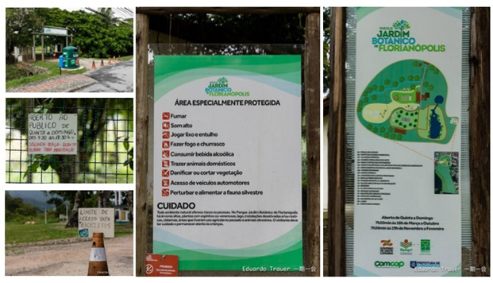
Figure 5 – Photographic Record: signage problems
Source: prepared by the authors, 2018

Other need highlighted concerns access to the park. Currently, there is no parking for vehicles inside the park. This makes it difficult for families with children, the elderly, people with reduced mobility, tourists, people living in remote neighbourhoods and school buses. The lack of paving in the internal areas also makes it difficult for people with special needs or mobility problems to visit.
To conclude this topic, we mention the suggestion of investments in security (video cameras and the presence of the municipal guard). We would also mention the finding of the advantages that currently exist in the location and infrastructure. Among them, the students mentioned that the proximity of the mangrove could facilitate access to the species to be preserved and that the area of ​​the park is sufficient to house the functions of botanical garden. The possibility of reforming existing buildings, to house the herbarium, the greenhouse and the research laboratory, was also mentioned.

Challenges for management
The students mapped the stakeholders, dividing them into three groups: managers, partners and users. Figure 6 summarises the maps:
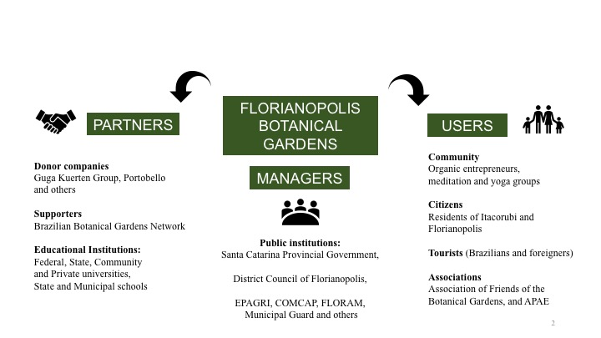

Figure 6 – Map of the stakeholders of the Botanic Garden of Florianopolis
Source: prepared by the authors, 2018

With regard to the challenges related to management, the students suggested the establishment of partnerships with public agencies, educational and business institutions in order to carry out scientific research and environmental education activities. Collaboration with technology companies was specifically recommended, because Florianopolis is a regional technology hub. In this sense, such partners could create technological solutions - such as applications, games, videos and digital libraries - to stimulate visiting and facilitate environmental education and the online dissemination of the Botanical Garden Park of Florianopolis.
Concerning the management of communication, the students suggested that there be continuous investments in the dissemination of the social programme of the park. In addition, students recommended encouraging community participation, especially the Association of Friends of the Botanical Garden, to promote a cultural program attuned to the needs of the visitors.
In relation to infrastructure maintenance and improvements, the students believe that encouraging donations of business resources, promoting paid events, and selling food and beverages at the Botanical Garden Park might be an interesting option to raise funds.
Considering political instability and the pressures of real estate speculation; the students pointed out the urgency of legally guaranteeing the permanence of the botanical garden park on the current land, in order to avoid possible risks of discontinuation of the area.

Conclusions and Recommendations
This work started from the assumption that the innovation of public spaces requires dense planning and management efforts, since such spaces encompass complex problems whose diagnoses require comprehensive and interdisciplinary analyses. To this end, we conducted a didactic experience that consisted of the development of a study plan, applied in the Botanical Garden Park of Florianopolis.
Understanding of the problem evolved progressively. In this way, there was a growing involvement of the students, who visited the location several times and discussed the exercises proposed intensely. The design thinking approach was relevant and stimulating, since its application confirmed that the sequence of exercises carried out provided clear guidelines and facilitated the investigation of the problems researched. The practical exercises fostered new tacit knowledge, while the writing and presentation of the final reports formalised explicit new knowledge. In this way, students and teachers have confirmed the suitability of design thinking for coping with complex problems. Due to the limitations of the course timetable, this experience focused on the exploration and framing of problems, but had to exclude the stage related to the development of solutions for the study plan.
In order to continue the research proposed here, we suggest the development of new didactic experiences in public spaces with similar research scopes. Such studies can be undertaken in disciplines related to business management, innovation and knowledge management; to biology and botany; architecture and urbanism; or visual design and communication.
Future research may use this article as an initial contextualisation to improve management and seek solutions to problems identified here in the Botanical Garden Park of Florianopolis. In our analysis, the creation of a centre focused on knowledge of the biodiversity of the Island of Santa Catarina could be an interesting opportunity for this space because it aligns to the identified potentialities. Its conception could reinforce aspects of the identity, knowledge, conservation and environmental education of the ecosystems of Florianopolis.

Acknowledgements:
This study was financed in part by the Coordenação de Aperfeiçoamento de Pessoal de Nível Superior - Brasil (CAPES) - Finance Code 001.
The authors thank the students, users and management bodies of the Botanical Garden Park of Florianopolis; to ESAG/UDESC and to PPGEGC/UFSC. The first author, Maria Collier de Mendonça, thanks CAPES for the PNDP Grant and the contributions of Robert K. Logan (OCAD University) and Ulrike Gretzel (University of Southern California) during the research process.

References

Brasil, (2003). Conselho Nacional do Meio Ambiente. Resolução Conama nº 339, de 25 de setembro de 2003. Dispõe sobre a criação, normatização e o funcionamento dos jardins botânicos, e dá outras providências. Diário Oficial da União. 213. ed. Brasília, DF, 03 nov. 2003. p. 60-61. Retrieved from http://www.mma.gov.br/port/conama/legiabre.cfm?codlegi=377

Brown, T. (2010). Design Thinking: Uma metodologia poderosa para decretar o fim das velhas idéias. Rio de Janeiro: Elsevier. (C.Yamagami, Transl.).

Buchanan, R. (1992). Wicked Problems in Design Thinking. Design Issues, [s.l.], v. 8, n. 2, p.5-21, 1992. JSTOR. http://dx.doi.org/10.2307/1511637. Retrieved from http://web.mit.edu/jrankin/www/engin_as_lib_art/Design_thinking.pdf.

Buzan, T. (2005). Mapas mentais e sua elaboração. São Paulo: Cultrix. (E.L.Calloni & C.M.Wowsgrau, Transl.)

Co-author and reference excluded for blind reviewing purposes. (2017)…

Florianopolis. Comcap. Prefeitura Municipal de Florianópolis (2016). Parque Jardim Botânico de Florianópolis abre sábado: Parte da área de 19 hectares será aberta à visitação depois de 20 anos de expectativa da comunidade. Retrieved from http://www.pmf.sc.gov.br/noticias/index.php?pagina=notpagina¬i=

______. Autarquia de Melhoramentos da Capital Comcap. Prefeitura Municipal de Florianópolis (2018). Visitação: Jardim Botânico de Florianópolis. Retrieved from http://www.pmf.sc.gov.br/entidades/comcap/index.php?cms=visitacao&menu=4&submenuid=1676

______. Floram Fundação Municipal do Meio Ambiente. Prefeitura Municipal de Florianópolis 2018). Ecossistema. Retrieved from http://www.pmf.sc.gov.br/entidades/floram/index.php?cms=ecossistema&menu=0.

Florianopolis (Municipality). Decreto nº 17.708, de 07 de junho de 2017. Dispõe sobre a criação do Jardim Botânico de Florianópolis e dá outras providências o prefeito municipal de Florianópolis. Diário Oficial Eletrônico do Município de Florianópolis. 2033. ed. Florianópolis, SC, 25 set. 2017. p. 1-2. Retrieved from http://www.pmf.sc.gov.br/arquivos/diario/pdf/25_09_2017_19.00.25.26b62425f8d24b95c2f8dadfbab6ad00.pdf

G1 SC (Santa Catarina) (2013). Manguezal urbano do Itacorubi, em Florianópolis, é 2º maior do Brasil. Ecossistema sofre influência das marés e possui vegetação característica. Fauna é composta por espécies de origem terrestre e também aquática. Florianópolis, 17 set. 2013. Retrieved from http://g1.globo.com/sc/santa-catarina/nossa-terra/2013/noticia/2013/09/manguezal-urbano-do-itacorubi-em-florianopolis-e-2-maior-do-brasil.html.

______ (2016). Parque em área destinada a Jardim Botânico deve abrir em dois meses: Local deve dispor de área recreativa, cultural e para educação ambiental. Gestora da área não informou data para conclusão do Jardim Botânico. Florianópolis, 18 jul. 2016. Retrieved from http://g1.globo.com/sc/santa-catarina/noticia/2016/07/parque-em-area-destinada-jardim-botanico-deve-abrir-em-dois-meses.

Holloway, M. (2009). How tangible is your strategy? How design thinking can turn your strategy into reality. Journal of Business Strategy, 30(2/3), 50-56. doi:10.1108/02756660910942463

Juliani, D. (2015). Framework da cultura organizacional nas universidades para a inovação social (Doctoral dissertation, Universidade Federal de Santa Catarina, 2015). Florianópolis, SC: UFSC.

Leis, H. R. (2005). Sobre o conceito de interdisciplinaridade. Cadernos de Pesquisa Interdisciplinar em Ciências Humanas, Florianópolis, v. 6, n. 73, p.2-23, jan. 2005. ISSN 1984-8951. Retrieved from https://periodicos.ufsc.br/index.php/cadernosdepesquisa/article/view/

Liedtka, J., & Ogilvie, T. (2015). A magia do design thinking: Um kit de ferramentas para o crescimento rápido da sua empresa. HSM. (B. Alexander, Transl.).

Logan, R. K. (2012). Design Thinking, Strategic Foresight, Business Model Generation and Biology: A Mashup. Conference paper for use in workshops at Mars and in the Think Tank course at OCAD University. Ontario College of Arts and Design University. Retrieved from https://www.researchgate.net/publication/267037971

Lupton, E. (2013). Intuição, Ação, Criação: Graphic Design Thinking. São Paulo: G. Gili. (M. Bandarra, Transl.).

Magnoli, M. M. (2006, June). O parque no desenho urbano. Retrieved July 3, 2018, from https://www.revistas.usp.br/paam/article/view/40250

Melles, G., Howard, Z., & Thompson-Whiteside, S. (2012). Teaching Design Thinking: Expanding Horizons in Design Education. Procedia - Social and Behavioral Sciences,31, 162-166. doi:10.1016/j.sbspro.2011.12.035

Author and reference excluded for blind reviewing purposes. (2017, September 1). Design Thinking... Retrieved July 4, 2018.

Pereira, T. S., & Da Costa, M. L. M. N. (2010). Os Jardins Botânicos brasileiros: desafios e potencialidades. Ciência e Cultura, 62(1), 23-25. Retrieved July 03, 2018, from http://cienciaecultura.bvs.br/scielo.php?script=sci_arttext&pid=S0009-67252010000100010&lng=en&tlng=pt.
Takeuchi, H., & Nonaka, I. (2008). Gestão do Conhecimento. Porto Alegre: Bookman. (A. Thorell, Transl.).

Vianna, M. et al. (2012). Design thinking: Inovação em negócios. Retrieved July 3, 2018, from http://livrodesignthinking.com.br/livro_dt_MJV.pdf

Course taught in the undergraduate course in Business Administration at the State University of Santa Catarina, in the first term of 2018.
State-owned company, linked to the Government of the State of Santa Catarina, responsible for the research and extension of rural and fishing activities.
Mixed economy company responsible for the collection of solid waste and public cleaning of the capital, contracted by the District Council of Florianópolis, its majority shareholder.
The proposed themes are based on the eight dimensions previously studied by exclusion of co-author (2017) and Giffinger et al. (2007) for the analysis of Smart Cities. Works by co-authors can be found on the website of the Research Lab (… http://www.../).

