http://dx.doi.org/10.23925/2179-3565.2023v14i2p36-49
RISUS - Journal on Innovation and Sustainability volume 14, número 2 - 2023
ISSN: 2179-3565
Editor Científico: Arnoldo José de Hoyos Guevara
Editor Assistente: Vitória C. Dib
Avaliação: Melhores práticas editoriais da ANPAD
SUSTAINABILITY IN THE SUPPLY CHAIN: A RESEARCH BASED ON GRI REPORTS
Sustentabilidade na cadeia de suprimentos: uma investigação a partir dos relatórios de GRI

Getúlio Camêlo Costa¹, Marcio Cardoso Machado^{1,2}, Marcio Shoiti Kuniyoshi², Victor Silva Corrêa¹
¹Postgraduate Program in Administration, Paulista University (UNIP),
²Administration Department, Pontifical Catholic University of São Paulo (PUC-SP).
Email: getuliocamelo@hotmail.com, mcmachado@pucsp.br, m_kuniyoshi@pucsp.br, victor.correa@docente.unip.br

ABSTRACT

The transparency of sustainability practices has become essential for communication between companies and stakeholders. GRI reports, by nature, can be necessary tools for this disclosure. This article, therefore, aims to investigate how sustainability practices reported in GRI reports make the sustainability of the supply chain transparent. The methodology used was exploratory qualitative, and the data were extracted from the sustainability reports of companies listed in the Bovespa yearbook (B3) and analyzed using the content analysis technique. The results reinforce the initial proposition that companies' sustainability GRI reports can be used to identify green supply chain management practices, which are associated with the main organizational activities and are standardized by the GRI manual.
Keywords: sustainability, transparency, supply chain, GRI reports.

ACEITO EM: 20/04/2023
PUBLICADO: 31/05/2023

RISUS - Journal on Innovation and Sustainability volume 14, número 2 - 2023

ISSN: 2179-3565
Editor Científico: Arnoldo José de Hoyos Guevara
Editor Assistente: Vitória C. Dib
Avaliação: Melhores práticas editoriais da ANPAD

SUSTENTABILIDADE NA CADEIA DE SUPRIMENTOS: UMA INVESTIGAÇÃO A PARTIR DOS RELATÓRIOS DE GRI
Sustainability in the supply chain: a research based on GRI reports

Getúlio Camêlo Costa¹, Marcio Cardoso Machado^{1,2}, Marcio Shoiti Kuniyoshi², Victor Silva Corrêa¹
¹Postgraduate Program in Administration, Paulista University (UNIP),
²Administration Department, Pontifical Catholic University of São Paulo (PUC-SP).
Email: getuliocamelo@hotmail.com, mcmachado@pucsp.br, m_kuniyoshi@pucsp.br, victor.correa@docente.unip.br
RESUMO

A transparência das práticas de sustentabilidade tem se tornado de fundamental importância para a comunicação entre as empresas e seus stakeholders. Os relatórios de GRI, por sua natureza, podem ser uma importante ferramenta para essa divulgação. Este artigo, portanto, tem o objetivo de investigar como as práticas de sustentabilidade relatadas nos relatórios GRI tornam transparente a sustentabilidade da sua cadeia de suprimento. A metodologia utilizada foi qualitativa exploratória. Os dados foram extraídos dos relatórios de sustentabilidade das empresas listadas no anuário Bovespa (B3) e analisados por meu da técnica de análise de conteúdo. Os resultados reforçam a proposição inicial de que os relatórios GRI de sustentabilidade das empresas podem ser usados na identificação das práticas de gestão da cadeia de suprimentos verde, as quais estão associadas às principais atividades organizacionais e padronizadas pelo manual GRI.
Palavras-chave: sustentabilidade, transparência, cadeia de suprimentos, relatórios GRI.

INTRODUCTION

Sustainability actions and practices are of considerable importance for supply chain management; however, companies still undertake a great deal of effort to implement them (Fekpe & Delaporte, 2019). When companies focus only on intra-organizational sustainable practices management without considering the sustainable practices of their external suppliers, that is, in their supply chain, their sustainability performance can be limited and vulnerable (Kang et al., 2018). To ensure that suppliers follow sustainable practices, companies invest in activities such as sustainability-related identification with suppliers to develop in suppliers, sustainability-related practices (Gouda & Saranga, 2018). Green Supply Chain Management (Seuring & Müller, 2008) is one of the main approaches to supply chain sustainability. This evidence highlights the efforts of companies to implement sustainability practices throughout the supply chain. In addition to the aspects related to the efforts to implement sustainability practices, there is a need to provide transparency to such efforts.
The use of efficient mechanisms for the disclosure and visibility of sustainability actions and practices to stakeholders remains challenging for many companies. To achieve high supply chain visibility, organizations must make the necessary information readily available to decision-makers to develop sustainable supply chain strategies (Kamble et al., 2020). Tensions can occur early in developing sustainability initiatives in supply networks, where focal firms often impose significant changes. However, a focal company can resolve these network tensions through strong communication with stakeholders (Alinaghian et al. 2021). Some companies already provide sustainability information in their annual reports and websites, but this is not a common practice for most organizations, making it difficult to understand the actions and practices along the supply chain (Bubicz et al., 2021). Thus, verifying the importance of disclosure and visibility of sustainability actions and patterns along the entire supply chain is possible. As part of this disclosure strategy, companies can use Global Report Initiative (GRI) guidelines to prepare their reports.
GRI indicators can assist companies in monitoring their policies and commitments as they unfold their sustainability strategy, which encompasses supply chain sustainability while providing visibility of their efforts to all stakeholders. The guidelines established by GRI provide a well-established framework on how companies should assess and report their sustainability efforts (Wissuwa & Durach, 2021). GRI reports' publication and consequent disclosure also provide the necessary transparency for reporting sustainability actions (Isaksson and Steimle, 2014; Isaksson and Steimle, 2009). This transparency through a GRI report can increase the opportunity to gain a potential competitive advantage and improve long-term relationships with stakeholders (Chen et al., 2015). Thus, using GRI reports as a strategy for disclosure and the consequent transparency of sustainability actions can increase the visibility of sustainability throughout the chain. Despite the importance of sustainability in the supply chain, the visibility of sustainability actions for stakeholders, and sustainability reporting, studies that treat these three dimensions together are still tangential.
In this context, this study sought to identify, through the analysis of sustainability reports (GRI), the sustainable supply chain management practices used by Brazilian companies listed on the B3 list based on the following research question:

RQ: How do the sustainability practices reported in GRI reports make the sustainability of your supply chain transparent?

Therefore, this study uses an exploratory research approach to analyze the content disclosed in companies' sustainability reports on the B3 list. Therefore, each sustainability dimension was coded and associated with supply chain reports. NVivo® software was used for this purpose.
Even recognizing that the concept of sustainability has a scope more significant than that of Green Supply Chain Management, the two concepts will be used interchangeably for this article.

1 THEORETICAL BACKGROUD
Green Supply Chain Management (GSCM) intends to structure and regulate the practices employed by companies that can enable sustainability and increase competitiveness in the supply chain. GSCM reconfigures the supply chain by adding practices such as remanufacturing, material recycling, reuse of raw material scraps, and environmentally oriented projects, reducing the total effect of industrial activities during the product's life cycle.
Therefore, GSCM complements environmentally compliant supply chain management practices (Srivastava, 2007). Supply chain management can be defined as the integrated administration of processes essential to the business committed to the management of facilities and the physical, financial, and information flows, including the original producers of basic inputs to the final post-consumption disposal for the supply of goods, services, and information, to add value to customers and other stakeholders (stakeholders in the business: shareholders, employees, managers, community, and government) (Lambert, 2008).
Supply chains have been studied and defined by several researchers, without distinction for the terms "supply chain" and "supply network," adopting them as synonyms (Ballou et al., 2000; Carter et al., 2015). However, despite these particularities, in this study, the terms are considered equivalent to the objectives of the research, which want to verify the practices that enhance the management of the green supply network without sticking to the etymology of the words.
Christopher (2009, p.16) confirms the precepts of Chopra & Meindl (2011) by stating that "the supply chain is the network of organizations involved, through links, upstream and downstream, in the different processes and activities that produce value in the form of products and services intended for the final consumer." This supply network, also called the supply chain, adopts the distribution of goods or services, framing all the actors, from raw materials to the delivery of the final product, according to the customers' wishes.
However, Christopher and Towill (2002) state that supply network management involves a significant change in traditional relationships, characterized by the buyer-supplier relationship. Carter et al. (2015) recognize that the network is a set of relationships between customers and suppliers, responsible for the flow of goods from source to final consumer.
According to Beamon (1999), this new environmental era poses a new challenge for companies worldwide. The stimulus was to develop ways to enable interactions between industrial development and environmental protection. To begin to realize this challenge, the basic structure of the supply chain is redefined by accommodating the environmental concerns associated with waste and minimizing resource use. According to the LMI (2005), green supply chain management recognizes the disproportionate environmental impact of supply chain processes in an organization, as shown in Figure 1.
In relation to the usual chain, the green supply chain brings in its fundamentals a strong environmental responsibility and a new posture concerning the products consumed and the production processes, making decisive the analysis of the effects of the product cycle and the procedures, aiming to reduce the environmental impact (Barbieri et al., 2009; Beamon, 1999; Zhu & Sarkis, 2004).

Figure 1 - Green Supply Chain Management

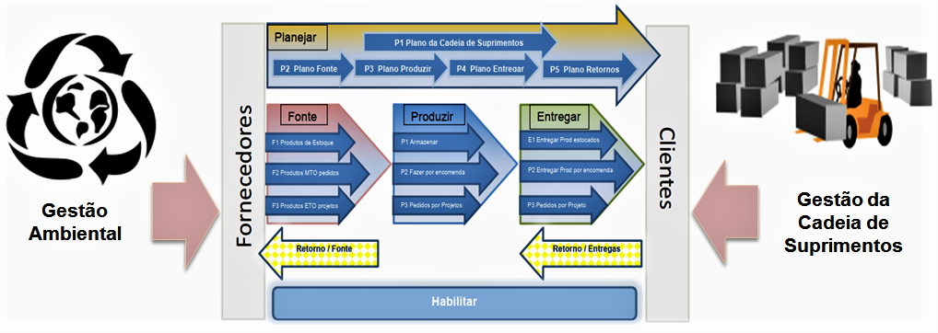
Source: Adapted from LMI Report (2005).

The concept of Green Supply Chain Management is the addition of environmental awareness in supply chain management and was introduced at the end of several manufacturing processes (An et al., 2008). These have obligatorily analyzed product cycle effects, along with the spirit of environmental preservation and environmental legislation, transforming into manufacturing practices and responding to the influences of public opinion. (Barbieri et al., 2009; Beamon, 1999; Zhu & Sarkis, 2004).
In recent years, researchers and players from various industries have been paying attention to GSCM with an interdisciplinary approach to adopting a "greener" perspective in supply chain management (Sarkis et al., 2011; Srivastava, 2007). With an environmental focus, relationship factors, technology, and organizational practices are considered in the supply chain scenario, which are indispensable for making decisions related to internal and external operations (Zhu & Sarkis, 2004).
Therefore, it is necessary to expand cooperation among supply chain components when adopting GSCM practices (Zhu et al., 2011). One way to develop this collaboration process is to pass and spread knowledge about "green" issues across companies that constitute a supply chain (Dües et al., 2013).

Table 1 – Some GSCM practices classified in the literature
Authors | Ranked GSCM Practices | Emphasis
(Zhu et al., 2008);  (Sarkis et al., 2011) | Internal environmental management; green purchasing; customer cooperation; ecodesign; and investment recovery. | Need to increase cooperation between partners in the chain.
(Sarkis et al., 2011)  (Srivastava, 2007) | Reverse Logistics | Importance for the composition of a green supply chain.
(Rao & Holt, 2005) | Pollution prevention, cleaner production practices, closed-loop manufacturing or its reverse logistics incorporated to the maximum extent possible in the chain, reduction of consumption and waste generation, and finally waste recycling. | The production phase of the organization's goods and services.
Note: Prepared by the Author.

A green appeal in the supply chain may start with the conditions of offers and continue through storage, design, manufacturing and packaging, distribution, and final consumers, and may extend to collection, recycling, remanufacturing, disassembly, and resale of products, product parts, or packaging, as well as control over air and noise emissions and environmental impact (Lakhal & H'mida, 2003).
Some of the most common practices are listed in Table 1. However, there is a lack of appropriate logistics management models for the flows associated with each chain member to improve the green supply chain management process. According to Borges and Garcia Herreros (2011), implementing a green supply chain in Brazilian companies is still a significant challenge because most of them are not only unaware of the meaning of the term but also lack information about the advantages and opportunities that it can generate.
According to GRI (2021), sustainability reports help reduce the volatility of the stock prices of publicly traded companies and the cost of capital. Additionally, they can provide important information to researchers and market analysts. For these reasons, one can see that sustainability reports are both a necessity and an opportunity. It is also a tool that analyzes up-to-date information regarding business management situations.
For initial verification of the indicators, the public sustainability reports published by the following companies were analyzed: Ambev, Bombril, Brasil Agro, Braskem, BRF, Celulosi Irani, Duratex, Embraer, Fibria Celulose, Fleury, Gerdau, Grendene, JBS, Klabin, Natura, Nestlé, Petrobrás, Suzano, Telefônica, and Vale do Rio Doce.
According to the Guidelines Implementation Manual (GRI, 2021), the GRI guidelines for Sustainability Reporting present principles and content so that distinct organizations, regardless of their size, sector, or location, can compose sustainability reports. These GRI guidelines organize the spirit of sustainable development and reporting in terms of performance: (a) economic, (b) environmental, and (c) social, referred to as the Triple Bottom Line, triple bottom line, or even Tripod of Sustainability, as indicated in Figure 2.

Figure 2 - Sustainability tripod

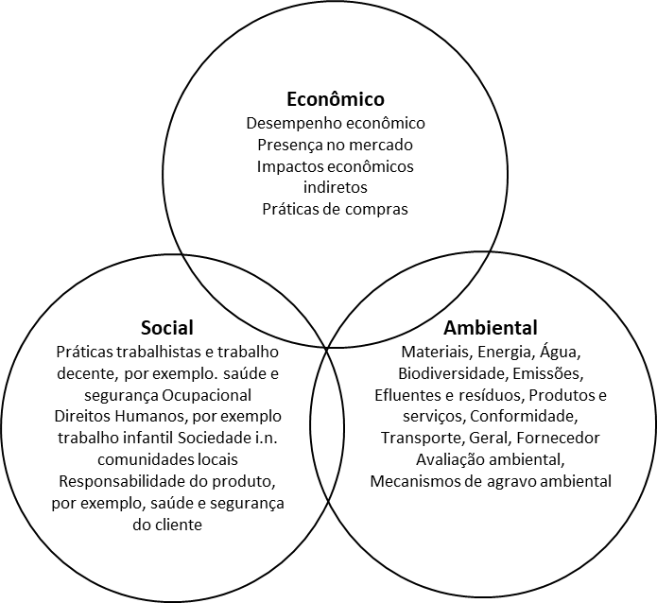
Source: Adapted from (Wilson, 2015)

The Sustainability Tripod supports the assumption that for organizations to achieve perenniality in the marketplace, there must be a balance among the three variables (economic, social, and environmental) without compromising their progress or future.
From the reports analyzed of the 20 companies chosen from the Bovespa (B3) list, common indicators were evidenced, with similar composition metrics, in addition to the specific indicators adopted by organizational management. In other words, although companies follow a general reference in the GRI manuals for the composition of their indicators, this does not mean that there is uniformity in their use. Even so, it is possible to verify that there are common material themes to be addressed in the reports and to which the indicators relate with greater or lesser relevance. The practices adopted by organizations direct this aspect.
The Corporate Sustainability Index (ISE) aims to enable good socio-environmental practices for Brazilian organizations by employing the Triple Bottom Line (TBL) concept in its formulation, which thoroughly evaluates companies’ economic, financial, social, and environmental perspectives. According to Elkington (1997), the creator of this management model, TBL, induces the organization to focus on the social and ecological values created or eliminated in addition to the economic value added.
In the current scenario of the operational growth of supply networks, the relationships established between companies, suppliers, and customers are fundamental to the validity of this adopted pattern.

2 METHODOLOGY
Research is the essential operation of science in questioning and the conception of reality (Barczak, 2015; Cho & Trent, 2006). In this case, as shown in Figure 3, this research has an applied nature, aiming to generate knowledge with practical utility to solve specific problems. Its methodological strategy is qualitative research, seeking to observe, point out, and analyze the phenomena studied, whose research data are characterized as qualitative representations of human acts and expressions.

Figure 3 - Methodological Proposal

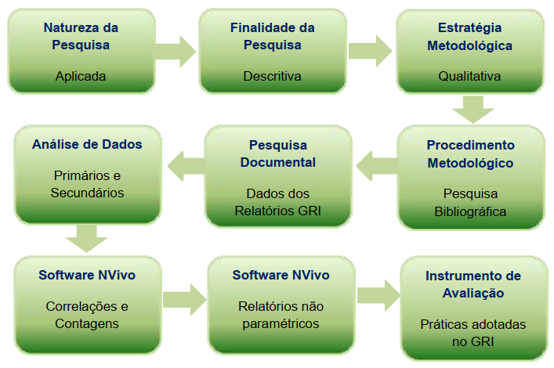
Source: Prepared by the Author.

Therefore, a qualitative strategy was employed that was influenced by the researcher’s subjective interpretation and emotional understanding (Yin, 2015). The qualitative methodological approach is appropriate when a fact cannot be investigated in adverse circumstances where it can quickly occur (Brown, 2010). The purpose of this study is descriptive and requires a range of information on the issues researched.
The analyzed data were extracted from the sustainability reports of companies listed in the Bovespa (B3) yearbook. Furthermore, through documentary analysis of the secondary data and possession of sustainability indicators by the companies present in these reports, the possibility of comparing the data pointed to which companies performed more or less management practices in the green supply chain.
The reference cases are companies with the highest relevance for Sustainability Indicators in the Annual Report of the B3 listing. From the isolated analysis of each corporate sustainability report, the predominant indicators in environmental, social, and economic management were verified.
The analysis units chosen for this research were the GRI reports of the following companies: Ambev, Bombril, Brasil Agro, Braskem, BRF, Celulosi Irani, Duratex, Embraer, Fibria Celulose, Fleury, Gerdau, Grendene, JBS, Klabin, Natura, Nestlé, Petrobrás, Suzano, Telefônica and Vale do Rio Doce. These empirical units of analysis are the focal companies (or main actors) of each supply network researched, the information that comprises the factors and management indicators in each network, and their adopted green practices. Additionally, focal companies can influence other supply chain members, establish rules or provide operational control, maintain permanent contact with the final consumer, and structure the activities and products offered to the market.
For the 20 selected companies, GRI indicators common to their sustainability reports are presented. However, it is worth pointing out that this research aimed to identify which GRI indicators were not common to the companies offered in these sustainability reports but were also related to the management of green practices or sustainable organizational development. In this sense, a complementation of the literal replication of the content mainly seeks to determine which indicators are not present in most reports but are part of the practices adopted in corporate management.
In qualitative research, the material being examined "can be enhanced by the use of qualitative software computer programs." (Creswell, 2008, p.197). The computer program used in this study as a data collection instrument was NVivo®, in the current version 12:12.5.0.815 (64-bit), Plus Edition, manufacturer QSR International, which is one of the most widely used in national academic research and adopted by researchers from major study centers and established universities (NVivo, 2020).
Figure 4 illustrates the design of the qualitative content analysis using NVivo® software. Its differential or differences were presented in its complementary functionalities, enabling the integration of enhancements to data queries, preparation of conceptual schemes, and production of reports, in addition to the opportunity for data analysis and working together in the standard of treatment of audio, images, and various information from different sources simultaneously, without the need to perform the anticipated textual reproductions of the material.

Figure 4 - Conceptual Map for Content Analysis Instrument

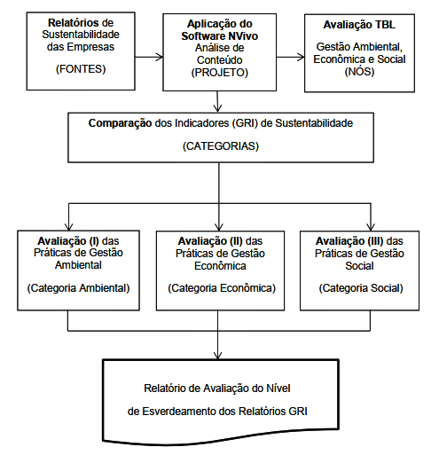
Source: Prepared by the author.

Overall, NVivo® supports a qualitative research methodological strategy and works with a project design. This information was generated in categories saved in a database throughout the data-analysis process. These categories define the basis of the project structure, which one wishes to outline and execute using the data selected for the research. In other words, in this study, the categorization of green practices adopted by companies was obtained from the set of GRI reports.
3 ANALYSIS OF RESULTS
To identify the most used or most relevant material topics, 20 sustainability reports in text format were analyzed by importing these documents into the database. The program then applied the auto coding process, showing the relevance of the automatically coded topics, the number of files that appeared, and the total number of references in the search. These previous verifications point out whether the path adopted, or the database structure is correctly associated with the categorized nodes using a list of keywords for the examination. Thus, NVivo® software presented a comparative number of partial references, allowing the visualization of the most cited words through a hierarchy graph and their correlations with the total number of items or themes automatically generated. Graphically, it was possible to perceive the relevance of these words or terms based on the size of the colored boxes (Figure 5).

Table 2 - Categories Coded by NVivo® (n=20)
Companies | A: Environmental | B: Economic | C: Social | Subtotals (1)
1 : RS AMBEV 2016 | 26 | 3 | 42 | 71
2 : RS BOMBRIL 2015 | 30 | 11 | 27 | 68
3 : RS BRASIL AGRO 2017 | 1 | 11 | 10 | 22
4 : RS BRASKEM 2015 | 53 | 26 | 33 | 112
5 : RS BRF 2016 | 49 | 19 | 61 | 129
6 : RS CELULOSE IRANI 2016 | 41 | 12 | 63 | 116
7 : RS DURATEX 2017 | 0 | 0 | 0 | 0
8 : RS EMBRAER 2016 | 68 | 20 | 110 | 198
9 : RS FIBRIA 2016 | 0 | 0 | 0 | 0
10 : RS FLEURY 2017 | 48 | 8 | 51 | 107
11 : RS GERDAU 2017 | 0 | 0 | 0 | 0
12 : RS GRANDENE 2017 | 0 | 0 | 0 | 0
13 : RS JBS 2016 | 38 | 3 | 36 | 77
14 : RS KLABIN 2015 | 0 | 0 | 0 | 0
15 : RS NATURA 2016 | 0 | 0 | 0 | 0
16 : RS NESTLÉ 2016 | 32 | 5 | 45 | 82
17 : RS PETROBRÁS 2017 | 0 | 0 | 0 | 0
18 : RS SUZANO 2016 | 2 | 2 | 0 | 4
19 : RS TELEFONICA 2016 | 33 | 8 | 36 | 77
20 : RS VALE 2016 | 66 | 16 | 95 | 177
Subtotals | 487 | 144 | 609
Source: Prepared by author (2019).

Table 2 summarizes the number of occurrences of TBL categories (economic, environmental, and social) per report analyzed via software, indicating that some of the pieces analyzed do not present any of the categories above table 2 summarizes the number of occurrences of TBL categories (economic, environmental, and social) per report analyzed via software, indicating that some of the information analyzed do not present any of the categories above. This is because some companies have not adopted the GRI reporting standard in their structure; consequently, seven companies scored zero in these categories.
From the first angle of evaluation of the main categories taken as references, one can see that there is strong evidence for the social type regarding the total number of references cited in the documents. On the other hand, by checking the subtotals of these same references for the reports separately, one can easily observe those that stood out the most by checking the list originated by NVivo®.

Figure 5 - Cross-Reference Table by NVivo®.
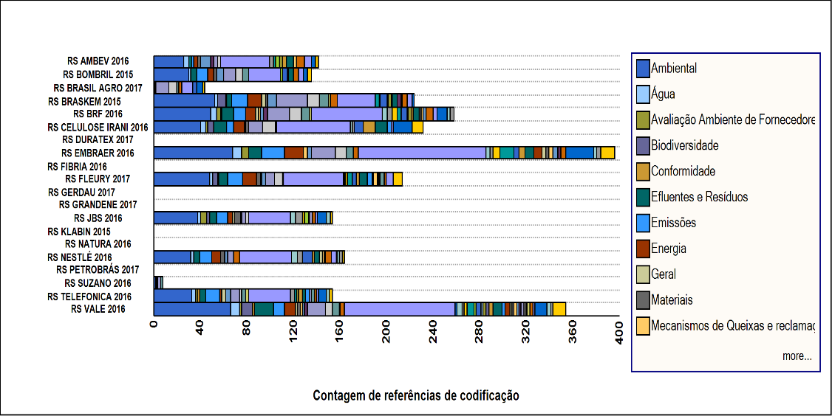
Source: Elaborated by the author.

Figure 5 visually demonstrates the companies that referenced sustainability aspects the most. Even when other isolated filters were applied to the sustainability categories and their respective subcategories, the data converged to the same interpretations, generating similar tables.

4 DISCUSSION

The data validation at the end of the analyses was essential in developing the readings and interpretation of the information and comparing the documents selected for the database of the content analysis support tool. To this end, convergence was sought between the information researched in the literature and that obtained after content analysis.

Table 3 - Green Practices Adopted x Material Themes
Major Related Category | Practices Identified in the Literature | Report Items whose practices are observed | What should be observed in each item of the Report in relation to those practices
Environmental | Internal environmental management; Ecodesign; Reverse logistics; pollution prevention; cleaner production practices; closed loop manufacturing; waste generation; waste recycling. | Eco-efficiency in Plants and Operations | Materials; energy; water; biodiversity; emissions; effluents and waste; products and services; compliance; transportation; general; supplier environmental assessment; environmental impact complaint mechanisms (Indicators Prefix: EC)
Economic | Green Purchasing; Investment Recovery. | Financial Sustainability | Economic Performance; Market Presence; Indirect Economic Impacts; Purchasing Practices (Indicators Prefix: EN)
Social | Cooperation with customers; Consumption Reduction; workshops and lectures; Green Marketing; supplier-oriented programs. | 1- Developing and Valuing the Collaborator;  2- Intensifying Communication and Education  for Sustainability  3- Expansion of Social Investment;  4- Quality Management;  5- Environmental and Social Management. | Employment; Labor Relations; Occupational Health and Safety; Training and Education; Diversity and Equal Opportunity; Equal Pay for Women and Men; Supplier Evaluation on Labor Practices; Labor Practices Grievance Mechanisms; Investments; Non-Discrimination; Freedom of Association; Collective Bargaining; Child Labor; Forced or Compulsory Labor; Safety Practices; Indigenous Rights; Assessment; Supplier Evaluation on Human Rights; Mechanisms for Complaints and Grievances Regarding Human Rights; Local Communities; Anti-Corruption; Public Policy; Unfair Competition; Compliance; Supplier Evaluation on Impacts on Society; Mechanisms for Complaints and Grievances Regarding Impacts on Society; Customer Health and Safety; Product and Service Labeling; Marketing Communications; Customer Privacy; Compliance (Prefix Indicators: LA; HR; SO; PR)
Note: Prepared by the author (2019).

The diagnoses and correlations performed by NVivo® have enabled several conferences and associations between the theory investigated and reality. These factors act as springboards to solve the initial launch problem.
That is, it was verified that there is a close relationship between the green practices analyzed in the literature and those diagnosed, which expresses the importance of the interrelation between theoretical themes and those used as specific subjects in the reports or material themes.
As indicated in Table 3, it is undeniable to observe that the practices adopted for the large "social" category of the sustainability tripod stood out, not only by the more significant number of subcategories verified but also by the exposure of their respective indicators present in the documents, confirmed by the reports extracted from NVivo® as post-analysis results.
It was also found that, in terms of a set of green practices adopted, following the GRI parameters and duly associated with the list of aspects, the "greenest" reports were those that presented the largest set of green practices, material themes, or more important and specific issues related to the TBL categories. Thus, it was clear that the more sustainability indicators found in the correlations performed by the program, the more sustainable the level of the business report.

CONCLUSION
This study proves to be important and significant for the subject of supply networks in organizations because there is still insufficient research on this topic. The objective was to evaluate the practicability of using GRI Reports to identify sustainability practices in the supply chain based on an analysis of companies' GRI reports, their green methods, and indicators adopted in Supply Chain Management.
The literature review organized this research to highlight the fundamental theoretical aspects of Supply Chain, Supply Chain Management, Supply Chain as Supply Networks, Supply Chain Integration, Green Supply Chain Management, Practices Adopted in Green Supply Chain Management, and Sustainability Reports of companies.
In response to this research problem, it was confirmed that companies' GRI sustainability reports could be used to identify green supply chain management practices, which are associated with the main organizational activities and standardized by the GRI-G4 manual.
The presentation of which companies and their respective green practices adopted in their management were the most referenced in sustainability reports can be cited as a leading academic contribution. In other words, it also has managerial importance for reading important data for managers and others involved in corporate business and its markets because of the possibility of an agile content analysis made possible by the NVivo® program. Thus, one can see qualitatively which issues stood out the most in their business networks.
These reasons may raise shareholders’ acceptance criteria regarding their possible investments given that the companies selected for the research are on the B3 list.

REFERENCES

Alinaghian, L., Qiu, J., & Razmdoost, K. (2021). The role of network structural properties in supply chain sustainability: a systematic literature review and agenda for future research. In Supply Chain Management (Vol. 26, Issue 2, pp. 192–211). Emerald Group Holdings Ltd. https://doi.org/10.1108/SCM-11-2019-0407
An, H. K., Amano, T., Utsumi, H., & Matsui, S. (2008). A framework for Green Supply Chain Management complying with RoHS directive. CCR Conference, 1–14. http://www.crrconference.org
Ballou, R. H., Gilbert, S. M., & Mukherjee, A. (2000). New Managerial Challenges from Supply Chain Opportunities. Industrial Marketing Management, 29(1), 7–18. https://doi.org/10.1016/S0019-8501(99)00107-8
Barbieri, J. C., Cajazeira, J. E. R., & Branchini, O. (2009). Supply chain and product life cycle assessment: Theoretical review and example of application . O Papel (Brazil), 70(9), 52–72. http://www.scopus.com/inward/record.url?eid=2-s2.0-72749126891&partnerID=40&md5=e3bb326497b141cb095cf0bba46613a6
Barczak, G. (2015). Publishing Qualitative versus Quantitative Research. Journal of Product Innovation Management, 32(5), 658–658. https://doi.org/10.1111/jpim.12277
Beamon, B. M. (1999). Measuring supply chain performance. International Journal of Operations \& Production ManagemenT, 19(3–4), 275–292. https://doi.org/10.1108/01443579910249714
Borges, F. Q., & Garcia Herreros, M. M. A. (2011). Green business and the challenges of competitiveness in the environment of supply chain management: The case of natura cosmetics s/a . Informacao e Sociedade, 21(3), 13–20. http://www.scopus.com/inward/record.url?eid=2-s2.0-84856830914&partnerID=40&md5=5a1782aab9e6fab8d66263d7c76f3a2f
Brown, a. P. (2010). Qualitative method and compromise in applied social research. Qualitative Research, 10(2), 229–248. https://doi.org/10.1177/1468794109356743
Bubicz, M. E., Dias Barbosa-Póvoa, A. P. F., & Carvalho, A. (2021). Social sustainability management in the apparel supply chains. Journal of Cleaner Production, 280. https://doi.org/10.1016/j.jclepro.2020.124214
Carter, C. R., Rogers, D. S., & Choi, T. Y. (2015). Toward the theory of the supply chain. Journal of Supply Chain Management, 51(2), 89–97.
Chen, L., Tang, O., & Feldmann, A. (2015). Applying GRI reports for the investigation of environmental management practices and company performance in Sweden, China and India. Journal of Cleaner Production, 98, 36–46. https://doi.org/10.1016/j.jclepro.2014.02.001
Cho, J., & Trent, A. (2006). Validity in qualitative research revisited. Qualitative Research, 6(3), 319–340. https://doi.org/10.1177/1468794106065006
CHOPRA, S., & MEINDL, P. (2011). Gestão da Cadeia de Suprimentos: Estratégia, Planejamento e Operações (4th ed.). Pearson Prentice Hall.
CHRISTOPHER, M. (2009). Logística e gerenciamento da cadeira de suprimentos: criando redes que agregam valor (2nd ed.). Cengage Learning.
Christopher, M., & Towill, D. R. (2002). Developing market specific supply chain strategies. International Journal of Logistics Management, 13(1), 1–14.
Creswell, J. W. (2008). Educational research: Planning, conducting, and evaluating quantitative and qualitative research (3rd ed.). Pearson Education Limited.
Dües, C. M., Tan, K. H., & Lim, M. (2013). Green as the new Lean: How to use Lean practices as a catalyst to greening your supply chain. Journal of Cleaner Production, 40, 93–100. https://doi.org/10.1016/j.jclepro.2011.12.023
Elkington, J. (1997). Cannibals’ with forks: the triple bottom line of 21st century business. Oxford University Press.
Fekpe, E., & Delaporte, Y. (2019). Sustainability integration and supply chain performance of manufacturing small and medium size enterprises. African Journal of Economic and Management Studies, 10(2), 130–147. https://doi.org/10.1108/AJEMS-05-2018-0152
Fonseca, A., McAllister, M. L., & Fitzpatrick, P. (2014). Sustainability reporting among mining corporations: A constructive critique of the GRI approach. In Journal of Cleaner Production (Vol. 84, Issue 1, pp. 70–83). Elsevier Ltd. https://doi.org/10.1016/j.jclepro.2012.11.050
Gouda, S. K., & Saranga, H. (2018). Sustainable supply chains for supply chain sustainability: impact of sustainability efforts on supply chain risk. International Journal of Production Research, 56(17), 5820–5835. https://doi.org/10.1080/00207543.2018.1456695
GRI. (2021). GRI 1: Foundation 2021. In Global Sustainability Standards Board (GSSB) (Ed.), GRI Standards (pp. 1–39).
Isaksson, R., & Steimle, U. (2009). What does GRI-reporting tell us about corporate sustainability? TQM Journal, 21(2), 168–181. https://doi.org/10.1108/17542730910938155
Kamble, S. S., Gunasekaran, A., & Gawankar, S. A. (2020). Achieving sustainable performance in a data-driven agriculture supply chain: A review for research and applications. In International Journal of Production Economics (Vol. 219, pp. 179–194). Elsevier B.V. https://doi.org/10.1016/j.ijpe.2019.05.022
Kang, M., Yang, M. G., Park, Y., & Huo, B. (2018). Supply chain integration and its impact on sustainability. Industrial Management and Data Systems, 118(9), 1749–1765. https://doi.org/10.1108/IMDS-01-2018-0004
Lakhal, S. Y., & H’mida, S. (2003). A gap analysis for green supply chain benchmarking. Proceeding of the 32nd International Conference on Computers & Industrial Engineering, 45–54.
Lambert, D. M. (2008). Supply chain management: processes, partnerships, performance (D. M. Lambert, Ed.). SCMI.
LMI. (2005). Taylor Wilkerson on Best Practices in Implementing Green Supply Chains.
NVivo. (2020). QSR International Pty Ltd. (No. 2020).
Rao, P., & Holt, D. (2005). Do green supply chains lead to competitiveness and economic performance? International Journal of Operations and Production Management, 25(9), 898–916. https://doi.org/10.1108/01443570510613956
Sarkis, J., Zhu, Q., & Lai, K.-H. (2011). An organizational theoretic review of green supply chain management literature. International Journal of Production Economics, 130(1), 1–15. http://www.scopus.com/inward/record.url?eid=2-s2.0-78651308932&partnerID=40&md5=711207ccd748df1c2d3b623d4c152308
Seuring, S., & Müller, M. (2008). From a literature review to a conceptual framework for sustainable supply chain management. Journal of Cleaner Production, 16(15), 1699–1710.
Srivastava, S. K. (2007). Green supply‐chain management: a state‐of‐the‐art literature review. International Journal of Management Reviews, 9(1), 53–80.
Wilson, J. P. (2015). The triple bottom line: Undertaking an economic, social, and environmental retail sustainability strategy. International Journal of Retail and Distribution Management, 43(4–5), 432–447. https://doi.org/10.1108/IJRDM-11-2013-0210
Wissuwa, F., & Durach, C. F. (2021). Turning German automotive supply chains into sponsors for sustainability. Production Planning and Control. https://doi.org/10.1080/09537287.2021.1893405
Yin, R. k. (2015). Qualitative Research from Start to Finish (Second Edi). The Guilford Press.
Zhu, Q., & Sarkis, J. (2004). Relationships between operational practices and performance among early adopters of green supply chain management practices in Chinese manufacturing enterprises. Journal of Operations Management, 22(3), 265–289. https://doi.org/10.1016/j.jom.2004.01.005
Zhu, Q., Sarkis, J., & Lai, K. H. (2008). Confirmation of a measurement model for green supply chain management practices implementation. International Journal of Production Economics, 111(2), 261–273.
Zhu, Q., Sarkis, J., & Lai, K. H. (2011). An institutional theoretic investigation on the links between internationalization of Chinese manufacturers and their environmental supply chain management. Resources, Conservation and Recycling, 55(6), 623–630. https://doi.org/10.1016/j.resconrec.2010.12.003

