http://doi.org/10.23925/2179-3565.2025v16i3p13-25

RISUS - Journal on Innovation and Sustainability volume 16, número 3 - 2025
ISSN: 2179-3565
Editor Científico: Arnoldo José de Hoyos Guevara
Editor Assistente: Vitória Catarina Dib
Avaliação: Melhores práticas editoriais da ANPAD
AN INEVITABILITY OF GENERATIVE ARTIFICIAL INTELLIGENCE ERA
A CASE OF SAUDI EDUCATION
Uma inevitabilidade da era da inteligência artificial generativa - um caso da educação saudita

A. K. Alghamdi, D. A. Hasan, S. A. Nassif, M. A. Abdullah
King Abdulaziz University, Department of Information Systems, Jeddah, Saudi Arabia
E-mail: aalghamdi4928@kau.edu.sa, dhasan0002@kau.edu.sa, snassif0001@kau.edu.sa, maaabdullah@kau.edu.sa

ABSTRACT

Saudi Arabia’s Vision 2030 promotes the integration of advanced technologies, particularly artificial intelligence (AI), across various sectors, including education. This research investigates the extent of Saudi university students’ familiarity with Gen AI tools such as ChatGPT, Grammarly, and GitHub Copilot and how they employ these technologies for academic support, research, and problem-solving. Additionally, it analyzes the impact of Gen AI tools on learning outcomes and addresses ethical issues related to their use, including plagiarism, dependence on AI, and data privacy. Using a structured questionnaire, targeting students in higher education at Saudi Universities. This study evaluates gaps in students’ awareness of Gen AI and outlines measures for the ethical and effective integration of these tools in higher education. Findings indicates that Saudi students are highly engaged with Gen AI tools, with positive attitude towards its advantages and insisting for more clear instructions and policies by their universities regarding ethical concerns. These results suggest the Importance of Gen AI tools in higher education and the crucial need for clearer ethical policies.
Keywords: Artificial Intelligence, Generative Artificial Intelligence, GenAI Education, Saudi Arabia, UTAUT model

SUBMETIDO EM: 18/05/2025
ACEITO EM: 10/09/2025
PUBLICADO EM: 30/10/2025

RISUS - Journal on Innovation and Sustainability volume 16, número 3 - 2025
ISSN: 2179-3565
Editor Científico: Arnoldo José de Hoyos Guevara
Editor Assistente: Vitória Catarina Dib
Avaliação: Melhores práticas editoriais da ANPAD
UMA INEVITABILIDADE DA ERA DA INTELIGÊNCIA ARTIFICIAL GENERATIVA UM CASO DA EDUCAÇÃO SAUDITA
An inevitability of generative artificial intelligence era - a case of Saudi education

A. K. Alghamdi, D. A. Hasan, S. A. Nassif, M. A. Abdullah
King Abdulaziz University, Department of Information Systems, Jeddah, Saudi Arabia
E-mail: aalghamdi4928@kau.edu.sa, dhasan0002@kau.edu.sa, snassif0001@kau.edu.sa, maaabdullah@kau.edu.sa

RESUMO

A visão 2030 da Arábia Saudita promove a integração de tecnologias avançadas, particularmente Inteligência artificial (IA), em vários setores, incluindo a educação. Esta pesquisa investiga a extensão da Universidade Saudita a familiaridade dos alunos com as ferramentas de IA de geração, como ChatGPT, Grammarly e Github Copilot, e como eles empregam essas tecnologias para suporte acadêmico, pesquisa e Solução de problemas. Além disso, analisa o impacto das ferramentas Gen AI nos resultados de aprendizagem e aborda questões éticas relacionadas ao seu uso, incluindo plágio, dependência de IA e privacidade de dados. Usando um questionário estruturado, direcionado a estudantes do ensino superior em universidades Sauditas. Este estudo avalia lacunas na conscientização dos alunos sobre a Gen AI e delineia medidas para a integração ética e efetiva dessas ferramentas no ensino superior. Os resultados indicam que os estudantes sauditas estão altamente engajados com as ferramentas da Gen AI, com atitude positiva em relação às suas vantagens e insistindo por instruções e políticas mais claras de suas universidades em relação às preocupações éticas. Esses resultados sugerem a importância das ferramentas Gen AI no ensino superior e a necessidade crucial de políticas éticas mais claras.
Palavras-chave: Inteligência Artificial, Inteligência Artificial Generativa, Educação GenAI, Arábia Saudita, modelo UTAUT.

INTRODUCTION

Saudi Arabia’s Vision 2030 (Saudi Vision 2030, 2016) presents a comprehensive roadmap for economic diversification and technological advancement. It includes emerging 3 technologies such as AI, the Internet of Things (IoT), and blockchain
across various sectors. Therefore, Saudi Arabia invests in research, innovation, and talent development to secure a competitive global edge. Furthermore, the Saudi Data and Artificial Intelligence Authority (SDAIA) has supported around 11,000 teachers with AI specialties in training, educating, and spreading new technology throughout the nation in coordination with the Saudi 2030 vision. Some talented Saudi students’ schools, like in Jeddah and Yanbu, aimed to implement AI in their education (Alghamdi & Alabasi, 2022).

Generative Artificial Intelligence, known as "Gen AI," is a type of artificial intelligence (AI) technology that can create new and unique outputs, including text, images, and audio, among other forms of data. According to the publication by Oliver (n.d.); Figure 1 shows Saudi Arabia in the lead on the number of Gen AI weekly users scoring 68% in comparison to globally 55% and with the USA 46%.

Figure 1 - Percentage of weekly Gen AI users

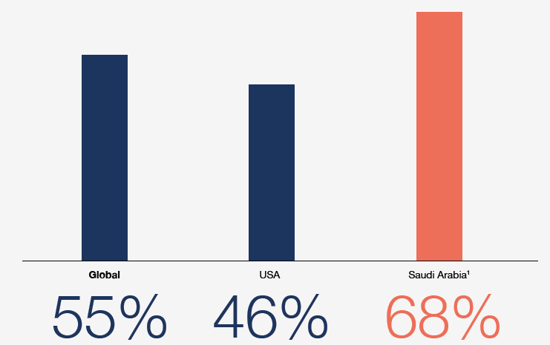

Gen AI has created new opportunities for applications in higher education. Examples of these applications include ChatGPT, Midjourney, and GitHub Copilot. These tools can create personalized learning experiences, develop or update teaching materials, code for research, and draft responses to student inquiries (Chiu et al., 2023).
This report focuses on Gen AI literature and its applications in the Kingdom of Saudi Arabia, focusing on students as the primary stakeholders in education. The Gen AI usage guide was published by the Saudi Arabia Ministry of Education and SDAIA to improve the quality of Saudi education outcomes ethically and principled (SDAIA & Ministry of Education, 2025) and ensure compatibility with the global development of Gen AI.
This work emphasizes students’ awareness, perspectives, and utilization of Gen AI as a learning tool for content design and creation. The selected studies in this report examined Gen AI applications in higher education, now referred to as “University 5.0,” which signifies a transformative approach that integrates advanced technologies, enhances collaboration between academia and industry, and stresses lifelong learning. This builds upon “Education 5.0,” which denotes the next phase in education, highlighting the integration of advanced technologies, personalized learning experiences, and achieving soft skills alongside traditional knowledge. This approach seeks to equip students for the complexities of the modern world by fostering creativity, critical thinking, and collaboration.
Therefore, this paper aims to comprehensively understand the Saudi education sector and its perspective on the emergence of technologies, including Gen AI tools and the digital transformation of learning. While Saudi Arabia’s 2030 Vision is to integrate technologies among sectors, Gen AI tools' specific impact and ethical concerns in higher education remain underutilized. Thus, the study addresses this gap by investigating Saudi university students’ awareness, usage, and ethical engagement with artificial intelligence tools, particularly Gen AI, for their practical and ethical integration into education.
Building upon the research focus and objectives, this study is guided by the following primary questions: (1) To what extent are Saudi students in higher education aware of Gen AI tools and their capabilities? The findings would determine the student’s familiarity and understanding of these emerging technologies. (2) How does using Gen AI tools impact Saudi students’ educational achievements? From this question, we aim to evaluate the effectiveness of Gen AI on students' academic learning outcomes and their performance in the overall educational experience. (3) How ethically are the Saudi students using Gen AI tools? This investigates students’ ethical concerns, their perspective of academic integrity, and adherence to university regulations.
To address these questions, this search methodology involves a questionnaire to investigate further how students use Gen AI. Additionally, it aims to evaluate Saudi students' familiarity with and knowledge of Generative AI tools, such as ChatGPT, while identifying gaps in understanding and exposure across various academic disciplines. This study will explore the everyday use cases of Gen AI tools among Saudi students, including academic support, research, and problem-solving, to improve learning outcomes. Furthermore, it examines students' perceptions of ethical challenges, such as plagiarism, reliance on AI, and data privacy issues. It also assesses students' awareness of and adherence to institutional guidelines on the responsible use of Gen AI tools. Finally, it proposes strategies for effectively integrating Gen AI tools in higher education to ensure ethical use and discipline-specific applicability.
This paper is divided into the following sections. Section 2 discusses the background information of the popular Gen AI tools mainly used by students and related studies that address the use of technologies in the education sector. Building on this, Section 3 highlights the research methodology on how this research would collect and analyze related data for Saudi higher education students. An illustration of the detailed methodology is also provided. Following the methodology, Section 4 presents the findings of the conducted questionnaire along with a thorough analysis. In Section 5, these findings discuss the research questions and existing literature, addressing implications for theory, practice, and policy and comparing them with previous studies and unexpected outcomes. Finally, Section 6 summarizes key insights and provides recommendations for future research.

1 LITERATURE REIVEW

This section briefly summarizes artificial intelligence (AI) and its subfield, generative AI (Gen AI). It defines Gen AI tools, discusses their benefits and limitations, and considers their impact on revolutionizing education. The discussion further provides additional context for the widespread use of Gen AI tools in Saudi educational contexts.

  - Background

In computer science, AI involves studying the development of machines that can perform tasks typically requiring human intelligence. According to the Saudi Data and AI Authority, these tasks encompass reasoning, understanding natural language, identifying patterns, learning from data, and making decisions. AI systems analyze large datasets using algorithms and models to accomplish these tasks, enabling them to respond and adapt to complex scenarios with minimal human interaction. While this capability enhances creativity and efficiency across various industries, it also brings forth ethical considerations, data privacy concerns, and accountability challenges (Saudi Data and AI Authority, 2023).
Specifically, Gen AI is a subfield of AI that learns patterns from large datasets to create new materials, including text, images, and audio (Saudi Data and AI Authority, 2023). Essentially, Gen AI models emulate and analyze the complexities of human creativity, enabling the automated production of scalable and customized content across various fields. Due to its numerous benefits, such as increased productivity, cost-effectiveness, and the ability to produce diverse customized outputs that cater to individual user needs, this technology is revolutionizing traditional methods.
However, Gen AI still has several significant drawbacks. Major issues include concerns about data privacy and the spread of innate biases in training data, which can provide distorted or morally dubious results. Furthermore, Gen AI's rapid growth raises important questions about misinformation, intellectual property, and the possible overreliance on automated systems, which calls for rigorous evaluation of ethical and legal frameworks (Saudi Data and AI Authority, 2023).
A recent study by Saudi Data and AI Authority (2024) found significant adoption of AI tool integration in Saudi Arabian educational settings in 2024. Approximately 55% of college students report regularly using ChatGPT, making it the most popular tool for research and academic writing assistance. Additionally, around 42% and 38% of students use writing assistants like Grammarly and QuillBot to polish written assignments, improve clarity, and strengthen language proficiency. Furthermore, programming and engineering students frequently use technical tools such as GitHub Copilot, with usage rates nearing 30%. In comparison, students in design-related fields reportedly use creative applications such as Midjourney at a rate of about 25%. These statistics highlight how AI has transformed learning methods, creating individualized learning environments and expediting academic processes.
Table 1 compares the significant features and adoption percentages of the most widely used AI technologies in Saudi Arabia's education sector in 2024, as seen below (Saudi Data and AI Authority, 2024).

Table 1 - Most widely used gen ai tools in Saudi education
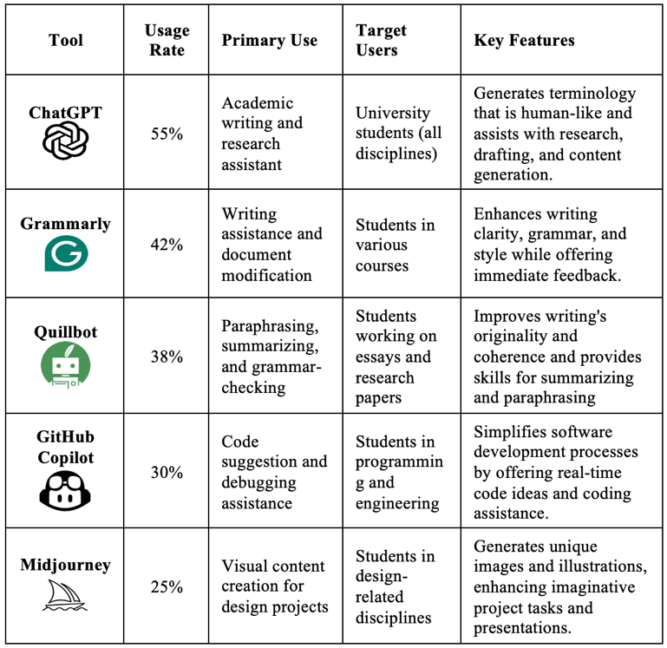

1.2 Related Works

This section discusses the theoretical frameworks and empirical studies within the higher education research field while preserving the use of Gen AI tools in education from the student perspective. Although previous studies underlined the advantages of various student-level enhancements, they also present significant concerns regarding plagiarism, ethical issues, and lower creativity and productivity. Reviewing relevant studies provides the foundation for our research on Saudi university students' awareness and ethical utilization of Gen AI tools.
A comprehensive search was conducted for open-access and accessible studies from 2020, focusing on high-index and high-citation papers. Multiple databases were utilized, including Google Scholar, ERIC, the Saudi Digital Library, IEEE, Elicit, and Elsevier. The search identified key tools and findings related to the applications of Gen AI in higher education. The most common applications of Gen AI were observed among students in programming, engineering, healthcare, and design, where it is expected to offer innovative solutions. Regarding Gen AI tools and techniques, chatbots and large language models (LLMs) like GPT were the most frequently mentioned in the reviewed studies. Although a few studies referenced content-generating tools, they lacked detailed descriptions.
The lightning-fast growth of Gen AI technologies, including ChatGPT, Gemini, and DeepSeek, has caused a lot of attention to their potential applications in higher education. These approaches are praised for simplifying teaching and administrative processes, increasing student involvement, and personalizing learning. Despite these potential advantages, several challenges have arisen, such as academic integrity, scalability, and ethical concerns. This review integrates evidence from survey-based, systematic reviews, technical, and conceptual studies, focusing on current utilization, unique challenges, and emerging opportunities in Saudi Arabia.
The empirical study delivers initial insights into how Gen AI will ultimately be implemented and utilized in schools and universities. In one instance, Al-Smadi (2023) discusses how predictive analytics could potentially assist students and offers that, given a lot of promise, nobody can predict the long-term implications of institutional ethical behavior. In subsequent studies by Budianto (2023), students also have experience with ChatGPT and other Gen AI tools, and they constantly use these for study, translation, and summarization work. Furthermore, also states that there are still acute academic fraud issues, including plagiarism, even amidst positive feelings. International studies also support these findings, Coman et al. (2023) lays down that the frequency of Romania's Gen AI usage is tied to higher levels of student satisfaction, whereas in Eriksson (2023) stresses Swedish faculty issues enduring. Research by Smith, A., & Johnson (2024) shows that with extensive familiarity prevalent, the regular integration of Gen AI into standard teaching practice remains evolving.
Systematic reviews further broaden their coverage by combining many methods of investigation and discovering patterns in literature. Al-Zahrani (2024) find a gap between the otherwise acknowledged capabilities of Gen AI and its utility, real-life applications. While Gen AI has the potential to enable individualized learning and enhance learner engagement.
Technically, the development, design, and scalability of Gen AI technologies to educational institutions are our primary areas of study interest. Although Gupta et al. (2024) talks about the application of Gen AI towards engineering domains, including its potential as well as scalability and performance-related issues it should overcome. Brown et al. (2024) presents Course GPT as something to be used to maximize student engagement and automate the learning process. Further, Goh et al. (2024) recognize the need for rigorous testing and iterative tuning of RAG chatbots because these must overcome technical issues to be heavily used across many learning environments.
Conceptual models provide further richness with Gen AI integration’s theoretical and ethical dimensions. Martínez, L., & Lopez (2024), addresses the cognitive implications of utilizing automated systems, warning against overdependence while advocating for balanced pedagogical approaches. Ethical concerns are central to this debate; for example, Ahmed & Malik. (2024) discusses data privacy concerns, bias in algorithmic output, and the broader implications for academic integrity. While there have been some attempts, such as those by SDAIA and King Abdulaziz University, to develop ethical guidelines, there remains a persistent gap in the degree to which these guidelines are disseminated and upheld.
In Saudi Arabia higher education, the integration of Gen AI is progressing very rapidly. Empirical study Almassaad et al. (2024) identifies students' widespread use of Gen AI technology for learning tasks like summarizing, research, and language translation and administrators employing them for automating work processes and facilitating teaching methods.
Nevertheless, ethical considerations mask such success: e.g., research by Aldossary et al. (2024) which stated present challenges related to academic honesty and the crafting of skewed materials. The demand for more empirical studies to address the long-term consequences of the impact of these technologies on outcomes in education and organizational practice is provoked by how fast Gen AI is being accepted and how thin the literature has been in presenting longitudinal research in this area.

Table 2 - GenAI Integration in Higher Education: Global and Saudi Perspectives Related Work
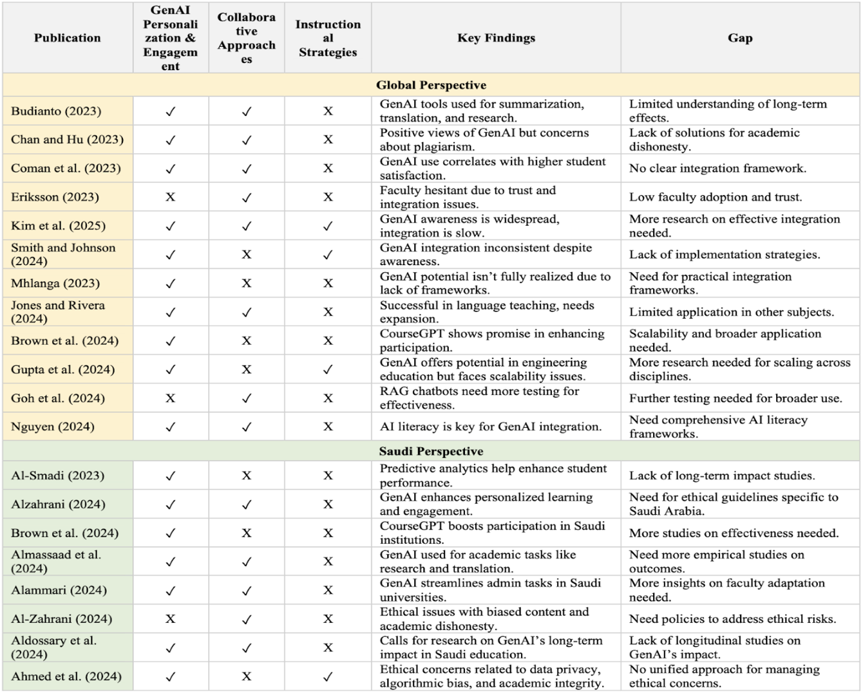

Despite the growing body of work on Gen AI, specific consequential gaps are rich with future research directions. First and foremost, longitudinal research is essential to explain the long-term implications of Gen AI on learning achievements among students, the workload of instructors, and institutional policy in general. In addition, developing strong frameworks that bridge technical creativity and ethics-driven guardrails is strictly necessary. These frameworks should include practical factors like scalability, training, and technology over-reliance risk avoidance. Due to the specific Saudi Arabian institutional, cultural, and regulatory context, further research is needed to enlighten how such environments influence Gen AI adoption and effective deployment and that ethical standards are identified and respected.
Table 2 presents the key findings on Gen AI Integration in Higher Education: Global and Saudi Perspectives. It refers to how Gen AI enhances personalization, collaboration, and pedagogy. At the same time, issues such as scalability, ethics, and the need for more research on long-term impacts, ethics guidelines, and practical implementation arise.
To conclude from the previous studies, Gen AI has been rapidly used in education, offering opportunities for personalized learning, enhancing student engagement, and allowing students to be more innovative in their studies. Related studies present a high awareness and usage of Gen AI tools among different academic studies in multiple majors while highlighting the ethical and plagiarism concerns for their long-term learning impacts.
Additionally, review articles emphasized the need to uphold ethical considerations when using Gen AI tools, specifically in the educational sector. The study also emphasizes the effectiveness of Gen AI innovations in their performance scalability and cross-disciplinary use issues. Conceptual articles offer thought-provoking insights on Gen AI's theoretical, ethical, and long-term learning consequences. These results will guide the development of a survey-based research study investigating institutional, cultural, and ethical factors, particularly emphasizing Saudi higher education. This research aims to facilitate the successful and responsible integration of Gen AI tools into Saudi higher education by leveraging global research findings and innovation while maintaining ethical and academic standards.

2 METHODOLOGY

This research explored the integration of Gen AI within Saudi Arabia’s higher education sector. We focused on the global education concept of Education 5.0 from 2020 to 2025 to examine the adoption, challenges, impacts, and ethical implications of Gen AI tools among Saudi higher education students. Therefore, using and integrating Gen AI tools in the higher education sector will be analyzed using global studies. Measuring the student’s awareness, impact, and ethical concerns would help the research identify the gaps and recommendations for enhancing the adoption of Gen AI tools in Saudi Arabia.
We aim to collect data through a structured questionnaire, targeting students in higher education at Saudi Universities, especially computer science majors, as a focus study group. The findings from the questionnaire analysis will demonstrate the results, leading to a comprehensive discussion and conclusion that would offer recommendations for integrating Gen AI in Saudi higher education. Figure 2 presents the research methodology approach drawn up to evaluate the integration of generative AI in Saudi Arabia's higher education system, emphasizing tools, applications, and ethical considerations within Education 5.0.

Figure 2 - Research Methodology Framework Illustrating

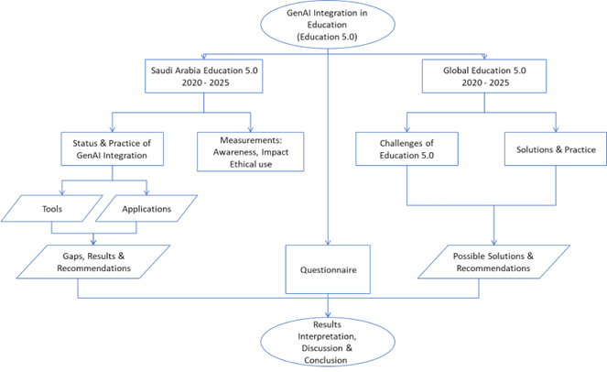

A questionnaire was constructed in this research based on the UTAUT to assess awareness, use, and ethical concerns regarding Gen AI tools among Saudi university students. The model applied widely in technology adoption research, aims at four major constructs: Performance Expectancy, Effort Expectancy, Social Influence, and Facilitating Conditions. These constructs were used to guide the questions asked in the survey and to examine drivers of students' intentions to adopt and use Gen AI tools such as ChatGPT, Grammarly, Gemini, and GitHub Copilot (Ustun et al., 2020).

There are different sections on the questionnaire, with each encompassing aspect of the UTAUT model, i.e.:
Demographic Information: Background information of the participants, age, gender, level of study, and college or institution studied is collected in this section for a representative sample from different backgrounds.
Generative AI Tools Awareness: This item determines the awareness of Generative AI tools among the students. Respondents were queried whether they were aware of the tools and how they learned about them. Awareness of popular tools such as ChatGPT and Grammarly was rated on a scale from "Not familiar at all" to "Very familiar."
Usage of Gen AI Tools: This subsection examines the frequency with which students use Gen AI tools for academic purposes. The survey asks about the type of academic tasks for which students employ these tools, such as writing assignments, coding, brainstorming ideas, and making study summaries.
Performance Expectancy: In the UTAUT model, performance expectancy refers to what extent an individual believes that using a particular technology will enhance his or her job performance. The survey picks up the students' perceptions about how Gen AI tools help them complete their academic work faster and enhance the quality of work. Effort Expectancy: This refers to the perceived ease of use of the technology. Items in this scale inquire about how easily the students can learn and use Gen AI tools for learning. It also includes items on students feeling comfortable using these tools.
Social Influence: This is a construct that measures the extent to which the students are influenced by others in their surroundings to use Gen AI tools. The survey examines students' perceptions of whether their peers and lecturers value the effective use of these tools and whether this influences their intention to use them.
Facilitating Conditions: specify the support systems and resources that enable individuals to utilize technology. This dimension considers the extent to which students can access required resources, technical support, and academic guidance, thereby enabling them to use Gen AI tools in a meaningful way.
Ethics of Using Gen AI Tools: Ethics of using Gen AI tools is the second primary segment of the survey. It addresses plagiarism, over-reliance on AI, biased data in AI-generated content created by AI, and data privacy. The segment also includes students' attitudes toward ethical responsibility for crediting AI-generated work and being willing to use the tools with definite academic standards.
Behavioral Intention & Actual Use: The final section of the survey assesses students' intentions to utilize Gen AI tools in the future as well as their intention to recommend the tools to others in their social circle for academic purposes.
The questionnaire was kept short, with an estimated completion time of 5-7 minutes, to gain a high level of response from the participants. The response will provide an understanding of the determinants of Saudi students' adoption and use of Gen AI tools, offering a foundation for comprehending challenges and opportunities that these tools introduce to higher education.

  - Data Collection and Sample Overview

The study investigated Saudi university students' awareness, usage behavior, and ethics on the use of Gen AI tools in university education. Data were collected during the second semester of the 2024-2025 academic year from various public and private universities in Saudi Arabia, yielding 225 complete responses. Females made up the majority of respondents (92%), while males accounted for only 8%. Regarding the age groups, the largest demographic was between 18 and 24 years old (72%), followed by students aged 25–34 (14.7%). In addition, 9.8% fell within the 35-44 age group, while the smallest group comprised those aged 45 or older (3.6 %). In terms of academic level, the results show that 77.3% were undergraduate students, 12% were master’s students, and 6.7% were PhD students. The participants in the research were from various colleges, including Computer and IT Colleges, which represent most respondents, as shown in Figure 3; Common First Year, Health Colleges, Science Colleges, Engineering Colleges, and Humanities Colleges.

Figure 3 - Distribution of Respondents by College Enrollment

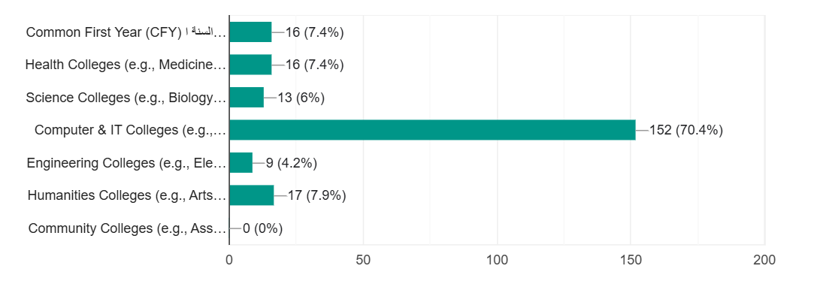

2.2 Data Analysis and Results

The data obtained via the survey were measured in accordance with the constructs of the UTAUT and complemented by items related to ethical use of Generative AI (Gen AI). Descriptive statistics (mean, standard deviation, frequency, and percentages) were employed for combining the answers of the students in all sections of the survey. All the constructs were examined separately in a bid to reveal students' awareness, behavior, perceptions, and intentions towards adopting Gen AI tools into their lives of learning. Pearson correlation analysis was employed to determine relationships between UTAUT constructs. As observed from Figure 4, Performance Expectancy, Effort Expectancy, and Behavioral Intention were highly positively correlated, indicating theoretical congruence of the UTAUT framework (table 3).

Table 3 - Summary of survey results
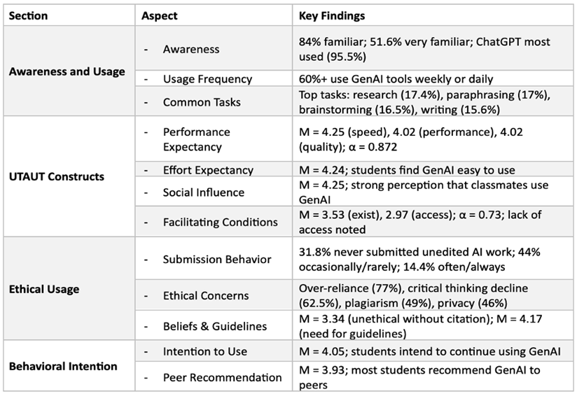

Figure 4 - Correlation Heatmap: UTAUT Constructs

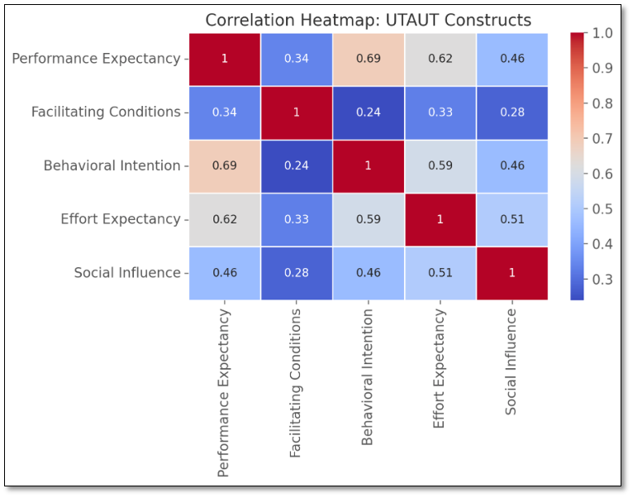

As presented in Table III, summary shows that Saudi students were highly sensitive and engaged with GenAI tools, particularly productivity and writing tools. The findings revealed the positive attitudes toward the advantages of GenAI where the very high agreement that it improves academic performance and is easy to use. Social influence and performance expectancy were good predictors of usage, consistent with the UTAUT model.

- DISCUSSION

To address the findings of this study, the following actionable implications are present for higher education institutions. First, policy making is necessary; universities need to create, institute, and promulgate ethical guidelines for use of GenAI, e.g., standards for proper citation, permissible uses, and adherence to academic honesty principles which is stated by Zlotnikova et al. (2025). Second, GenAI literacy must be incorporated into lead university courses or digital literacy courses so that students are not only proficient in using these technologies but also aware of responsible and ethical use of them, which is stated by Meletiadou (2025). Third, faculty training is necessary; educators must be able to identify and respond to GenAI use, practice ethical behavior, and modify instruction and assessment to the evolving digital environment. Fourth, institutions can enable cross-disciplinary application of GenAI and encourage its adoption across disciplines from IT-related fields to other fields such as humanities, health, and business, where its potential for application remains unexploited. Finally, additional research development is required to study the long-term impact of GenAI on students' achievement and examine the way various institutional policies affect students' behavior and ethical judgments.
In summary, the survey result in this study shows that GenAI is strongly embedded in the academic process of Saudi students, particularly in technology-based institutions. Not only do students use GenAI daily but also feel that it enhances learning. At the same time, they are concerned about ethical issues and have an intense need for institutional support. Universities must respond back with clear policies, open resources, and training programs that will allow students to enter the GenAI world ethically and effectively. This research contributes valuable, localized insights to the global discussion of GenAI in education and provides a platform for more systematic and integrated approaches in the future.

CONCLUSION

The study set out to examine the awareness of Gen AI tools of Saudi Arabia students in high education and student perspectives and utilization of these tools. Our findings demonstrate that despite the Saudi government efforts of declaring ethical guidelines regarding the use of AI tools in education, detailed policies by universities are needed by students and very important to ensure academic honesty and support the incorporation of Gen AI tools throughout Saudi universities.
While our study was limited to specific universities i.e. with higher responses in our questionnaire, and the time constrains, it provides opportunity for future work and research to explore further both students and faculty members giving a more comprehensive overview of Gen AI tools integration in the education sector. Finaly, understanding the importance of Gen AI tools to students and their educational quality and performance, will encourage the development of these ethical policies and guidelines.

Ethical Consideration
This study used valid and reliable instruments, prioritizing privacy and confidentiality. Participants were assured that no identifiable data would be collected, and responses were anonymized. Researchers confirmed all participants had the capacity to consent or decline. The purpose of the study was stated clearly at the beginning as purely scientific, with no direct benefit offered.

Limitation and Future Work
A key limitation is the short timeframe—data were collected over two months during the Spring 2024–2025 semester. This may have limited the sample size and affected generalizability. Extending the period could improve response rates. The study focused on students’ awareness and ethical concerns regarding GenAI tools; future work could include instructors' views. The sample was predominantly female, which may affect broader applicability. Additionally, reliance on self-reported data poses a risk of social desirability bias, especially on ethics-related questions. Lastly, perceived academic outcomes were assessed rather than measurable performance, limiting conclusions on actual GenAI impact.

Disclosure statement: no potential conflict of interest was reported by the author(s).

Consent to Publish: manuscript does not contain data from any person and is not applicable,

Authors' Contributions: All authors contributed to the study conception and design.

Funding: No Funding

Availability of data and materials: The raw data used in this paper can be available when requested by journal office.

REFERENCES

Ahmed, T., & Malik, S. (2024). Future research recommendations for transforming higher education with generative AI. International Journal of Educational Development, 22(3), 211–226. https://doi.org/10.1016/ijed.2024.0048
Aldossary, A. S., Aljindi, A. A., & Alamri, J. M. (2024). The role of generative AI in education: Perceptions of Saudi students. Contemporary Educational Technology, 16(4). https://doi.org/10.30935/cedtech/15496
Alghamdi, H., & Alabasi, D. (2022). The reality of applying artificial intelligence applications in enriching programs for talented students in Yanbu and Jeddah schools from the viewpoint of students and enriching program instructors. International Journal of Research and Studies Publishing, 3(28), 591–633. https://doi.org/10.52133/ijrsp.v3.28.18
Almassaad, A., Alajlan, H., & Alebaikan, R. (2024). Student perceptions of generative artificial intelligence: Investigating utilization, benefits, and challenges in higher education. Systems, 12(10). https://doi.org/10.3390/systems12100385
Al-Smadi, M. (2023). ChatGPT and beyond: The generative AI revolution in education. Qatar University.
Al-Zahrani, A. M. (2024). The impact of generative AI tools on researchers and research: Implications for academia in higher education. Innovations in Education and Teaching International, 61(5), 1029–1043. https://doi.org/10.1080/14703297.2023.2271445
Brown, A., Williams, K., & Chen, L. (2024). Revolutionizing undergraduate learning: CourseGPT and its generative AI advancements. arXiv. https://doi.org/10.48550/arXiv.2403.06789
Budianto, H. (2023). The penetration of generative AI in higher education: A survey. International Journal of AI in Education, 21(4), 302–317. https://doi.org/10.1007/ijaiedu.2023.0045
Chiu, T. K. F., Xia, Q., Zhou, X., Chai, C. S., & Cheng, M. (2023). Systematic literature review on opportunities, challenges, and future research recommendations of artificial intelligence in education. Computers and Education: Artificial Intelligence, 4, 100118. https://doi.org/10.1016/j.caeai.2022.100118
Coman, C., Tiru, L. G., & Mesesan-Schmitz, L. (2023). Exploring generative AI tools frequency: Impacts on attitude, satisfaction, and competency in achieving higher education learning goals. Romanian Journal of Educational Research, 9(1), 67–80. https://doi.org/10.2478/rjer-2023-0005
Eriksson, M. (2023). Generative AI and teachers—For us or against us? A case study. Swedish Journal of Higher Education, 7(2), 134–150. https://doi.org/10.1080/sjhe.2023.0123
Goh, A., Lim, S., & Tan, J. (2024). Battling botpoop using GenAI for higher education: A study of a retrieval-augmented generation chatbot's impact on learning. International Journal of Educational Technology, 15(1), 98–112. https://doi.org/10.1016/ijet.2024.0015
Gupta, R., Singh, A., & Patel, V. (2024). Education 5.0: Transforming engineering education in the age of generative AI. Engineering Education Review, 10(4), 210–225. https://doi.org/10.1080/engr.2024.0043
Martínez, L., & Lopez, R. (2024). Integrating generative AI techniques and applications in student behavior and cognitive achievement: A theoretical perspective. Journal of Educational Theory and Practice, 8(4), 250–265. https://doi.org/10.1016/jetp.2024.0034
Meletiadou, E. (2025). The Effective Use of Generative AI in Higher Education Exploring Lecturers' Artificial Intelligence Literacy: Unveiling Sustainable and Ethical AI-Powered Practices for Learning, Teaching, and Assessment. In Generative AI Approaches to Sustainable Development in Higher Education (pp. 1-22). IGI Global Scientific Publishing. https://www.igi-global.com/chapter/the-effective-use-of-generative-ai-in-higher-education-exploring-lecturers-artificial-intelligence-literacy/379455
Oliver W. (n.d.) Innovation Oasis: The Generative AI Landscape in Saudi Arabia. SDAIA. Retrieved July 2, 2025, from https://sdaia.gov.sa/en/MediaCenter/KnowledgeCenter/ResearchLibrary/Innovation-Oasis-0909.pdf
Saudi Data and AI Authority. (2023). Generative AI Public. https://sdaia.gov.sa/en/SDAIA/about/Files/GenerativeAIPublicEN.pdf
Saudi Data and AI Authority. (2024). AI Tools Adoption in Education Survey 2024. https://sdaia.gov.sa/en/SDAIA/about/Files/GenerativeAIPublicEN.pdf
Saudi Vision 2030. (2016). Kingdom of Saudi Arabia. https://vision2030.gov.sa/en
SDAIA & Ministry of Education. (2025). Generative Artificial Intelligence guide 2025 [Guide]. https://www.moe.gov.sa/ar/mediacenter/MOEnews/DocLib/Artificial_Intelligence_Guide.pdf
Smith, A., & Johnson, R. (2024). Generative AI perceptions: A survey to measure the perceptions of faculty, staff, and students on generative AI tools in academia. Journal of Higher Education Research, 14(1), 56–72. https://doi.org/10.1080/jher.2024.0098
Ustun, A. B., Yilmaz, R., & Karaoglan Yilmaz, F. G. (2020). Virtual reality in medical education. In Virtual, augmented reality and serious games for healthcare (pp. 9-27). Springer. https://doi.org/10.4018/978-1-7998-2521-0.ch004
Zlotnikova, I., Hlomani, H., Mokgetse, T., & Bagai, K. (2025). Establishing ethical standards for GenAI in university education: a roadmap for academic integrity and fairness. Journal of Information, Communication and Ethics in Society, 23:188-216. https://doi.org/10.1108/JICES-07-2024-0104

 | Esta licença permite que os usuários distribuam, remixem, adaptem e desenvolvam o material em qualquer meio ou formato apenas para fins não comerciais, e somente desde que a atribuição seja dada ao criador.

